Systems and Reporting Subcommittee Meeting Minutes
The purpose of the meeting is to discuss system changes and reporting updates. This meeting occurred virtually via Microsoft Teams on Wednesday May 20, 2026, at 1PM.

Attendees
Image below lays out the state DCF staff and W-2 agencies who attended the meeting.
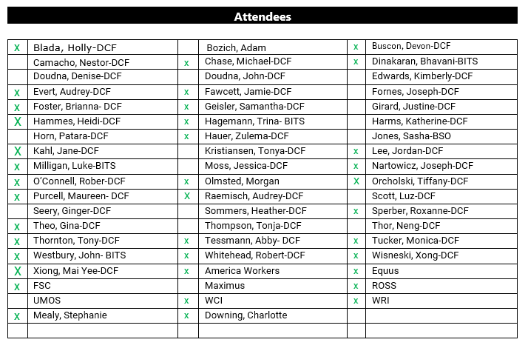

Report Updates from BAR’s Rob O’Connell

Upcoming Changes to WebI Personal Folder and BI Inbox
- WebI Personal Folder / BI Inbox – Upcoming Changes
- Upgrade for WebI is coming, date TBD (by end of year is the projected vision)
  - General updates to folders will happen, however, reports in personal folders might not be updated

System Updates from BWF’s Automation Team
CWW Changes for June will go live on 6/20/2026.

June Project Updates
- Changes impacting ACCESS, MyACCESS, CWW and reports are provided in the chart below

Release Date | Project | Project Description
May 29, 2026 | RMB/RMC Report | - New report located in WebI that lets agencies know what renewals and changes submitted from ACCESS  - Report will show the following statuses:  - Completed  - In progress  - No action taken  - Received  - Expired  - Location: WISDOM folder  - Go-live: 05/29/2026
June 13, 2026 | MyWI ID: Tableau | - New log-in process beginning  - Go-live: 06/13/2026  Action item Mai: Confirm that CWW and ECF has gone live with MyWI ID  Confirmation: CWW/ECF has gone live with MyWI ID. If agency staff (external users) are not able to log-in, it’s because their email/WAMS ID was not previsioned. An excel document will be sent out to agencies to provide the State with the users who are having log-in issues, to get their emails/WAMS ID’s previsioned.
June 20, 2026 | Communication Preference Center (CPC) | - Changes impacting ACCESS, MyACCESS and CWW  - Project is focusing on obtaining informed consent from participants and applicants  - Training will be available 06/12/2026
June 20, 2026 | MF screen decommission: Eligibility Override & CTS | - Part of the roadmap to decommission Mainframe screens  - Workers will now have the ability to complete overrides for individuals in CWW and not have to go into Mainframe  - Training will be available 06/12/2026
June 20, 2026 | ACCESS/MyACCESS for Confidential Cases | - This will allow individuals with a confidential case to create ACCESS accounts  - Limiting access to Client Correspondence  - Only workers who have access to the case, will have access to the notices
June 20, 2026 | Guest Registration | - Applicants applying for FS/HC/CC will be able to submit an application without creating an ACCESS account, known as Guest Registration.  - Applicants will complete the basic information; name, address, requested program and can submit  - W-2, JAL and EA will not allow guest registration
June 20, 2026 | HR1: Non-Citizenship Eligibility | - A new registration status without 5-year-bar (5YB)  - 23 – Lawful Permanent Resident

Upcoming WWP Project Updates from Heidi Hammes
- Four upcoming projects
  - #1: Supervisor and QC/QA staff will benefit from the WebI reports (region access)
    - Is there value in expanding this access? WebI vs. WWP
      - Jody and Kailee prefer WebI
      - Maybe a lower priority to enhance this
        - Agencies have their own internal process, so this isn’t needed at this time.
- #2: Developing FEP dashboard-full caseload visual
  - Heidi H. will send out an email survey to determine what information will be beneficial for FEP workers, to include on a dashboard—will send out in the next two weeks (potentially around week of 6/15/26)
- #3: WWP Search Page
  - Will reach out to agencies to get feedback, once more detail is flushed out
- #4: Informal Assessment Redesign
  - Field specific change requested (feedback provided from the feedback sessions that occurred with the FEP workers in 2025)
  - Internal discussion is still happening at DCF to see priority
  - State will reach out to agencies once details are flushed out

Walk On Agenda Topics
None.

Additional Information
The following link will bring you to minutes and attachments discussed in our meetings: https://dcf.wisconsin.gov/w2/partners/toolbox/systemsubcommittee

