WWP Processes: Phase 2

Trainer Toolkit

Class Dates: ________ - _________

Table of Contents
Training Team Preparation Checklist 3
PIN Assignments Worksheet 4
Information for the Producer 5
Information for the Support Trainer 6
Information for Main Trainers 7
Training Day Technology Tips and Tricks 8
General Tips 8
WWP Troubleshooting 8
PowerPoint (PPT) Troubleshooting 8
Toggling Between Applications During Screen Sharing 9
Zoom-Specific Features 11
Post-Training Debrief Questions 14
Trainer Breakout Day 1 15
Trainer Breakout Day 2 16
Trainer Breakout Day 3 17

Training Team Preparation Checklist

Training Team Readiness
☐Determine roles (producer, support trainer, trainer(s))
☐Clarify role expectations
☐Create trainer breakout for the course
☐Schedule prep and debrief sessions

Trainer Prework
☐Complete trainer prework as outlined in the course
☐PIN entries in WWP for learners and trainer
☐Worker tasks assigned to correct trainer
☐Update self-facilitated introduction slide on the PPT
☐Prep platform for class needs (closed captioning, polls, breakout rooms, etc.)
☐Log into any systems used during class to check your access
☐Save a copy of the course TN, PG, and PPT to your computer to open on day of
training
☐Printing the TN is recommended

PIN Assignments Worksheet

Learner | Case Name and PIN | CWW | WWP | Reassign to Learner
 | Candace | ☐ | ☐ | ☐
 | Ashley | ☐ | ☐ | ☐
 | Candace | ☐ | ☐ | ☐
 | Ashley | ☐ | ☐ | ☐
 | Candace | ☐ | ☐ | ☐
 | Ashley | ☐ | ☐ | ☐
 | Candace | ☐ | ☐ | ☐
 | Ashley | ☐ | ☐ | ☐
 | Candace | ☐ | ☐ | ☐
 | Ashley | ☐ | ☐ | ☐
 | Candace | ☐ | ☐ | ☐
 | Ashley | ☐ | ☐ | ☐
 | Candace | ☐ | ☐ | ☐
 | Ashley | ☐ | ☐ | ☐
 | Candace | ☐ | ☐ | ☐
 | Ashley | ☐ | ☐ | ☐
 | Candace | ☐ | ☐ | ☐
 | Ashley | ☐ | ☐ | ☐
 | Candace | ☐ | ☐ | ☐
 | Ashley | ☐ | ☐ | ☐
 | Candace | ☐ | ☐ | ☐
 | Ashley | ☐ | ☐ | ☐
 | Candace | ☐ | ☐ | ☐
 | Ashley | ☐ | ☐ | ☐
 | Candace | ☐ | ☐ | ☐
 | Ashley | ☐ | ☐ | ☐
 | Candace | ☐ | ☐ | ☐
 | Ashley | ☐ | ☐ | ☐
Extra Cases | Candace | ☐ | ☐ | ☐
 | Ashley | ☐ | ☐ | ☐
Trainer Cases | Candace | ☐ | ☐ | ☐
 | Ashley | ☐ | ☐ | ☐

Information for the Producer

To Add in the Chat
Closed Captioning
To hide subtitles, click on Live Transcript and choose Hide Subtitle.

Renaming Instructions
If your display name is not correct, rename yourself by clicking on the more button (…) next to your display name.

If you called in by phone, please rename your phone number to match your login name.

WWP Training Environment
https://wwptrn.wisconsin.gov

Annotation Tools - Stamp
View Options – Annotate – Stamp

Annotation Tools - Text
View Options – Annotate – Text

Chain Reaction Teams
Chain Reaction Team 1:

Chain Reaction Team 2:

BWF Work Programs Help Desk Home Page
Q&A Document: https://dcf.wisconsin.gov/w2/partners/toolbox/helpdesk

Evaluation
Please complete the eval at:

Break Timers
Nature scenes: https://www.youtube.com/watch?v=l8o3F3YiV3M
Productivity Arrows: https://www.youtube.com/watch?v=PHJWV1SmPTc
Cute Puppies: https://www.youtube.com/watch?v=MKLr_Aw391U
Among Us: https://www.youtube.com/watch?v=xYmG0a5CC-I
House Mix: https://www.youtube.com/watch?v=OPyjgRp-Rb8

BWF Work Programs Help Desk
Email: bwfworkprogramshd@wisconsin.gov; Phone: (608) 422-7900

Information for the Support Trainer

Fill-Ins for the PG to Put in the Chat
Meet Candace (TN 12-13, PG 53)
~Nakeisha is 15, Neveah is 4
~Sickle cell anemia
~Doctor every month, transfusions every two weeks
~Used to work full time, works 5 hours
~CNA, Home Health Companion
~Nurse

Meet Ashley (TN 47-48, PG 54)
~Braxton is 2
~Apartment Manager

Non-Participation Good Cause Details (TN 76, PG 35)
~CSJ, W-2 T
~sanctionable
~FA, activity

Payment Information (TN 77, PG 36)
~Round down

Delayed Cycle Payment (TN 78, PG 37)
~Will not
~2nd
~Overpayment

Payment Details (TN 79-80, PG 38, 40)
~View only, one
~Pulldown
~Pending

Transfer and Disenrollment (TN 87, PG 46)
~end
~Participation Statuses
~editable

Information for Main Trainers

EP Dates Worksheet
Candace

Date/Day of Week for 1st Day of Class: ________________
- EP Begin Date (Today): ___________
- EP End Date (1 month): ____________

- FC Begin Date (next Tuesday): ____________
- WE Begin Date (next Monday, Wednesday, or Friday): _____________
- CE Begin Date (Thursday): ____________

Ashley

Date/Day of Week for 2nd Day of Class: ________________
- EP Begin Date (5 days ago): _____________
- EP End Date (One month from today): ______________

- ES End Date (Yesterday): __________
- ES Start Date (next Mon, Wed, Thurs, or Fri): ____________
- MO Edit Planned End Date (this Thursday): _____________
- MO Add Schedule Start Date (next Tuesday): ___________
- WE Start Date (5 days ago): ____________

Training Day Technology Tips and Tricks

General Tips
- Turn off other Wi-Fi devices. Use an ethernet cord to plug into your modem directly for internet. This increases your chances of a stable connection during training.
- Use Ctrl + to zoom in and Ctrl – to zoom out when working in WWP.
- Remember to use breakout rooms as needed.
  - Trainers can use breakout rooms to quickly discuss something.
  - Support trainers can use breakout rooms to work with a learner.

WWP Troubleshooting
If learners indicate they have issues accessing information in the system, ask the following:
- Are you logged into the training environment?
- Are you using Internet Explorer as your browser?
- Are you assigned the correct security role and listed under Workforce Resource as the agency? Click on your name in the upper right corner to see that information.
- Are you using the PIN that was assigned to you in WWP or given to you at the beginning of class?

If a trainer or learner receives a red fatal error:
- Click on the fatal error and it should go away.
- If you can’t continue working on the page, go back to a different page. Then come back to the page you were working on it and you should be able to move forward.

PowerPoint (PPT) Troubleshooting
- If your PPT uses the zoom feature, don’t start the slide show from a slide in the middle. Always start with slide one.
- Be aware of moving your mouse between monitors when running the PPT. If you move your mouse to the monitor that is not sharing the PPT in slideshow mode, you must make an initial click back on the screen with your PPT. Then click a second time to move to the next animation or slide.

Toggling Between Applications During Screen Sharing

Prior to Screen Sharing
- Have everything open that you plan to share, such as the program system, PowerPoint, etc.
- If using two monitors, move everything you plan to share to one monitor. When you share your screen, choose to share that monitor and not just a window. This means anything you switch to on that monitor will display. It is best practice to use the monitor that is bigger and doesn’t have your webcam.
  - You can have the PPT open and in slide show mode on that monitor and minimize the presenter view on your main monitor.
- Remember to share your computer audio from the screen share dialog box.

Using Alt+Tab
- While sharing your screen, Press Alt+Tab on your keyboard to display a window that show all your open applications.
- Take your finger off the Tab key and tap the Tab key to move through the applications until you get to the one you want to display.
- The application will display on whatever screen you previously used to display the application.

Using Your Task Bar
- Another option for switching between applications while screen sharing is to use your task bar. To do this you must change your computer settings to display the task bar on your main computer and not your second monitor.
- Right click on your task bar at the bottom of the screen and select Taskbar Settings.
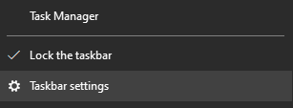

- Scroll down to the multiple displays section, and turn off the setting for Show taskbar on all displays.
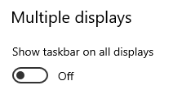

- The taskbar only displays on your main monitor and you can use it, like you usually would, to switch between applications. Again, the applications will display on the screens you originally used to display the application.
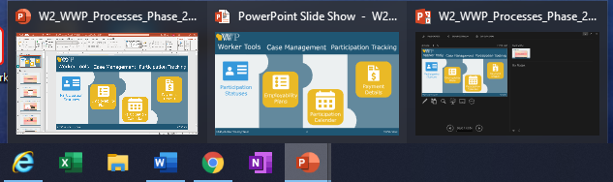

Zoom-Specific Features
Renaming Learners
- Encourage learners to rename themselves first.
- If you need to rename a participant, click on More > next to their name and choose Rename. Then, type in the correct name.
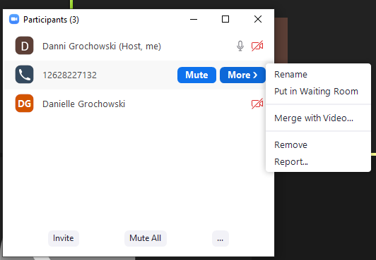

Connecting phone number with a learner’s video
- It’s important to match learners who call in by phone with their video profile so that both end up in the same breakout room.
- If it is not obvious who the phone number belongs to, ask learners who called in by phone to rename their phone number so you can match it.
- In the Participants box, click on More > next to the phone number. Choose Merge with Video.

- Zoom displays any learners who are logged in, but didn’t connect to audio through their computer. Select the name you want, and click Merge.
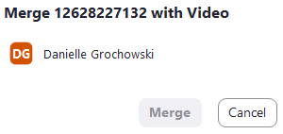

Breakout Rooms – auto send and auto end
- When setting up breakout rooms, always choose to set up the rooms manually. This allows you to move learners to different rooms, but leave the trainers and notetaker in the main room.
- When setting up breakout rooms for the first time, click on options.
- Check the option to Automatically move all assigned participants into the breakout rooms. This saves a step of having learners click a button to join.
- Use the options to have breakout room automatically close after a certain amount of time and to display a countdown timer. In the example below, the countdown timer of 60 seconds will start after the 4 minutes. This means learners will have a full 5 minutes in the room.
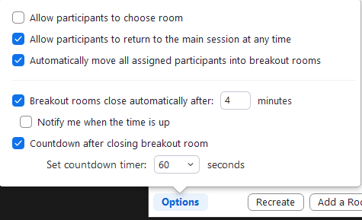

- These setting will remain for all future breakout rooms unless you change them (even in future sessions).

Moving Text Annotations
- When learners use the text annotation to type on the screen, only the trainer sharing their screen can move the text boxes elsewhere on the screen.
- Open your annotation toolbar, and choose the Select tool. Then, click on the annotation you move and move it elsewhere on the screen.

Exit Full Screen Mode
- When another trainer shares their screen, it automatically displays in full screen mode, messing up your set up with the chat box, etc.
- Press the ESC button to put everything back into a frame and out of full screen. You should still see what they display and have your other dialog boxes open as well as access to your computer’s task bar.

Pause Your Screen Share
- If you need to access other applications on the monitor you are sharing, but don’t want learners to see you can pause what you’re sharing. This keeps the same thing on the screen for learners, but allows you to move around to other things.
- Click Pause Share (next to New Share) on your Zoom control panel.
- Zoom displays a message that your screen is paused. Remember to click Resume Share when your ready to share everything again.

Enable Closed Captioning (CC)
- At the beginning of each class, the host must turn on the CC feature.
- Click on Live Transcript from the Zoom control panel. Then, click Enable Auto-Transcription. This turns on CC for everyone and starts it immediately.
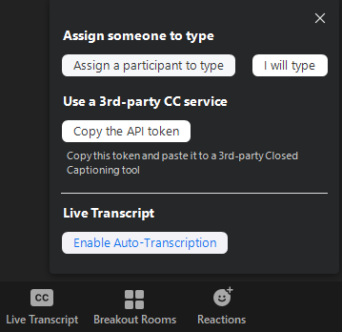

- To turn the CC off on your display only, click the carrot (^) on the Live Transcript button and select Hide Subtitle.
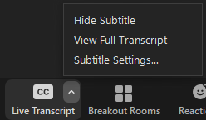

Post-Training Debrief Questions
The goal of the post-training debrief is to reflect, process, and collaborate regarding the training delivery. It includes:
- Discussing the training delivery from the learners’ perspective, ensuring they have the skills needed to work with families.
- Discussing the individual and team dynamics while delivering the training.

- What was the most effective moment in training today?

- What did we do well as a team that promoted a positive learning experience for learners?

- What did we do well as a team that promoted a positive training experience for us?

- In what ways did you successfully complete the tasks of your assigned role(s) during the delivery of the course?

- What were some important lessons we learned?

- Where do you feel we are getting stuck as a team?

- Where do you feel you are getting stuck individually?

- Where do you think learners are getting stuck?

- Which content or activity may need to be strengthened to be more effective?

- What can we do to ensure a successful experience (for learners and us) moving forward?

- What can you do to ensure successful course delivery moving forward?

Trainer Breakout Day 1
Producer: ________________

Topic | Talking | Sharing | Support | Planned Time | Actual Time | Producer and *Support Trainer Notes
Introduction, Meet Candace, Participation Statuses, Statuses for W-2 (8-14) | Danni | Sarah | Kelsey | 30 min |  | *Clear annotations  *Meet Candace fill ins  Breakout Rooms  https://wwptrn.wisconsin.gov
Participation Statuses App, Ending Statuses, EP Overview, Sit/Stand Energizer (15-19) | Sarah | Danni | Kelsey | 25 min |  | Poll 4: Participation Statuses

Trainer Breakout Day 2
Producer: ________________

Topic | Talking | Sharing | Support | Planned Time | Actual Time | Producer and Support Trainer Notes

Trainer Breakout Day 3
Producer: ________________

Topic | Talking | Sharing | Support | Planned Time | Actual Time | Producer and Support Trainer Notes

