Trainer’s Notes
Style Guide

Purpose
Standardize the layout and formatting of training materials developed within the Partner Training Team.

Objectives
Upon completion of this course, you will be able to:
- Correctly format the cover and table of contents;
- Accurately apply Trainers’ Notes heading styles to text within the document;
- Correctly create headers and footers on the cover page and in the body of the document; and
- Correctly use symbols when referencing materials outside the trainer’s notes.

Table of Contents
Developing Trainers’ Notes 3
Title/Cover Page 4
Goals and Objectives 4
Table of Contents 5
Headers and Footers 6
Materials/Suggested Pace/Introduction Page 7
Symbols 8
Heading Styles 9
TN Heading 1 9
TN Heading 2 9
Content 10
Bolded Words 10
Question and Answer Format 10
Fill in the Blank Items 11
Full Content Example 12
Working with Formal Assessment Results 12
Reviewing Formal Assessment Results 12
Learner Engagement 13
Engagement Strategy Format 13
Activity Format 14
Appendix Standards 15

Developing Trainers’ Notes
- Refer to course participants as “learners”.

- Note anything the trainer needs to prepare prior to class.

- Provide detailed instructions about the information the trainer needs to cover.
  - The trainer is not expected to be a subject matter expert; ensure you provide enough information for them to teach the topic.

- Use symbols for trainer reference.

- List answers or possible responses for discussion and activity debrief questions.
  - Note when the PG contains some of the questions, but not all of them.

- Provide background information as needed.
  - Include data references, additional context if certain questions are asked, resources, etc.

- Use short paragraphs, bulleted information, and extra white space when writing to make the content user-friendly.

- Include suggested variations for activities when possible.

- Remember, the TN contains everything the trainer needs to train the course.

Title/Cover Page
- The cover of the TN mirrors the cover of the PG, with the addition of “Trainer’s Notes”.
- Do not apply a Heading to the Title. If you do, Word automatically pulls it into the Table of Contents and you have to manually delete it.
- Headers and footers do not appear on the cover page of the Trainer’s Notes.
“Trainer’s Notes” need to be at the top, Arial, 60pt font, bold, italicized, centered

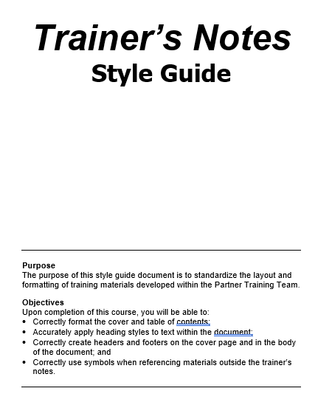

The title of the course is Tahoma, bold, and centered under Trainer’s Notes. The font size depends on the length of the title.

Purpose and objectives are at the bottom of the page.

Goals and Objectives
The developer has the option of putting appropriate objectives throughout the course when creating units/sections. These appear in both the TN and PG when using this option.

If you are creating units/sections, then this is an option.

Goals and Objectives
Upon completion of this unit, the participant will be able to:
Explain the new background check procedure.
Identify for whom a background check needs to be completed.
Demonstrate the background check procedure.
Background Information, Goals and Objectives, References:
- Title in 10pt Bold Comic Sans font.
- Body in 10pt, Comic Sans font.
- Indented on left and right by 5 pts, border, single line, 1pt width

Table of Contents
- Insert a table of contents using the TN headings, not PG headings.
- It is the developer’s discretion to show all three TN headings in the table of contents or just the first two.

Developer’s discretion to remove TOC page number from the table.
TN Heading 1

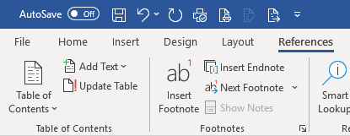

From the References tab, choose Table of Contents, then select Custom Table of Contents.

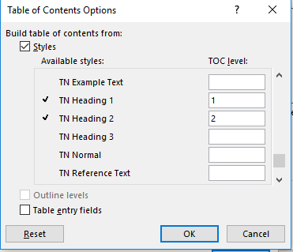
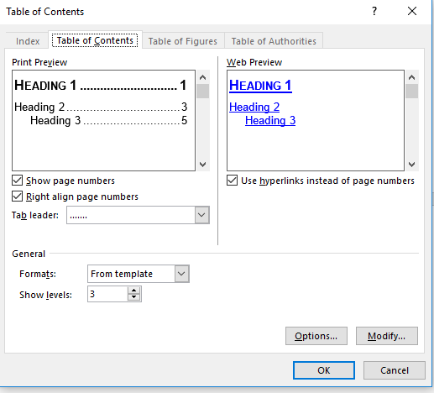
Clear the TOC level listed under Heading 1, Heading 2, and Heading 3. Then, add a TOC level for TN Heading 1 (level 1), TN Heading 2 (level 2), and TN Heading 3 (level 3) if you include it. Click OK to return to the Table of Contents dialog box. Click Ok to insert the TOC.
Click Options to select TN headings.

Headers and Footers
- Headers and footers do not appear on the cover/title page. Create a “next page” section break to separate the cover page from the rest of the document. Do not use the “different first page” checkbox on the Headers toolbar. Uncheck the “Link to Previous” button on the second page of your document and delete the header and footer text from the cover page.
- Format is the same as the PG with a few additions.

Name of the course that matches the PG, Arial 10pt, right tabbed
Arial 12pt, bold, left justified “Trainer’s Notes”.

The footer in Trainers’ Notes is the same format used in the Participant Guide with the addition of “TN” and a space before the page number.

Materials/Suggested Pace/Introduction Page
- List all appropriate materials for course delivery.
- Divide the course into chunks with an estimated time for each. Review the suggested pace at the Dry Run and/or TtT and update as needed. Re-check after initial class(es) is held.
- Include any additional materials/tasks the trainer needs prior to class, such as creating a case ahead of time.
- Section titles typically use TN Heading 3.

Child Support
- TN Heading 1 for “Preparation and Materials”,
- TN Heading 2 for Sub-headings, and
- TN Heading 3 for:
  - Training Cases Preparation before Class (when necessary).
  - Materials. Separate materials out to include “Media”, “Handouts” in bold and do not use a heading.

EXAMPLES:

Materials
- Computer, LCD projector, and portable speakers
- White board and markers or flip chart and markers
- Severity Continuum Activity
- Four envelopes titled physical, economic, emotional, stalking (use different colored envelopes or cards for each)
- Materials from Trainers’ Notes Appendix C

Optional:
- End Domestic Abuse Wisconsin: the Wisconsin Coalition Against Domestic Violence brochures

Suggested Pace
This is a 12-hour course. The following agenda is the suggested pace for each day.

Day 1
9:00 – 9:30: Introduction
9:30 – 10:25: Defining Domestic Abuse
10:25 – 10:40: Break

Day 2
9:00 – 9:15: Getting Started Day 2
9:15 – 9:55: Birdcage Activity
9:55 – 10:30: Warning Signs
10:30 – 10:45: Break

Symbols
Use symbols to reference other materials. Copy and paste them from this document as needed.
Arial 14pt
PPT 40
All symbols are:
- Found under Insert – Symbol - Wingdings
- Arial 20pt font

The following are the standardized symbols used in the Trainers’ Notes.

PPT 40 | References the corresponding slide number in the PPT.
Frank is paid weekly and  works 32 hours per week.  Broken heart appears  Click to start music. | - Indicates the trainer must click more than once on the same PPT slide to make something happen, such as an animation.  - If using a bulleted list, use the symbol once to indicate the trainer should click for each bullet.  - Follow the symbol with what the trainer says that goes along with the animation, text explaining the animation, or an instruction for the trainer.
PG 30 | References the corresponding page number in the PG.
PG 45 (Appendix A) | - Notes the corresponding page number in the PG Appendix the learner should be on.  - If you are referencing the appendix, but don’t expect learners to turn to, mention the appendix information in the content.
TN Appendix A | Additional information or handouts for the trainer in the appendix.
 | Indicate a trainer-guided or hands-on entry in the computer system.
Reference: Good Cause and Noncooperation Fact Sheet | References to policy manuals, operations memos, and statutes.
DV Case Scenario HO-1 | References additional handouts the trainer provides during class that are not in the PG.

Heading Styles
Use the TN heading numbers with the corresponding heading numbers in the PG. For example, if a section title in the PG is Heading 1, the same section title in the TN is TN Heading 1. Engagement strategies and activities use the TN Activity heading.

TN Heading 1
Arial 14pt bold, right justified, underline 1pt width.

TN Heading 2
Arial 12pt, bold, right justified, 1pt width underline.

TN Heading 3
Arial 12pt, bold, italicized, right justified, 1pt width underline.

TN Activity Heading
Arial 12pt, bold, italicized, highlighted Gray-25%, right justified, 1pt width underline.

NOTE: Trainer’s guides are being developed for both face-to-face classroom sessions as well as virtual classroom sessions. To help identify content included in the trainer’s guide for either distance or classroom delivery, it is necessary to label the headings in each session accordingly. Add (Distance) or (Classroom) to heading if the material is for that delivery method only. Do not include () if the material can be used for both delivery methods.

Content
Content typically includes general concepts, information, lecture, and questions/answers. Ensure the trainer knows what to say about the content.
Arial 12pt

Child support Specific:
- PG text quoted verbatim in the TN is green (RGB code: R = 83, G = 129, B = 53).
- Trainer Note/Prep highlighted within the TN is highlighted in yellow.

Bolded Words
- Used bolded verbs to provide specific instruction to the trainer. This is something the trainer needs to do other than lecture or facilitate an activity.
  - Examples include: ask a specific question, draw something on the board, divide learners into pairs, etc.
- Use a bolded “Note to Trainer” as an indicator for additional instructions or information for the trainer.
  - Examples include: regional considerations, background information on a policy/process, questions the trainer may hear, etc.

EXAMPLES
Ask Which agency has jurisdiction in the case?
Arial 12pt,
bold

Write example on the white board
_ _ _ _ _ _ _ _
State Code Co/Tribal Code Agency Suffix (when necessary)

Note to Trainer: Some of the participant information in the Grant cases may be different. That is intentional. The learners MUST review the information on the worksheet and compare it to the information contained in KIDS.

Question and Answer Format
- Include actual or possible answers to questions in the TN.
- Use the format that makes the most sense to display the questions and answers in the TN. This could be bullets, numbers, tables, etc.
W-2 italicizes answers
- What might W-2 participants have to do regarding the parent of any child in the W-2 group?
Answer: Name the parent and give information to help find the parent

What happens when you don’t use this tool?
- There is no automatic record of appointments and
hearings on the case or participant record.
CS uses red for answers
- Appointment letters don’t auto generate.

Child support includes a comment:
- {PG Activity: write in the items needed for each step} in red/italics for PG fill-ins (e.g., lists)

Fill in the Blank Items
When the PG contains fill in the blanks for learners to complete, indicate those answers in the TN.
W-2 underlines and italicizes answers

You can add up to four types of pay in the Detailed Wage Information section.

CS uses red/bold for answers

Establishes the financial relationship between the participants

Full Content Example

Working with Formal Assessment Results
PPT 18
PG 18

Click for each underlined word below.

After receiving a completed formal assessment, review the results to determine if follow-up with the provider or additional research is needed. Then, discuss the results with the participant. And, finally, apply the results of both the informal and formal assessment by determining if changes are needed to the participant’s placement, accommodations, goals, and assigned activities. You must do this within 30 days of receiving the formal assessment.

Reviewing Formal Assessment Results
PPT (mute)
PG 19

Ask What are some reasons you may want to review the completed formal assessment form before meeting with the participant?
Possible answers:
- Determine if case clarification is needed
- Determine how to best discuss the results with the participants
- Consider what changes may be needed

It can be tempting to flip to the last page in the formal assessment to see what activities and the number of hours a provider recommends. Taking the time to look at the whole report gives you a better picture of what the participant is experiencing, and leads to better case management decisions.

Note to Trainer: Learners often get hung up on needing to know the number of hours in the formal assessment. This is not a required entry in WWP.

Learner Engagement
Courses typically contain multiple ways to engage learners that fall under these categories:
- Engagement Strategy – Something simple such as a 1-2-4-All, Bright Ideas worksheet, energizer, etc. This is meant to be quick, does not require a lot of instruction, and may or may not have a short debrief.
- Activity – A larger scale engagement that typically involves additional materials, more time, longer instructions, a debrief, etc.

Engagement Strategy Format
An Engagement Strategy must include:
- A Title
and the following descriptors:
- Estimated Length: Total time to explain and complete the strategy.
- Trainer Instructions to Learner: What the trainer says to learners to explain the strategy.

An Engagement Strategy may include the following descriptors:
- Directions to Trainer: Additional information for the trainer to facilitate the strategy.
- Debrief Questions or Discussion Points: A couple of questions to ask or points to make after the strategy.
TN_ActivityHeading: Arial, 12pt, bold, italicized, highlighted Gray-25%, underlined with 1pt line, right justified.
EXAMPLE:
Arial 12pt, bold

Sit/Stand Energizer
Estimated Length: 5 minutes

Directions to Trainer: Read each statement below, asking learners to stand if that statement is true for them or sit down if the statement is not true for them.

Trainer Instructions to Learners: Before we dive into the Absent Parent page, take a moment and stand up at your station. I will read several statements. If a statement is true for you, remain standing. If a statement is untrue for you, sit down.

Statements
Stand if…
This is your first classroom training as part of New Worker.
You know what CWW stands for.
You learned something new about CWW Begin Months today.
You have ever accessed Process Help in CWW.

Activity Format
Activities must include the following descriptors:
- Purpose: Define the reason/objective of this activity.
- Materials: Additional items the trainer or learners may need such as markers, paper, handout, a PPT file, etc.
- Estimated Length: Total time to explain the activity, complete the activity, and debrief the activity.
- Directions to Trainer: Additional information for the trainer on how to facilitate the activity.
- Trainer Instructions to Learners: What the trainer says to learners to explain the activity.
- Debrief Questions or Discussion Points: A way to help learners make sense of the activity, connect the activity to their work, or wrap up key points from the activity. It is possible the debrief or discussion occurs during the activity instead of being a separate piece after the activity, which does not require a descriptor.

Activities may include the following descriptors:
- Expected Results: The anticipated outcome of the activity.
- Suggested Modifications: Alternate ways to facilitate the activity or alternate materials when certain materials are unavailable.

TN_ActivityHeading: Arial, 12pt, bold, italicized, highlighted Gray-25%, underlined with 1pt line, right justified.
EXAMPLE:

Building Absent Parent Pages Activity
PG 10-11
PPT 5-8
Arial, 12pt, bold

Purpose: To familiarize learners with how Absent Parent pages are built in CWW based on family make-ups.

Materials: Separate sheets of paper (numbered 1, 2, and 3), tape.

Estimated Length: 10 minutes

Directions to Trainer: Hang three sheets of paper, numbered one, two, and three, around the room. Display the family scenario graphic from the PPT and ask learners to determine how many Absent Parent pages are needed for the family. After they have determined how many Absent Parent pages are needed, they should walk to that numbered sheet (if space is limited, have learners turn and point to the numbers). The family scenario graphics are in the PG for learner reference. Debrief with learners after each family scenario before moving on to the next.
Directions to Learner: Let’s practice determining how many Absent Parent pages CWW builds based on a family’s make-up. Notice the numbered signs hanging throughout the room; these signs indicate the potential number of Absent Parent pages needed. When we display the family scenario graphic, look at it and determine how many Absent Parent pages you think you need. After you’ve decided on the number of pages, walk to that hanging sign. The family scenario graphics also are located in your Participant Guide for you to reference and record the number of Absent Parent pages.

Scenarios and Answers:
Click to display the scenario, then again to display the answer.

How many Absent Parent pages are needed for this family?

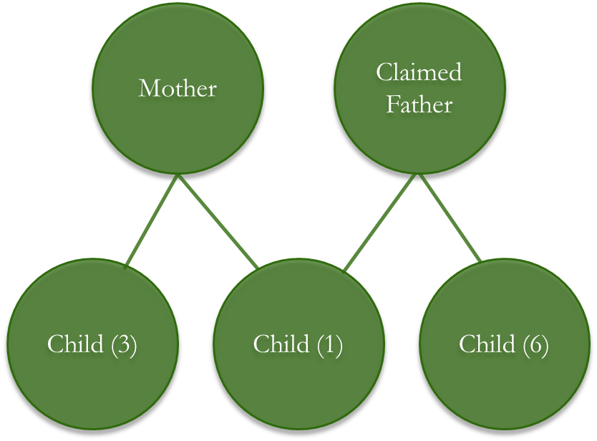
Answer: 3, the claimed father of the 1-year old, the other parent of the 3-year-old, and the other parent of the 6-year-old.

Note to Trainer: Although the claimed father and his 6-year-old are not listed as part of the W-2 Assistance Group during eligibility determination, CWW requires an Absent Parent page for the other parent of the 6-year-old.

Appendix Standards
- Do not use a Cover page/Title page for the Appendix section.
- Label each Appendix “TN Appendix [A, B, etc.] - Title of document” (e.g. TN Appendix A – W-2 Acronyms). Use the TN Heading 1 style.

