Tips for Recording Effectively in Audacity

Helpful Keyboard shortcuts

Zoom In ……………………..………..…….…… CTRL+1
Zoom Out ……………………………….….……. CTRL+3
Normal View ……………………………….…… CTRL+2
Replaces selected audio with silence…….….. CTRL+L
Cut…………………………………………….…. CTRL+X
Copy……………………………………………... CTRL+C
Paste…………………………………………….. CTRL+V
Play ……………………………………………… Spacebar
Loop Play ………………………………………... Highlight audio, then press spacebar
Fast Forward……………………………………. Right Arrow
Fast Backward ………………………………….. Left Arrow
Skip to End ………………………………………. End Key
Skip to Beginning……………………………….. Home Key

Basic

Before Recording
- Equipment
- Use a quality microphone (Snowball or Snowflake) or headset.
- Avoid recording in different rooms and changing computer settings and microphone set up.
- Dampen the sound by recording in a small room and hang blankets or poly foam on the walls.
- Use a microphone stand if you are using a desktop microphone. Measure the recording distance for future recording to have the same set up.
- Use a pop filter screen to prevent popping or turn your head away from the microphone when speaking “P” and “B” words.
- Use foam filters for the headset microphones to prevent popping.

- Computer settings
- Close all un-necessary programs and processes while recording.
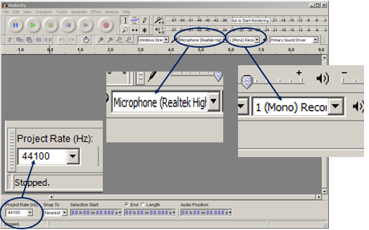
- Consider disconnecting from the internet to reduce your computer’s processor usage.
- Ensure you have the right microphone selected in Audacity. It defaults to the computer’s internal microphone, which will not deliver a good result.
- In Audacity, set the Project Rate to 44100 Hz. Higher rates will increase data load without improving quality.
- Set the recording channels to Mono using the devices tab in Audacity. Stereo requires twice the data.

- Preparation for recording
- Is it read as letters or as a word? Include pronunciation.
- Attitude or Point of View. Think about the end listener.
- Make sure your script is conversational and easy to read.
- Practice reading it a few times to make sure it flows right.
- Look for words or phrases where you might stumble while recording.
- Limit background noises. Unplug printer. Shut off furnace, fans, air conditioner, etc. Put a sign on your door.
- Position the microphone below your mouth.
- Move your microphone away from your computer to reduce ambient noise.
- Refer to Dave’s Tips for Scripts located on the Trainer’s Resource webpage for additional tips and best practices.

During Recording
- Tips for the narrator
- Use a printed script.
- Leave enough white space so it’s easy on the eyes.
- Have enough lighting to easily read the script.
- Have plenty of liquids available. Keep your vocal chords hydrated with clear liquids.
- Don’t ad-lib. Stick to the script. This:
- Reduces multiple takes,
- Maintains the same break points for editing,
- Makes it easier follow along with the audio, and/or
- Makes it easier to find a common edit point on re-takes.
- Take a deep breath before you speak by taking your breath off to the side of the microphone to avoid a big whooshing breath sound in your recording.
- Stand up when recording for better use of your diaphragm.
- Refer to Dave’s Tips for Scripts located on the Trainer’s Resource webpage for additional tips and best practices.

- Recording a track (skip this section if proceeding to the Advanced section)
- Normalize the audio, select the Effect tab > Normalize, set the db setting to -1.0, and click OK.
- Export the Audio to a .wav format by selecting the File tab > Export selected audio, rename if necessary, using the naming conventions provided, and save.

Advanced Techniques

Recording a track
- If you’re working with inexperienced voice talent, record short clips of two or three sentences at a time, and paste the clips together into a Master track.
- Record multiple tracks, with each track containing multiple takes of a small portion of the script. Later, select the best clip on each track and assemble them together in a Master track at the bottom of the project.
- Add tracks by clicking the Tracks tab, select Add New and New Mono Track in the drop down.
- Manage each track by:
- Deleting the track (click on the X),
- Naming the track (click on the Audio Track drop down), or
- Selecting Mute; or Solo a track to listen to one track at a time.
- In each track, leave 3 seconds without voices so you have a good recording of the ambient noise in the room, used to edit out ambient noise.
- Listen to each audio track before the narrator leaves to ensure there weren’t any issues with the recording. Select Solo on the track to listen to an individual track, or select Mute on each track except the track you want to listen to; otherwise all tracks will play at the same time.

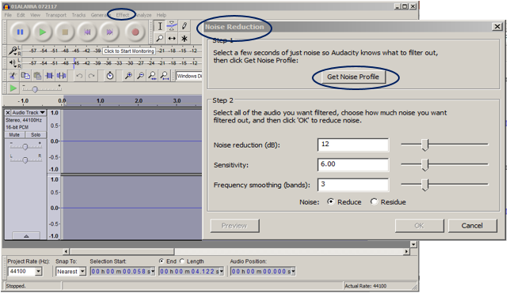
Editing a Track
- Filter out ambient noise.
- Highlight two seconds of ambient noise audio.
- Select the Effect tab > Noise Reduction and click Get Noise Profile. This lets Audacity know what room noise to filter out.
- Highlight the entire track.
- Select the Effect tab > Noise Reduction again and click OK.
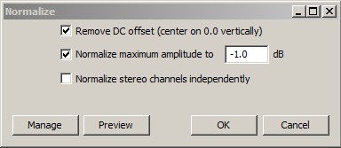
- Normalize the audio in each track by highlighting the entire track, selecting the Effect tab > Normalize, setting the db setting to -1.0, and clicking OK.

- Clean up the audio.
- Silence breaths or background noises by zooming in to identify the exact area, highlighting the segment, and CTRL+L.
- Adjust gaps in narration to taste by inserting (copy and paste a silent segment) or removing silence (highlight a segment and cut).
- If the decibels or peaks are different between tracks, the amplification can be adjusted in each track to create consistent peaks before joining tracks into a master track. Highlight the track or segments, select the Effect tab > Amplify, move the slider to the left, and click OK. Use Undo to re-adjust as necessary.

Creating a Master Track
- Construct a master track to combine several tracks into one track. For example, combine a large narration of a single individual broken down into several tracks, or combine tracks of several individuals to create a conversation.
- Insert a blank track into the bottom of the project, and label it Master or Final.
- Copy and paste the best snippet from each track into the Master track.

- Clean up the Master track audio.
- Remove silence, breaths, or background noises by zooming the track to identify the exact area, highlighting the segment, and CTRL+L.
- Adjust gaps in narration by inserting (copy and paste a silent segment) or removing silence (highlight a segment and cut).
- Join the clips (overlaps or breaks) with silence in the Master track into one string of audio by highlighting the entire track, and CTRL+J.

- Polish the audio. These steps more completely even out the volume of all the tracks copied into the Final track. If you have cuts you want to remain softer or louder, exclude them from this process.
- Compress the Final track by highlighting it and selecting the Effect tab > Compressor (accept default settings).
- Normalize the Final track again by highlighting the entire track, selecting the Effect tab > Normalize, setting the db setting to -1.0, and clicking OK.

Save a project at any time by selecting the File tab > Save Project As, clicking OK, and naming your project. This is not exporting your Master track to an MP3. Saving a project allows you to reuse, add to, or complete the project.

Export the Master Track
Highlight the final or master track, and export as MP3 by selecting the File tab > Export selected audio, rename if necessary, and save.

