Ongoing Processes 3
Trainer Guide

Table of Contents
CWW/WWP Entry Activities 3
Email Guidelines 3
Placement Change and Employment Checklist 4
Carmen 4
Haylee Employment/Luka Job Readiness 6
Luka Employment Checklist 7
Next Steps 9
Email Text 9

CWW/WWP Entry Activities

Email Guidelines

Subject Lines - Choose one
- (Section Name: Placement Change and Employment, Employment) – (Case name) – 1st REVIEW (or 2nd, etc.)
  - Use this when edits are needed. Instruct the learner not to submit the EP yet.
- (Section Name: Placement Change and Employment, Employment) – (Case name) – Submit EP
  - Use this when all updates have been completed successfully. Instruct the learner to submit the EP and reply when they have submitted the EP.
- (Section Name: Placement Change and Employment, Employment) – (Case name) – COMPLETE
  - Use this when the EP has been submitted successfully.

Feedback - For each case, choose one of the following
- (Section Name) entries complete. You correctly entered all pages as instructed, entered comments, recorded an informal assessment, developed/updated the EP, and tracked assigned activities.
- Use the format above to list the Page Title and error.
  - Examples:
Test Scores App – Carmen has TABE scores that need to be recorded.
PIN Comments – be sure to include your rationale behind your placement change decision.

Additional comments as needed if additional errors are made. Also add something that the worker did well.

Placement Change and Employment Checklist

Carmen

WWP
- Work History page updated with PT employment at the school and notes that she is still looking for other opportunities
  - Position: Lunch Room Aide Company: Elementary School
  - 15 hrs/week
  - $12.00/hr
  - Duties: Set up and take down lunch room, monitor students
  - Expected schedule Tue through Thur, 8:45-2:15 entered
  - No benefits, found via independent job search

- HSED tests scores for Language and Math entered, took on Monday
  - Language 155, passed
  - Mathematics 145, passed

- Job Readiness page indicates she now has a resume and cover letter

- Check Transaction History to ensure new informal assessment completed

- Create new Employability Plan:
  - Goals
    - Obtain HSED – Complete goal step of Pass Language and Math tests
  - Employments: Working part-time should be included
  - Activities:
    - Meeting with the Job Developer for 3 hours/week, MF 8-9:30
    - Independent Employment Search for 10 hours/week
    - Retention Services 1 hour/week, Friday afternoons
    - Attending HSED prep classes for 5 hours/week, MF 10-12:30
    - Individual study time for HSED prep classes for 3 hours/week, TU/W/TH for 1 hour/day.
    - Taking online GCF Global courses for 2 hrs/wk, Mondays 1-3
    - Meeting with the Education Navigator 1 hour/week, Friday afternoons
    - Make sure no activities interfere with part-time work schedule (Tue – Thur, 8:45am – 2:15pm)
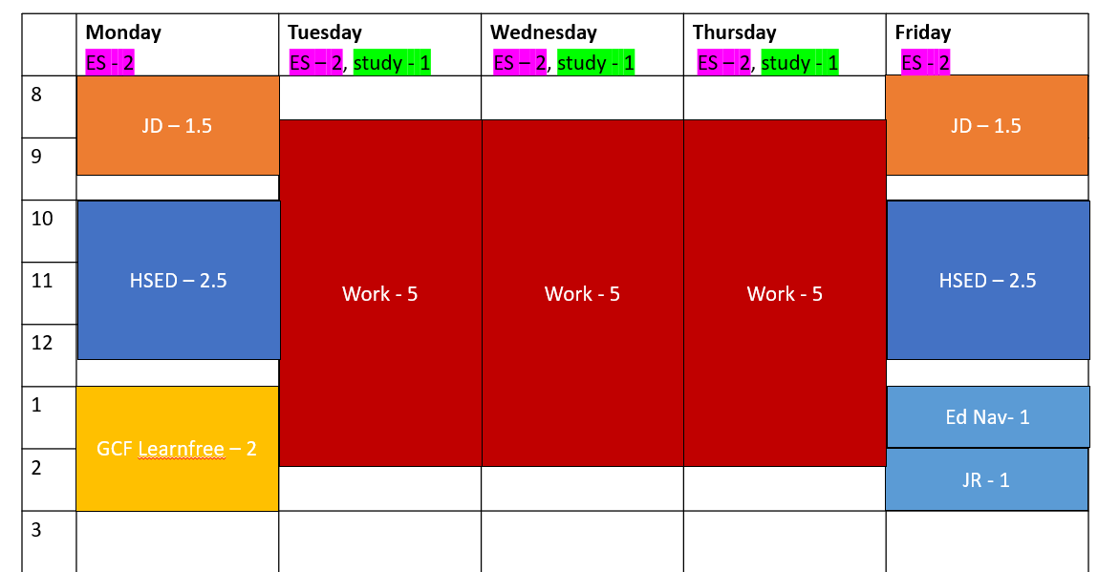
  - Supportive Services added

- PIN Comments entered (can be separate comments or one comment)
  - Employment entered, placement change, HSED tests completed, activity changes and progress, job retention, etc.
  - Comment Types: informal assessment, placement decision, employment, employability plan/activity assignment
    - Example Comment:
Carmen got a part-time job at Clay Lamberton Elementary School as a Lunch Room Aide doing lunch room set up/take down and serving. She'll be working 15 hours a week (Tuesday through Thursday 8:45-2:15) and earning $12 an hour. Carmen is excited about this job because the hours work well for Lucia's childcare. The position is not what she thought she'd be doing, but she knows there is room for potential advancement. I completed a new informal assessment with her. Carmen also passed her first set of HSED tests on Monday. She scored 155 in Language and 145 in Math. Additionally, she now has a resume/cover letter. She reports no other changes. I updated Carmen’s placement to CS2 as of today’s date. We will continue to help Carmen find more stable, year round employment as she works part-time and pursues her HSED.

CWW
- Enter employment in CWW and run eligibility
  - Check the Employment Summary to ensure the first month of the new employment is prorated with an override converted amount
  - Ensure comments are entered explaining override converted amount and showing math
  - A New Begin Month should be added showing ongoing calculation
    - The converted override amount and comments are removed.
  - Paid weekly at $12/hr, 15 hours per week, 1st check in 2 weeks – code AF
- Case Comments are entered explaining worker action and eligibility changes.
  - Example Comment:
Carmen reported that she starts a part-time job at Clay Lamberton Elementary School today. She'll be working 15 hours a week and earning $12 an hour. I verified her employment with an agency form and added the job to the Employment page. Her case remains open and passing. I updated her placement to CS2 as of today's date.
- Enter placement change from CSJ to CS2 on W-2 Placement page

**After all updates are complete, tell learners to submit the EP, and remind them to reply once they have submitted it. **

Haylee Employment/Luka Job Readiness

CWW
- Employment added
  - 10 hrs/wk at $13.50/hr at Parker’s school
  - Paid weekly with first check 2 weeks from today
  - Check Employment Summary to ensure the first month of the new employment is prorated with an override, then ongoing with the override removed
    - Ensure comments are entered on employment page explaining the override amount and math used.
- Enter Case Comments

WWP
Haylee
- New employment should be recorded on Work History page
  - Office assistant at Parker’s school, working 10 hrs/wk making $13.50/hr
    - Schedule 10-3, Tues and Thurs
  - Notes that she is excited about job and it is in with career goals
  - Supervisor listed as a contact (Ally Larson, 888-555-2354)
- EP (not submitted)
  - Possible updated goals/goal steps
  - PT employment should be checked
  - Other activities as necessary
    - If activities didn’t change, the Planned End Date should be extended to match the EP End Date
  - Supportive Services should be provided
  - Make sure no activities interfere with Haylee’s work schedule
  - The Need to Care for Disabled Child form activity should be complete
- PIN Comments should include information about new job and new EP
  - Comment types: Informal assessment, Employment, Employability Plan/Activity Assignment

WWP
Luka
- Job Readiness
  - History Questions
    - Liked his job at A+ Automotive until he had fight with his friend
    - Was starting to rebuild an engine
    - Offers loyalty, punctuality, and a good work ethic
    - Knows he needs to work on his attitude
  - Application Questions
    - Has submitted online applications, unsure if he is doing something wrong
    - Never needed to have resume or cover letter before
    - Has professional references he can use
    - Documents are current
  - Interview Questions
    - Last interview with A+
    - Uses Twitter occasionally, but doesn’t tweet anything concerning
    - Has nice jeans and a polo shirt, but only has tennis shoes
  - Action Needed: referral for clothing resources
- PIN Comments should include information remaining job readiness assessment questions
  - Comment types: Informal assessment, Employment, Employability Plan/Activity Assignment

**After all updates are complete, tell learners to submit the EP, and remind them to reply once they have submitted it. **

Luka Employment Checklist

CWW
- Employment added
  - 40 hrs/wk at $15/hr
  - Paid bi-weekly with first check 3 weeks from today
  - Check Employment Summary to ensure the first month of the new employment is prorated with an override, then ongoing with the override removed
    - Ensure comments are entered on employment page explaining the override amount and math used.
- Change placement to CMF+ on W-2 Placement page
- Enter Case Comments

WWP
- New employment should be recorded on Work History page, CA question updated
  - Automotive Lube Technician at Express Lube and Oil Change, working 40 hrs/wk making $15/hr, no benefits
  - Doing basic oil changes
  - Supervisor listed as a contact (Jason Young, jasony@expresslube.com)
- Career Locker Assessment
  - Skills include diagnostic, technical, problem-solving, and practical skills
  - Enjoys working in environments where he can use analytical skills, work with his hands, and be in a team environment
  - Career matches include machinist and automotive technician. This fits his desire to work with his hands on machines.
- Test Scores entered for TABE
  - Math score 610
  - Reading score 516
- W-2 Supportive Service Plan
  - All pages visited and plan submitted
  - Money Management Needs
    - Resource: UW – Extension Family Living Educator with address and phone number
    - Short Term Plan of Action: Work with FEP to determine prospective income and create budget. Bring list of expenses with you to appointment.
    - Long Term Plan of Action: Register/complete Managing Your Money workshop series. Maintain/update budget on monthly basis.
  - Education and Training Needs
    - Resource: WIOA with address and phone number; MATC Career Coach with address and phone number
    - Short Term Plan of Action: Look into mechanic certifications. Research financial aid options and talk with employer to see if they have continuing education assistance. Take the Accuplacer and speak with admissions counselor.
    - Long Term Plan of Action: Enroll in MATC’s mechanic program and obtain diploma.
- EP (not submitted)
  - Possible updated goals/goal steps
  - FT employment should be checked
  - Job Retention should be his only activity
  - Supportive Services should be provided
  - Career Assessment and TABE activities should be ended with code A and all other activities ended with code N
- Check Transactions to ensure a new informal assessment was completed for Luka
- PIN Comments should include new job, new placement, career assessment information, W-2 Supportive Service Plan, and EP update
  - Comment Types – Employment, Placement Decision, Job Readiness/Career Assessment, Employability Plan/Activity Assignment, W-2 Plans
    - Example Supportive Service Plan Comment:
Luka and I created his W-2 Supportive Service Plan during today’s appointment. He does not have any emergency, employment support, housing, access to economic support, childcare, transportation, legal assistance, heath care, or other needs. Luka is concerned about how he is going to budget his new income for an entire family. I informed him about the Managing Your Money workshop series at the UW-Extension office and provided him with the contact information for the Family Living Educator. He liked the idea of the workshop and intends to sign up. We discussed budgeting and how maintaining an accurate monthly budget will help with a family this size. At our next appointment, I will help him create a budget. He will work on maintaining and updating the budget on a monthly basis. Luka also mentioned he still wants to pursue a mechanic certification. I provided him with the contact information for the WIOA program. I also provided him with the contact information for a career coach at the local tech school. We discussed the steps he will need to take to get into school, including taking the Accuplacer, looking into certification options, reaching financial aid, and talking to an admissions counselor. I also recommended that he check with his employer to see if they offer any continuing education assistance.

**After all updates are complete, tell learners to submit the EP, and remind them to reply once they have submitted it. **

Next Steps
- Request the next curriculum.
  - Request: Ongoing Processes: Reviews
- Send the Email Text below.

Email Text

Before Reviews
Subject Line: Next Steps: Ongoing Processes: Reviews
So far, you’ve covered a lot of ongoing case changes. All those processes provide you with the knowledge and skills you need to conduct a case eligibility review. Next in Ongoing Processes, you’ll learn the steps to complete a W-2 eligibility review and you’ll conduct an eligibility review for both of your cases.

