Ongoing Processes 2
Trainer Guide

Table of Contents
CWW/WWP Entry Activities 3
Email Guidelines 3
Participation Tracking Checklist 4
Carmen 4
Person Add Checklist 6
Haylee 6
Luka’s Informal Assessment and Two-Parent Placement Change 7
Haylee 7
Luka 7
Haylee 8
Luka’s Employability Plan 8
Next Steps 9
Email Text 9

CWW/WWP Entry Activities

Email Guidelines

Subject Lines - Choose one
- (Section Name: Participation Tracking/Person Add/Luka’s Informal Assessment/Two-Parent Placement Change) – (Case name) – 1st REVIEW (or 2nd, etc.)
  - Use this when edits are needed. Instruct the learner not to submit the EP yet.
  - Person Add and Two Parent Placement Change sections do not have an EP to submit.
- (Section Name: Participation Tracking/Luka’s Informal Assessment/Two-Parent Placement Change) – (Case name) – Submit EP
  - Use this when all updates have been completed successfully. Instruct the learner to submit the EP and reply when they have submitted the EP.
- (Section Name: Participation Tracking/Person Add/Luka’s Informal Assessment/Two-Parent Placement Change) – (Case name) – COMPLETE
  - Use this when the EP has been submitted successfully.
  - Person Add does not have an EP to submit.

Feedback - For each case, choose one of the following
- (Section Name) entries complete. You correctly entered all pages as instructed.
- Use the format above to list the Page Title and error.
  - Examples:
Test Scores App – Carmen has TABE scores that need to be recorded.
PIN Comments – be sure to include your rationale behind your placement change decision.

Additional comments as needed if additional errors are made. Also add something that the worker did well.

Participation Tracking Checklist

Carmen

WWP
Note: The activities may not match up exactly with what the new worker actually entered. You may have to guide the new worker to enter participation on any of their assigned activities. Only one entry of non-participation is needed for each of these and the day it occurs doesn’t matter.

- W-2 Participation Calendar
  - Independent Job Search (ES 4 or 2hrs) and Work Experience (WE 3hrs)
    - Hours Participated: 0.0
    - Participant’s Reason: AA – Participant or Family Illness
    - Good Cause Granted?: Yes
    - Worker’s Reason: AA – Participant or Family Illness
    - Good Cause Hours: all hours good caused
  - Job Club (MO 3hrs)
    - Hours Participated: 0.0
    - Did not want to attend, good cause denied
    - Note: If job club has not yet started, learners will not be able to complete the MO entry.
  - All other activities for the week show full participation.

Note: Learners will “clean up” the EP during these entries because they will most likely move through NWT faster than the second week’s activities from Ongoing Processes 1 are supposed to start. In real life, enough time would have elapsed, and the first week’s activities would have ended as planned. This should not create a situation where Carmen is over 40 hours in one week during the change, but if they have done everything correctly, let them move forward.

- EP (in progress)
  - EP Begin Date of today, End Date one month from today
  - Goal steps marked complete
    - Primary Employment: Increase typing speed to 70 WPM
    - Other Program: Register for HSED Classes
  - End Job Club activity (MO) as K-Failed to participate with today’s date
  - Add (MO) Complete the Business Communication Courses through GCF Global that Focus on Communication Basics and Business Writing
    - Off-site, Home
    - Additional Information: Create an account at https://edu.gcfglobal.org/en/. move onto the Microsoft Office courses when finished with business communication
    - Starts tomorrow, recurs weekly on TU from 8-11, ends one month from today
  - End the following activities as A-Successfully completed with yesterday’s date
    - Register for HSED Courses (HE) (may be elapsed)
    - Complete Online Typing Lessons (MO)
    - Attend Job Readiness Essentials Workshop (MO)
  - Update planned end date of remaining activities to be one month from today
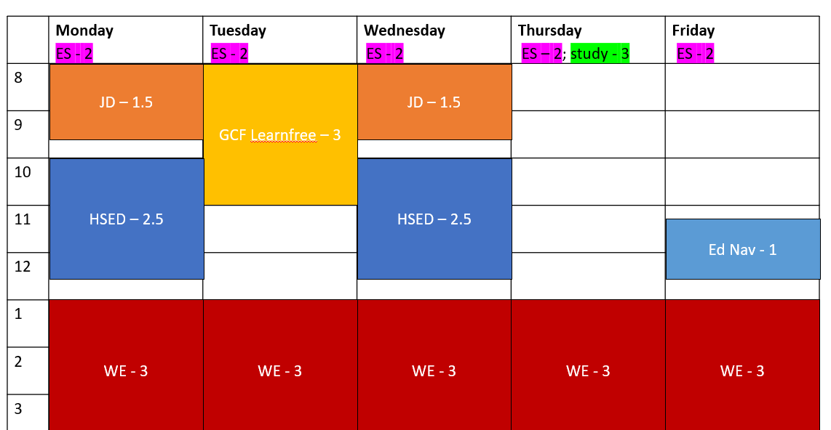
    - Learners were also instructed to update the Start Dates of the Education Navigator, HSED Classes, and HSED Study Time activities to today’s date if they had not started yet.

  - Appropriate Supportive Services
- PIN Comments documenting contact regarding participation
  - Missed job search and work experience due to being sick
  - Job Club facilitator job log
  - Comment Types: Good Cause Determination and Participation Tracking
    - Example Comment:
Carmen turned in activity logs for 12/28/23-1/3/24. She did not complete 3 hours of Job Club (MO) on 1/2. I called her to ask about this and she said she didn’t feel like going. This is not a good cause reason and I denied good cause. She did not complete 2 hours of job search (ES) and 3 hours of work experience (WE) on 1/3 because she was sick. This meets good cause policy and I provided good cause for these 5 hours. Carmen completed all other hours as assigned.
    - Be sure dates and hours in the comment match entries and not the example comment.
- Separate PIN Comment regarding EP update.

**After all updates are complete, tell learners to submit the EP, and remind them to reply once they have submitted it. **

Person Add Checklist

Haylee

CWW
- Luka (35) should be added to the household
  - HH Relationships show him as Sophia’s legal father
- Non-Financial information
  - Permanent Demographics: Provides SSN, BC, born in WI
  - Current Demographics: DL for ID
  - Absent Parent: page should be updated to indicate Legal Parentage is established for Sophia, and to no longer refer to IV-D because he is in the home
- Financial Information
  - Vehicle: 2012 Chevy Traverse valued at $8000, still owes $2000
- Case Comments include Luka entered the household

WWP
Haylee
- Participation Tracking
  - Check Participation Calendar/Non-Participation Good Cause Details for past three days of missed activities and full participation for any days prior to that
  - Good cause should not be provided because the reason Haylee gave of wanting to spend time with her family now that Luka moved back in does not meet good cause requirements
- Informal Assessment
  - Details or Notes field on the Family Barriers page updated to include completion of the Need to Care form.
- Participation Statuses
  - CD status assigned
- Job Readiness
  - Interview outfit question updated to show that Haylee now has an interview outfit
  - Clothing referral Action Needed item complete
- PIN Comments
  - Include participation comments as well non-participation
    - Good Cause Determination comment type to explain non-participation (Luka moved in and she wanted to spend time together as a family)
    - Per policy, if good cause is not granted, PIN Comments must reference the number of hours, dates, and activities missed.
  - Returned the Need to Care for a Disabled Family Member form. No confidential information entered.
  - New participation status

Luka’s Informal Assessment and Two-Parent Placement Change

Haylee

CWW
- W-2 Placement page updated to show Luka as placed parent (CSJ)
- W-2 Two-Parent Participation page completed
- Case Comments about placement change

Luka

WWP – Informal Assessment
- He speaks English at home, and fluently speaks Russian, but does not read or write Russian.
- Lost his job as a mechanic at A+ Automotive where he had worked full time for the last two years (ended 2 weeks ago and made $16.50 an hour).
- No previous Career Assessment.
- Past experience with FSET for 4 months 3 years ago.
- High School Diploma from Green Bay West High School seventeen years ago.
- He has not participated in any post-secondary education, is interested in getting auto certification.
- No military experience.
- He lived at his previous apartment for two years, moved when he could no longer afford rent without job. Rent was $625/month.
- Luka uses his personal vehicle for transportation. His driver’s license and auto insurance are current.
- Luka reports no legal issues, or personal barriers to employment.
- Sophia is his only child.
- Job Readiness information recorded
  - Work Preference Questions
    - He would like to stay in the automotive industry.
    - He enjoys mechanics and working with his hands. He has experience in the field, but no formal training. Is interested in obtaining certification.
    - He knows about three companies that he could apply to right now.
    - He doesn’t want to work for friends anymore as he feels that just causes problems.
    - He would like to work day hours and close to home. He would be willing to travel about 20 minutes or 15 miles for work.
  - Contact Questions
    - Phone and email are both set up
    - Provided email address
- PIN Comments summarize Luka’s assessment information (informal and job readiness)
- PIN Comments – Placement Decision explaining why he is the placed parent

Haylee

WWP
- PIN Comments
  - Explain why she is not the placed parent
  - Comment Type – Placement Decision

Luka’s Employability Plan

WWP
- Employability Plan (in progress)
  - Included at least one of each goal type (examples below), each goal should have at least one goal step:
    - Primary Employment (mechanic)
    - Secondary Employment (a career working with his hands, something in the auto industry, oil change technician)
    - Other Program (certificate in automotive repair)
    - Long-term Career (self-employed mechanic, own his own auto repair shop)
    - Personal (one-on-one time with Sophia)
  - Activities include (assigned 40 hrs/week):
    - Employment Search
    - Job Development
    - Career Assessment
    - TABE/Educational Needs Assessment
    - Other activities as appropriate
  - Included specific locations, times, etc. for activities that are not self-directed
  - Included supportive services
- PIN Comments summarizing Employability Plan and making connections between assessments, goals, and activities

**After all updates are complete, tell learners to submit the EP, and remind them to reply once they have submitted it. **

Next Steps
- Request the next curriculum.
  - Request: Ongoing Processes: Part 3
- Send the Email Text below.

Email Text

Before Ongoing Processes: Part 3
Subject Line: Next Steps: Ongoing Processes: Part 3
You’re moving your way through Ongoing Processes! In this next section, you’ll learn how to document changes due to employment. You’ll have hands-on experience with the Employment Page in CWW. You’ll also create a supportive service plan for a participant moving into a case management placement.

