Ongoing Processes 1
Trainer Guide

Table of Contents
CWW/WWP Entry Activities 3
Email Guidelines 3
Copy and paste to e-mail: 3
Subject Lines - Choose one 3
Feedback - For each case, choose one of the following 3
Ongoing Processes 1 Checklist 4
Carmen 4
Haylee 9
Additional Feedback that may be used for specific issues: 11
Employability Plan 11
Next Steps 13
Email Text 13

CWW/WWP Entry Activities

Email Guidelines

Copy and paste to e-mail:
Throughout this curriculum, you are making multiple changes to your cases, and we are checking to be sure that you entered all the changes and updated informal assessment information, placements, and activity assignments as needed.

Subject Lines - Choose one
- Changes at Next Appointment – (Case name) – 1st REVIEW (or 2nd, etc.)
  - Use this when edits are needed. Instruct the learner not to submit the EP yet.
- Changes at Next Appointment – (Case name) – Submit EP
  - Use this when all updates have been completed successfully. Instruct the learner to submit the EP and reply when they have submitted the EP.
- Changes at Next Appointment – (Case name) – COMPLETE
  - Use this when the EP has been submitted successfully.

Feedback - For each case, choose one of the following
- Changes at Next Appointment complete. You correctly entered all information as instructed, entered comments, recorded an informal assessment, and developed/updated the EP. You may now submit the EP. Reply to this email once you have submitted the EP.
- Use the format below to list the Page Title and error.
  - Examples:
Test Scores App – Carmen has TABE scores that need to be recorded.
PIN Comments – Be sure to include your rationale behind your placement change decision.

Additional comments as needed if additional errors are made. Also add something that the worker did well.

Ongoing Processes 1 Checklist

Carmen

Changes at Next Appointment

WWP
- Reading and Math TABE scores entered in the Test Scores App
  - 580 in Math
  - 568 in Reading

- Career Assessment complete
  - Elements
    - Work Styles
    - Skills
    - Interests
  - Completed four days ago
  - Provider: Local agency
  - Tool: Career Locker
  - Results
    - Works well with others and in team settings
    - Can manage her time and prioritize work projects
    - Communicates effectively and enjoys explaining processes
    - Values having responsibility or leadership roles, autonomy, and work environments where she feels she positively impacts others
  - Related Occupations
    - Explored jobs similar to those she has had in the past: cashier, customer support specialist, and sales associate
    - Explored other related occupations based on her interests: clerical jobs, receptionist, concierge, and data entry clerk
  - How are results applied to EP
    - Goals, plus education and Work Experience activities added to EP matches career assessment information

- Job Readiness
  - History Questions
    - Last job was at Kwik Trip. Liked working with the customers but had to quit after her hours were switched from first to second shift
    - Proud of getting Associate of the month two times in one year
    - Greatest strength being a loyal employee and always showing up for her shift
    - Could work on her assertiveness skills
  - Application Questions
    - Comfortable with submitting online applications and had done that in the past
    - Does not have a current resume, not comfortable with cover letter
    - Knows she has two references she can use
    - Identification and important documents are in order
  - Interview Questions
    - Last interview for her job at Kwik Trip
    - Not sure how to discuss why she left her last job
    - Not concerned about social media
    - Two potential interview outfits
  - All fields on this page should be complete.

- Action Needed App: All Action Needed items completed, except for transportation funding, which is ongoing

- Informal Assessment
  - Indicate a completed career assessment on the Work History page

- Employability Plans
  - Should not be submitted (In progress)
    - If the learner submitted the EP and updates are needed, attach the Correcting a Submitted EP for W-2 New Worker Training guide to the review email. Instruct learners to use that guide to help them create a new EP to make their updates.
  - Dates: Subsequent EP created with a 30-day timeframe
  - Goals
    - Primary Employment Goal (Complete goal step Career Locker career assessment)
    - Other Program Goal – Obtain HSED (Complete goal step Take TABE and review results with FEP)
  - Elapsed Activity
    - TABE was entered on initial EP to occur once and may be elapsed. Learners are instructed to end Elapsed Activity as A-SUCCESSFULLY COMPLETED.
  - Activities
    - Meet with Job Developer (ES, on-site, W-2 Agency, Contact Donna Developer with email and phone number, Recurring weekly M/W, 1.5hrs/day 8-9:30)
      - End date updated to match EP end date
    - Attend Job Club (MO, on-site, W-2 Agency, Contact Donna Developer with email and phone number, Additional Info – bring resume and dress professionally, Recurring weekly TU, 3hrs/day 8-11)
      - End date updated to match EP end date
    - Independent Job Search (ES, self-directed, From today through one-month, Recurring daily every weekday, 2hrs/day)
    - Register for HSED Courses (HE, off-site, Local Technical College, Not recurring, Friday 1hr/day 11:30-12:30)
    - Complete Work Experience (WE, off-site, Our Neighbors, Contact Shonda Supervisor with email and phone number, From today through one-month, Recurring daily every weekday, 3hrs/day 1-4)
    - Meet with Education Navigator (CE, on-site, W-2 Agency, Contact Edna Navigator with email and phone number, From next Friday through one-month, Recurring weekly F, 1hr/day 11:30-12:30)
    - Complete online typing lessons (MO, off-site, Public Library, Additional Info – create account on typing.com, Recurring weekly M/W, 2.5hrs/day 9:30-12)
      - End date updated to six days after today
    - Attend job readiness essentials workshops (MO, on-site, W-2 Agency, Recurring weekly TH, 3hrs/day 9-12)
      - End date updated to six days after today
    - Attend HSED Prep Classes (HE, off-site, Tech College, Starts one week from today and ends one month from today, Recurring weekly M/W, 2.5hrs/day 10-12:30)
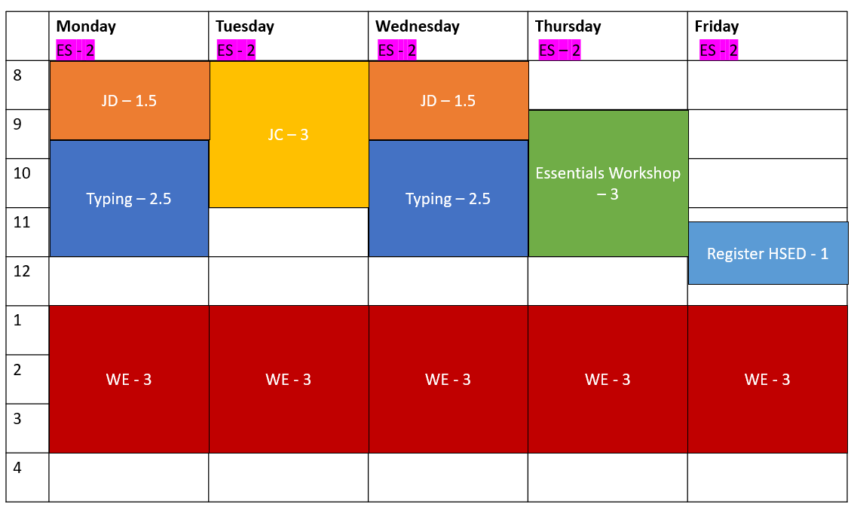
    - Individual Study Time for HSED Prep Classes (HE, off-site, Home/Library/Tech College, Starts one week from today and ends one month from today, Recurring weekly TH, 3hrs/day)

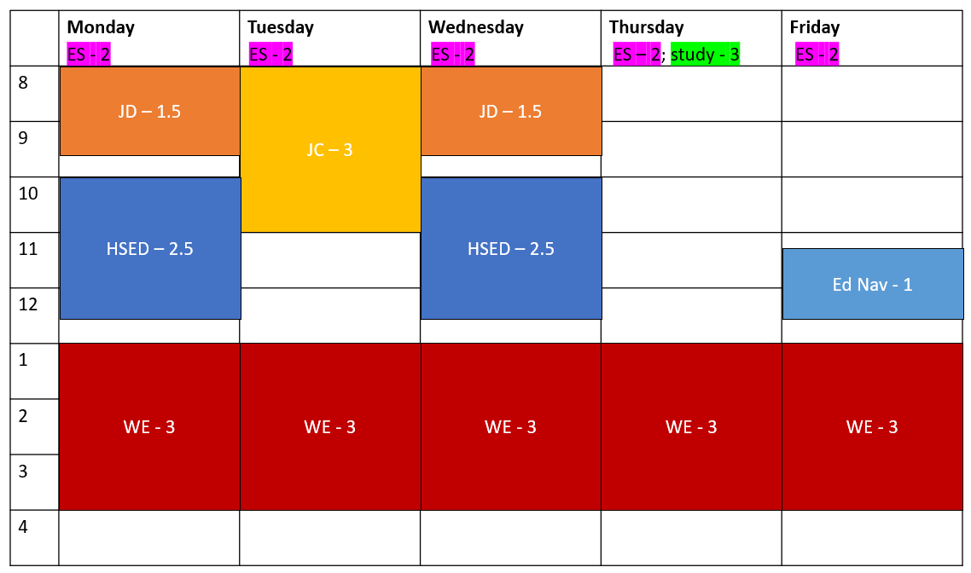
  - Supportive Services
    - Transportation Funding – Gas vouchers provided
  - Historical Activities
    - Completed Career Locker career assessments. Reason code A.
    - Completed TABE (if not elapsed). Reason code A.
    - Completed Research options for back up childcare. Reason code A.
- Completed Work experience orientation. Reason code A. Activity may have been deleted if it hasn’t occurred yet.

- PIN Comments to reflect the changes made
  - Ensure comments include how Career Assessment and Education Needs Assessment correlate to goals and activities.
  - Comment Type: Informal Assessment, Job Readiness/Career Assessment
    - Example Educational Needs Assessment Comment:
Carmen completed the TABE and we reviewed her scores during today’s appointment. She scored a 580 in Math and a 568 in Reading. Carmen expected to have a lower reading score, but doesn’t feel it will impact her ability to get her HSED within six months.
  - Comment Type: Employability Plan/Activity Assignment
    - Example Subsequent EP Comment:
We updated Carmen's EP at today's appointment. Prior to today's appointment, Carmen completed the TABE, her career assessments, and work experience orientation; set up child care; and made an appointment with Section 8 housing. I marked the WI Shares and housing Action Needed items as complete. I marked the TABE-related goal steps complete for her Other Program Goal, and the career assessment goal step complete for her Primary Employment Goal. I ended the TABE, career assessment, work experience orientation, and child care activities. Carmen applied for several clerical positions and called the employers to follow up on her applications, but has not gotten an interview yet. She will continue to work with the Job Developer 3 hours a week, with an added focus of creating a resume and cover letter. She still wants to attend Job Club 3 hours a week, as she hopes that it will increase her chances of getting interviews. Additionally, she will continue to look for and apply to positions, but we reduced this to 10 hours a week at Carmen’s request. Carmen thinks that she will reach her typing goal within the next week. She also says she isn't getting much out of Job Readiness Essentials. She wants to attend the next sessions, which focus on assertiveness, and then she wants the activity to end. I updated both planned end dates accordingly. The results of Carmen's TABE show she is ready to register for HSED classes. She is assigned 1 hour of registering for classes this week. Starting next week, she will attend HSED classes 5 hours a week, study for classes 3 hours a week, and meet with the Education Navigator to discuss her progress toward her HSED 1 hour a week. Carmen's career assessments aligned with her Primary Employment Goal of a receptionist position. She does not have experience in this field, so I assigned her 15 hours a week of work experience at Our Neighbors to gain clerical experience. I provided Carmen gas vouchers so she can complete her assigned activities.

**After all updates are complete, tell learners to submit the EP, and remind them to reply once they have submitted it. **

Haylee

Changes at Next Appointment

CWW
- Placement changes to W-2 T
- Case Comments reflect the placement change

WWP
- Update assessment information in the Participant Barriers App.
  - It should include accommodations for fatigue/weakness and stress management
  - Mental health report completed by Jane Jones
    - Manifests through sleep disturbance, decreased energy, and social withdrawal
    - will last 6 months to a year
    - no limit on hours as long as there are accommodations
    - recommend reassessment in 6 months
- FA – Formal Assessment Pending Participation Status ended
  - Should have auto ended when learners ended the AM activity on the EP. If FA status is open, check that the AM activity is closed.
  - Non-confidential details entered
  - No other statuses yet
- Career Locker Career Assessment entered
  - Meets all required elements
    - Work Styles
    - Skills
    - Interests
  - Interested in working with data and numbers
  - Potential career matches include bank teller, personal banker, and accounts receivable and payable clerk
    - Fits with her past education experience in Accounting. She would like to finish that degree.
  - Based on her work experience and skills, some related occupations included machinist, assembly production, and material handler.
  - Results are connected to the EP
- Informal Assessment
  - Career assessment question on Work History page updated
  - Need to Care form Action Needed item complete
  - Answered No to DV questions on Participant Barriers Page
  - Check Transactions to see a new informal assessment was completed

- Job Readiness
  - History Questions
    - Enjoyed her last job, left due to caring for her son
    - Good with organizing project details
    - Knows attendance is really important. She wants to be reliable but is unsure how that can work right now.
  - Application Questions
    - Not have a lot of experience with online applications
    - Does not have a resume or cover letter and does not know where to begin with developing one
    - Has personal references, does not have professional references
    - All her documents are in order
  - Interview Questions
    - Does not remember her last interview, but she got the job
    - Uses Facebook frequently. Does not think there is anything on there that would be a concern
    - Has one nicer outfit that she could use for an interview, unsure if it would fit.
  - Action Needed item of clothing referral
- EP in progress
  - Goals
    - If TABE or Career Assessment were listed as Goal Steps, they must be marked as complete.
  - Activities
    - AM activity ended
    - AC activity added
    - Use discretion in what is entered
      - All activities should align with goals
  - Supportive services being provided
- PIN Comments entered without disclosing confidential medical information including comments about career assessments, Participation Status, placement change, and EP update.
  - Comment Types: informal assessment, placement decision, employability plan/activities

**After all updates are complete, tell learners to submit the EP, and remind them to reply once they have submitted it. **

Additional Feedback that may be used for specific issues:

Employability Plan
Goals – It is best practice to develop SMART goals (Specific, Measurable, Attainable, Relevant, and Time-Based) to help gain participant buy-in, help participants stay on track, and help participants become more likely to achieve their goals.

- Goal Name – Title of the goal
- Goal Description - This summary includes background information regarding why it is important to the participant, and an overall timeline for this goal. You also can use this field to incorporate some of the SMART goal criteria.
- Goal Steps - Goal Steps are smaller, individual steps or tasks participants need to complete to reach their goal. They do not need to mirror activities, but rather map out the journey they need to take to get to their goal. It is best practice to add at least one Goal Step for every goal.
- Types:
  - Primary Employment Goal – Participant’s chosen field of interest; is attainable within the program.
    - Examples:
      - Office Assistant - Sue has attention to detail and likes assisting others. She wants full-time, first shift work. Her career assessment results show her workstyles and interests are a good match for this type of work.
      - Mechanic – Bob likes working on vehicles. He has experience fixing cars and likes working with his hands
  - Secondary Employment Goal - Participant’s back-up field of interest; is attainable within the program.
    - Examples:
      - Cashier/Customer Service - Sue is willing to take a job as a cashier or in the customer service field. She likes to work with people and has good customer service skills.
      - Factory Worker - Bob wouldn’t mind working in a factory if he can move around and doesn’t have to stay in the same place all the time.
  - Long-Term Career Goal - Aligns with participants’ career assessment results and career pathway; likely achieved beyond their program participation.
    - Examples:
      - Sue would like to become an accountant in the future. She knows she will need to complete several other steps before this can happen, including going back to school to complete her degree.
      - Bob would like to own an auto repair shop someday. He thinks he would be a good and fair boss. He needs to learn more about being a small business owner and save money for business start-up.
  - Other Program Goal - Goals related to education, skills or training, and overcoming barriers for participants to move in the direction of their employment goals; achievable while enrolled in the program.
    - Examples:
      - Obtain Driver’s License – Sue has never had a DL and wants one because the bus takes too long. She would like to pass temporary licensing test by the end of next month.
      - Complete an automotive certificate course – Bob would like to complete the Automotive Quick Service Technician certificate offered by the local tech college, as he knows this important for his future.
  - Personal Goal - Not required for program participation; helps strengthen the family and empower the participant.
    - Examples:
      - Sue knows she has a lot of stress in her life and needs to find ways to deal with it. She will try various coping strategies, such as drawing, journaling, yoga, and exercise to reduce her stress levels.
      - Bob would like to improve his health. He will exercise 30 minutes every day.

Employments – Any current employment listed on the Work History page or app displays here. If a participant is working, check the box to include it on the participant’s EP. Keep the employment in mind while developing activities with participants to ensure they are not exceeding 40 hours a week.

- Neither Carmen nor Haylee should have any employments entered at this time.

Elapsed Activities - This page shows any assigned activities on the active EP with a planned end date that is equal or prior to the begin date of the EP you are developing. You still must enter the actual end date for these activities.

- Carmen and Haylee will have elapsed activities listed. If this happens, instruct learners to end the activities by selecting a completion reason from the drop-down menu.
  - Carmen’s TABE activity was entered for one day
  - Haylee’s Formal Assessment activity was entered for one day

Activities - If a participant has current activities, they display here. These are the activities the participant is working on to achieve their goals.

Ongoing EP - Even though the system allows us to enter an EP that lasts 6 months, we really should never go more than what is reasonable/manageable/appropriate for the customer and for you to be able to effectively monitor and provide support. This way you always have a close enough understanding of what is going to move the customer to new and appropriate activities to continue to help them progress to their employment goals. This is especially true for a brand-new participant in the program. We want to closely follow his/her activities and progress to determine if the current activities are appropriate and that we offer activities that keep up with current circumstances.

Independent Job Search - This may include looking for suitable job opportunities, contacting potential employers, applying for jobs, completing job interviews and completing follow-up contact with employers. The participant must keep track of self-directed job search using an individual activity log developed by the agency. The case manager must have a minimum of weekly contact (phone or face-to-face) with the participant to discuss various job leads and progress made on employment contacts and sign the individual activity log. Provide detailed instructions to the participant on completion of the individual activity log to ensure actual participation time is documented. (See Operations Memo 07-55)

Next Steps
- Request the next curriculum.
  - Request: Ongoing Processes: Part Two
- Send the Email Text below.

Email Text

Before Ongoing Processes: Part Two
Subject Line: Next Steps: Ongoing Processes: Part Two
In the next step of Ongoing Processes, you’ll complete a CBT on participation tracking. Use what you learn from that CBT to process participation tracking for Carmen and Hayley and update their EPs as needed. You’ll also learn about two parent groups by adding a second parent to a case.

