Employability Plans
Trainer Guide

Table of Contents
System Entry Activities 3
Employability Plans 3
Email Guidelines for Responding to Trainees 3
Case Checklist 5
Next Steps 11
Requesting the Next Curriculum 11
Email Text 11
FEP 11

System Entry Activities

Employability Plans
The following information is for those in the following curriculums:
- FEP

Email Guidelines for Responding to Trainees

Copy and paste to e-mail:
In this section, we are reviewing your Employability Plan entries to ensure you have correctly entered an Employability Plan, summarized the Employability Plan in PIN comments, and justified your decisions accurately.

Subject Lines - Choose one:
- EP (case name) – 1st REVIEW (or 2nd, etc.)
  - Use this when edits are needed. Instruct the learner not to submit the EP.
- EP (case name) – Submit EP
  - Use this when all updates have been completed successfully. Instruct the learner to submit the EP and reply when they have submitted the EP.
- EP (case name) – COMPLETE
  - Use this when the EP has been submitted successfully.

Feedback - for each case, choose one of the following:
- Employability Plans complete. You correctly entered all pages as instructed, entered comments, and developed the EP.
- Use the format below to list the Page Title and error.
  - Examples:
Goals – Carmen has multiple Goal Steps for her Other Program Goal.
Activities – Carmen should have nine activities listed.

Additional comments as needed if additional errors are made. Also add something that the worker did well.

Additional Feedback that may be used for WP related specific issues:
Goals:
Participant’s Employment, Other Program, and Long Term Career Goals
This section of the EP identifies both employment goals that can be achieved during program participation and those that the participant would like to achieve beyond W-2.

Program Employment Goals
The primary goal should be employment that is achievable during program participation and currently available within the local labor market. The secondary goal can be more specific, related to the participant’s unique skills, education and interest. Remember that if the participant is unclear about employment goals, you may need to assist them with completing a career interest inventory or an assessment of transferable skills.

Other Program and Long Term Career Goals
If the participant’s ultimate career goal is beyond the scope of the program, it can be recorded on the EP as a long-term goal. This goal represents the final objective toward which a participant is working. The other program goal still should be related to finding employment. It also could be related to education, skills or training, and overcoming barriers for participants to move in the direction of their employment goals (take a GED test by MM/DD/YY, complete a CNA training program, raise reading level to xx.xx, etc.).

Participant’s Personal Goals
The participant’s personal goals are additional goals that are not required for W-2 program participation. These goals outline long-range and short-term activities participants can do to help achieve employment goals, and/or help resolve personal and family issues. Examples of personal goals may include: addressing parenting issues, obtaining financial counseling, involvement in support groups, moving to a safer neighborhood.

Goal Steps
These are smaller, individual steps or tasks participants need to complete to reach their goal. They should map out the journey participants need to take to get to their goal. It is best practice to add at least one Goal Step for every big goal that needs to be broken up into smaller, more management steps.

Case Checklist

Carmen

WWP
Employability Plan
Should be in progress
- If the learner submitted the EP and updates are needed, attach the Correcting a Submitted EP for W-2 New Worker Training guide to the review email. Instruct learners to use that guide to help them create a new EP to make their updates.

Dates
- EP should be written for two weeks.

Goals
- Primary Employment goal – Receptionist
  - Description: Carmen likes working with people and considers herself a good communicator. She wants full-time work with a consistent 9-5 schedule, and believes working as a receptionist would be a good fit.
  - Steps:
    - Complete Career Locker Career Assessment by next appointment.
    - Increase typing speed to 70 wpm.
    - Identify 10 employers that are hiring receptionists within the next month.
    - Complete GCF Global course on Microsoft Office 2019 within the next two months.
- Secondary Employment goal – Customer Service Representative
  - Description: Carmen liked the customer service side of her previous jobs and considers herself an extrovert. She has good communication skills, which would be an asset as a customer service representative. She would like to work full-time and work consistent 9-5 hours.
  - Steps:
    - Identify 10 employers that are hiring customer service representatives within the next month.
- Other Program goal – Obtain HSED
  - Description: Carmen does not have her diploma and believes obtaining an HSED will help her obtain full-time employment with consistent hours. She would like to get her HSED within six months.
  - Steps:
    - Take the Test for Adult Basic Education (TABE) and review results with FEP at next appointment.
    - Register for HSED classes at the local tech school within one month.
    - Pass language and mathematics tests within two months.
    - Pass social studies, science, civics, and health tests within six months.
- Long Term Career goal – Become an Office Manager
  - Description: Carmen believes working full-time as an office manager would provide her with stable employment and consistent hours. She believes her attention to detail, positive attitude, and loyalty would make her a good fit for this type of position. She would like to move up into an office manager position within the next two years.
  - Steps:
    - Obtain HSED.
    - Research office manager job duties and discuss with FEP within one month.
    - Identify 5 local employers with office manager positions within two months.
    - Complete 2 informational interviews with local office managers within three months.
    - Complete office management certification at local tech school within one year.
  - Personal goal – Spend more time with Lucia.
    - Description: Read to Lucia for at least 20 minutes, three nights a week.

Activities
- Ensure full activity descriptions and locations are listed
- Nine activities were identified:
  - CE, Career Locker (On-site)
    - Recurring weekly on Fridays, 2.0 hrs/day (1-3pm)
  - CE, TABE (On-site)
    - Edna Navigator listed as contact
    - Occur only once on Friday, 2.0 hrs/day (10:00am-12:00pm)
  - ES, Meet with JD (On-site)
    - Donna Developer listed as contact
    - Recurring weekly on M/W, 1.5 hrs/day (8-9:30am)
  - MO, Job Club (On-site)
    - Donna Developer listed as contact
    - Additional Information entered
    - Recurring weekly on Tuesdays, 3.0 hrs/day (8am-11am)
  - ES, Independent Job Search (Self-directed)
    - Recurring daily, 4.0 hrs/day
  - MO, Typing (Off-site: Public Library)
    - Additional Information entered
    - Recurring weekly on M/W, 2.5 hrs/day (9:30am-12pm)
  - LF, Back Up Childcare (Off-site: Varies)
    - Recurring weekly on TU/TH, 1.0 hrs/day (1pm-2pm)
  - MO, Essentials Workshop (On-site)
    - Recurring weekly on Thursdays, 3.0 hrs/day (9am-12pm)
  - WE, Work Experience Orientation (On-site)
    - Donna Developer listed as contact
    - Occur only once next week Friday, 2.0 hrs/day (10am-12pm)
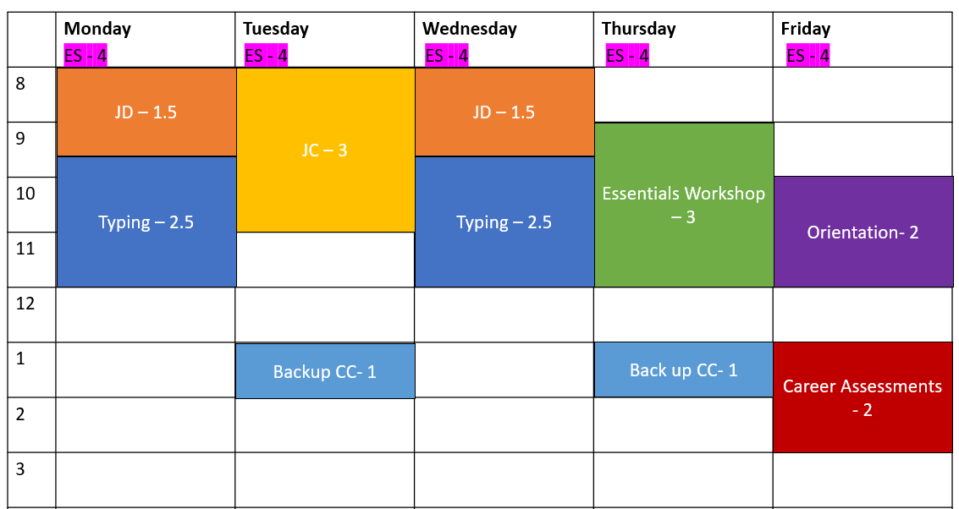
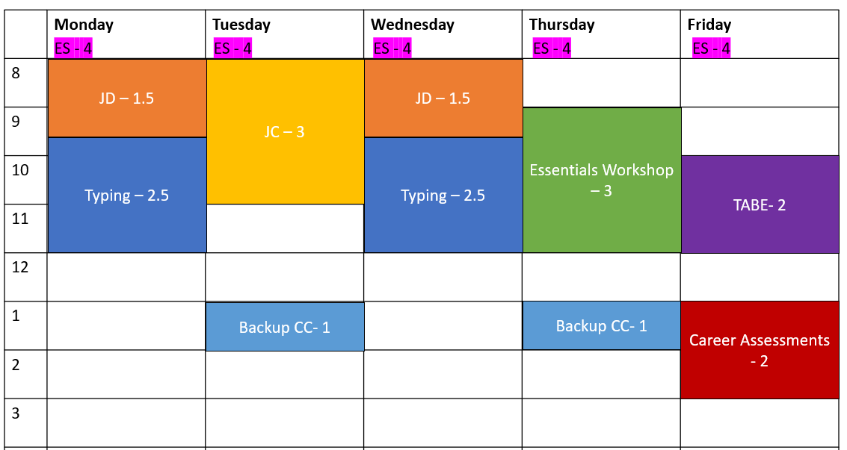

Supportive Services
- Transportation Funding (Gas vouchers provided to complete assigned activities.)
- Onsite Child Care

PIN Comments
- Comments should summarize goals, activities, and supportive services
- Explain why the specific activities were decided on, and how they will help Carmen reach her goals
- No “alphabet soup”; acronyms should be spelled out
- Comments should tell and explain the why
- Case worker rationale behind decisions should be explained
- Comment Type: Employability Plan/Activity Assignment
  - Example Comment:
Carmen and I developed her first EP at today's appointment. Carmen has a Primary Employment Goal of receptionist and a Secondary Employment Goal of customer service representative. Her Other Program Goal is to obtain her HSED, and her Long Term Career Goal is to become an office manager. She has a Personal Goal of spending more time with Lucia by reading to her at least 3 times a week. We discussed the benefits of completing a career assessment to help wither career planning. Carmen agreed to this and is assigned 2 hours a week of completing Career Locker career assessments. She is assigned 2 hours of taking the TABE on Friday. This is Carmen's first step toward her Other Program Goal, and it will help determine if 6 months to complete her HSED is realistic. Next Friday, Carmen is assigned 2 hours of Work Experience Orientation. Carmen is interested in Work Experience to get experience in an office setting, as she has none. She will work with the Job Developer 3 hours a week to get help navigating the local labor market and following up with employers. She also will attend Job Club 3 hours a week to practice her interview skills and get job search assistance. Both of these activities will increase her chances of finding employment. Carmen identified she needs to increase her typing speed to get a job as a receptionist. She is assigned 5 hours a week of practicing typing. Additionally, she mentioned she needs to work on time management, communication, and conflict resolution. She is assigned 3 hours a week of Job Readiness Essentials workshops to work on this. Carmen has informal childcare set up for Lucia, but needs to have a back-up plan. She is assigned 1 hour a week to do this. Lastly, she is assigned 20 hours a week of job search to look for and apply to positions in her preferred fields of interest. All of these activities move her in the direction of her goal of finding first shift employment in the customer service field. I provided gas vouchers to Carmen so she can complete her activities. She also is authorized to use the on-site childcare facility for the activities she completes at the W-2 agency when Lucia is not in school.

**After all EP entries are correct and complete, instruct learners to submit Carmen’s EP and reply after it has been submitted. **

Haylee

WWP
Employability Plan
Dates
- Not specified in Entry Guide. Based on Haylee’s situation (CMC placement, counseling, etc.), EP should be written for a shorter period as placement will be ending and information will be returned from medical provider. Trainer/learner discretion.

Goals
- Goals entered (at least one for each Goal Type)
  - Primary Employment
    - Example: Manufacturing
  - Secondary Employment
    - Example: Accounts payable/receivable clerk
  - Other Program
    - Refer back to policy on what constitutes a good Other Program Goal
    - Example: Obtain Associates Degree in Accounting
  - Long Term Career
    - Refer back to policy on what constitutes a good Long Term Career
    - Example: Accountant
  - Personal
- All goals should have an appropriate Goal Description and at least one Goal Step

Activities
- Activities entered, including:
  - LF or PA, Baby and Me (offsite at YMCA)
    - Occurs weekly
  - CE, Career assessment (onsite)
    - Could occur at multiple week sessions
  - CM, Counseling sessions (offsite)
    - occurs weekly
  - AM, Complete Mental Health Report Form (offsite)
    - Occurs today only
    - Should not contain confidential information
  - Other as appropriate

Supportive Services
- Appropriate supportive services entered.
  - Example: Transportation Funding

Participation Status
- FA Status with a Begin Date of today.
- Current box should be checked.
- Appropriate Details entered.
  - Should not contain confidential information.

PIN Comments
- Comment Type(s)
  - Employability Plan/Activity Assignment

- PIN Comments should include rationale behind EP activities.
  - No “alphabet soup”; acronyms should be spelled out
  - Case worker rationale behind decisions should be explained
  - Confidential medical diagnoses should not be mentioned

**After all EP entries are correct and complete, instruct learners to submit Haylee’s EP and reply after it has been submitted. **

Next Steps

Requesting the Next Curriculum
- Request the Ongoing Processes curriculum.
- Contact e-mail to prep for next curriculum
  - See “E-mail Text” below
  - Include:
    - Status
    - What to expect in the next series of course
    - A reminder to follow the Guide step by step
    - A reminder to submit case numbers after eligibility is determined

Email Text

FEP

After Employability Plans and before Ongoing Processes
Subject Line: Next Steps: Ongoing Processes
You have finished Employability Plans. Next, you work with your cases on an ongoing basis.

This is a more advanced New Worker Training course that requires attention to detail and intense concentration on W-2 processes. You are provided the information; it is up to you to use that information to update your cases.

You should work through each component thoroughly before moving forward. Pay close attention to all instructions and activities. This course is all about processes, so each piece is a step-by-step process within itself. Remember what you learned in Case Management within the W-2 Program. It's a constant process of looking at what's going on with the case, reviewing the changes, making decisions about next steps, recording everything, and then following up on all of it. It's a process of putting all the pieces together, both on the case and in your mind.

As you complete your entries, submit your PINs to the Partner Training Team for review. If you have any questions or have any problems, contact PTT at PTTTrainingSupp@wisconsin.gov.

