08 Building on Assessment
Trainer Guide

Table of Contents
Entry Activities 3
Feedback Introduction 3
Trainer Guide Note 3
Ana – Building on Assessment 4
WWP 4
Brittany – Building on Assessment 12
CWW 12
WWP 13
Chantelle 19
WWP 19
Additional Feedback that may be used for specific issues: 24
Employability Plan 24
08 Building on Assessment Completed: Next Steps 26
Requesting the Next Curriculum 26
Email Text - FEP 26

Entry Activities

The following information is for those in the following curriculums:
- FEP

Feedback Introduction
Copy and paste the following into the email of the first check of Ana’s entries:
Throughout this curriculum, you are making multiple changes to your cases based on additional assessment information. We are checking to be sure that you entered all the changes and updated informal assessment information, placements, and employability plans as needed.

Trainer Guide Note
Throughout this guide, you’ll see “learner discretion” several times. When you see this, it means you can accept any response the learner enters that makes sense with the scenario.
- At times, we provide general guidance within the scenario. When that occurs, we provide the information in this guide as well. Use it to help you determine what makes sense.
- Keep in mind, when we say, “learner discretion,” it means there isn’t one correct answer.
  - For example, we give the guidance that Brittany has an interview outfit, but isn’t sure if it fits. The learner could select Yes, as Brittany does have an outfit, or No, as the outfit doesn’t do her any good if it doesn’t fit. You must accept either option.
- If you see “learner discretion” for a Details or Notes field, it’s up to the learner to decide if they want to enter something in that field. Although you can recommend they add something, don’t require it unless the system requires an entry in that field.

Ana – Building on Assessment

WWP

Work History
- Career Assessment: Yes; Details: Completed Career Locker. Details on Career Assessment page

Child and Youth Supports
- First Name: Elena; Care Arrangement: Licensed/Certified

Test Scores App
- Test Type: TABE 9 & 10; Date Taken: five days ago
- Reading
  - Scale Score: 568/999
- Mathematics
  - Scale Score: 580/999

Career Assessments
- Element(s): Work Styles, Skills, Interests
- Completion Date: four days ago
- Assessment Provider: learner’s agency
- Assessment Tool Used: Career Locker
- Assessment Results:
  - Works well with others and in team settings
  - Can manage time and prioritize work projects
  - Communicates effectively with co-workers and customers
  - Enjoys explaining processes to others
  - Values:
    - Having responsibility and leadership roles
    - Making decisions on her own
    - Work environments that have a positive impact on others
- Related Occupations: Receptionist, Concierge, Data Entry Clerk
  - Learner also might include Cashier, Customer Support Specialist, Sales Associate
- How Results Applied to EP and Activities: Goals directly related to gaining employment in her desired career field, education and work experience in an office setting are steps in achieving goals

Job Readiness
- History Questions
  - About Last Job: Worked at Kwik Trip, she liked working with customers, but had to quit when her hours changed from first to second shift
  - About Time Felt Proud: Getting associate of the month two times in one year
  - Greatest Strengths: Being a loyal employee and always showing up for her shift
  - Areas Would Like to Improve On: Assertiveness skills
- Application Questions
  - Comfortable Submitting An Online Job Application: Yes
  - Have a Current Resume/Cover Letter: No
  - Have Three Personal or Professional References: No; Details: Has two, but needs to think of a third
  - Have Documents Needed for Employment: Yes
- Interview Questions
  - About Last Interview: Was nervous, but it went well because she got the job
  - Anything You Don’t Want a Potential Employer to See on Social Media: No
  - Outfit to Wear for a Job Interview: Yes
- No Action Needed

Employability Plan Overview
- EP Begin Date: today’s date
- EP End Date: one month from today
- EP without activities: No
- Notes: N/A
  - If the learner has something entered in the Notes field, it must be information specifically for the parent. If it isn’t, make them change it.

Goals
- Primary Employment Goal - Receptionist
  - Completed Goal Step:
    - Complete career assessment by next appointment
- Other Program Goal – Obtain HSED
  - Completed Goal Step:
    - Take the Test for Adult Basic Education (TABE) and review results with FEP at next appointment

Employments
- Ana isn’t working.

Elapsed Activities
- Activity: Career Planning & Counseling; Activity Description: Complete the Test of Adult Basic Education (TABE); Completion Reason: A – Successfully Completed
  - This activity might not be elapsed due to the date the learner is creating the EP.

Historical Activities
- Activity: CE – Career Planning & Counseling; Activity Description: Complete Career Locker Career Assessments
  - End Activity: checkbox selected
  - Completion Reason: A – Successfully Completed; Actual End Date: Yesterday’s date
    - If the activity displays on the Historical Activities page and the learner selected an incorrect Completion Reason, they cannot update it.
- Activity: CE – Career Planning & Counseling; Activity Description: Complete the Test of Adult Basic Education (TABE)
  - If this activity isn’t elapsed, the learner must end it.
    - End Activity: checkbox selected
    - Completion Reason: A – Successfully Completed; Actual End Date: Yesterday’s date
      - If the activity displays on the Historical Activities page and the learner selected an incorrect Completion Reason, they cannot update it.
  - If this activity hasn’t started yet, the learner must delete it.
- Activity: WE – Work Experience; Activity Description: Attend work experience orientation to prepare for an office-related worksite
  - End Activity: checkbox selected
  - Completion Reason: A – Successfully Completed; Actual End Date: Yesterday’s date
    - If the activity displays on the Historical Activities page and the learner selected an incorrect Completion Reason, they cannot update it.
  - If this activity hasn’t started yet, the learner must delete it.
- Activity: LF – Life Skills; Activity Description: Research options for back up child care via the Youngstar website, visit local providers, and make phone calls
  - End Activity: checkbox selected
  - Completion Reason: A – Successfully Completed; Actual End Date: Yesterday’s date
    - If the activity displays on the Historical Activities page and the learner selected an incorrect Completion Reason, they cannot update it.
- Activity: MO – Job Readiness/Motivation; Activity Description: Attend Job Club to obtain job search assistance, practice interview skills, and learn about the labor market
  - End Activity: checkbox selected
  - Completion Reason: A – Successfully Completed; Actual End Date: Yesterday’s date or today’s date
    - If the activity displays on the Historical Activities page and the learner selected an incorrect Completion Reason, they cannot update it.

Activities
- Activity: MO – Job Readiness/Motivation; Activity Description: Complete the business communication courses through GCF Global that focus on communication basics and business writing
  - Activity Location: Off-Site
  - Business Name: Home
  - Additional Information: Create an account at https://edu.gcfglobal.org/en/. Move onto the Microsoft Office courses when finished with business communication.
  - Start Date: tomorrow’s date; Recurring: Yes
  - Frequency: Weekly; Days: Tuesday
  - Planned End Date: matches EP end date
  - Hours Per Day: 3.0
  - Begin Time: 8:00 am; End Time 11:00 am
- Activity: MO – Job Readiness/Motivation; Activity Description: Complete online typing lessons to work on increasing overall typing speed
  - Planned End Date: six calendar days from today
- Activity: MO – Job Readiness/Motivation; Activity Description: Attend Job Readiness Essentials Workshops focused on communication, time management, and conflict resolution skills
  - Planned End Date: six calendar days from today
- Activity: HE – HSE (High School Equivalency Diploma); Activity Description: Register for HSED Courses
  - Activity Location: Off-Site
  - Business Name: any technical college; Location: technical college city/state; Street Address/Zip: technical college address; Phone Number: technical college’s phone number
  - Start Date: Friday’s date; Recurring: No
  - Hours Per Day: 1.0
  - Begin Time: 11:30 am; End Time 12:30 pm
- Activity: CE – Career Planning and Counseling; Activity Description: Meet with Education Navigator to discuss progress toward HSED and to get assistance in preparing for your HSED tests
  - Activity Location: On-Site
  - Business Name: learner’s agency; Location: learner’s city/state; Street Address/Zip: learner’s agency address; Phone Number: learner’s phone number
  - Activity Contact:
    - Contact Title: Other – Education Navigator
    - Name: Edna Navigator; Email: ednan@w2agency.com; Phone: 920-555-0055
  - Start Date: next Friday’s date; Recurring: Yes
  - Frequency: Weekly; Days: Friday
  - Planned End Date: matches EP end date
  - Hours Per Day: 1.0
  - Begin Time: 11:30 am; End Time 12:30 pm
- Activity: HE – HSE (High School Equivalency Diploma); Activity Description: Attend HSED prep classes
  - Activity Location: Off-Site
  - Business Name: any technical college; Location: technical college city/state; Street Address/Zip: technical college address; Phone Number: technical college’s phone number
  - Start Date: one week from today; Recurring: Yes
  - Frequency: Weekly; Days: Monday, Wednesday
  - Planned End Date: matches EP end date
  - Hours Per Day: 2.5
  - Begin Time: 10:00 am; End Time 12:30 pm
- Activity: HE – HSE (High School Equivalency Diploma); Activity Description: Individual study time for HSED prep classes
  - Activity Location: Off-Site
  - Business Name: Home, Library, Technical College
  - Start Date: one week from today; Recurring: Yes
  - Frequency: Weekly; Days: Thursday
  - Planned End Date: matches EP end date
  - Hours Per Day: 3.0
- Activity: WE – Work Experience; Activity Description: Complete work experience at Our Neighbors. Work duties focus on basic office skills
  - Activity Location: Off-Site
  - Business Name: Our Neighbors; Location: learner’s city/state; Street Address/Zip: learner discretion; Phone Number: learner discretion
  - Activity Contact:
    - Contact Title: Work Site Provider
    - Name: Shonda Supervisor; Email: shondas@ourneighbors.com; Phone: 920-555-1111
    - Learner must check the ROI signed box and enter today’s date
  - Start Date: today’s date; Recurring: Yes
  - Frequency: Daily – Every Weekday
  - Planned End Date: matches EP end date
  - Hours Per Day: 3.0
  - Begin Time: 1:00 pm; End Time 4:00 pm
- Activity: ES – Employment Search; Activity Description: Meet with Job Developer to get assistance navigating the local labor market and following up with potential employers
  - Planned End Date: matches EP end date
- Activity: ES – Employment Search; Activity Description: Complete independent job search. Focus search on positions in an office setting within a 10 mile radius
  - Planned End Date: matches EP end date
  - Hours Per Day: 2.0

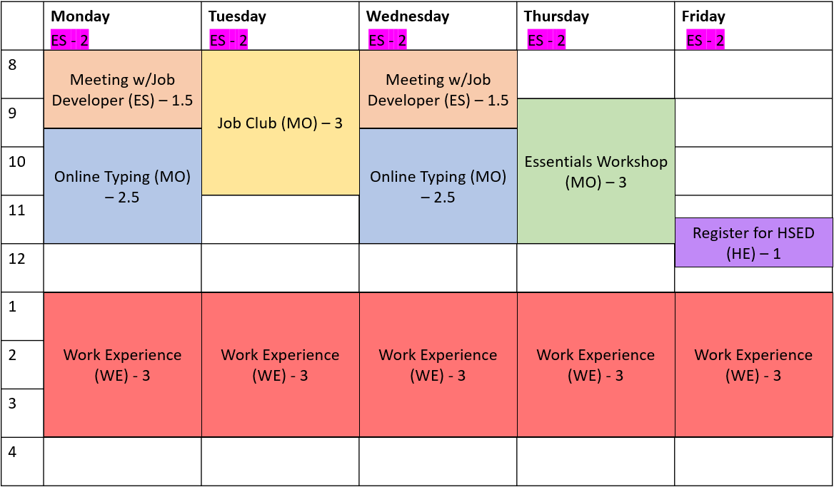

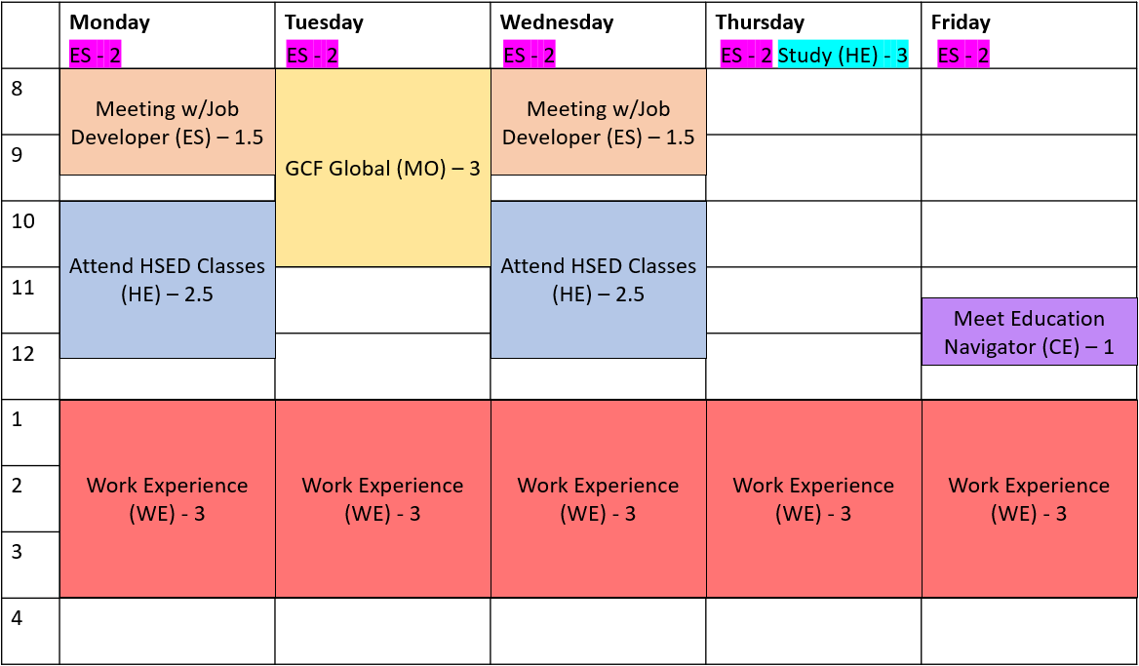

Employability Plan
- Learner did not submit the EP.

Supportive Services
- Expense Type: Transportation
  - Expense Details: learner discretion
    - It must be for gas, as she drives her own car.
  - Amount: learner discretion
  - Issuance Date: today’s date
- Learners can update this information only the same day they enter it.

PIN Comments
- Learners may have all the information in one comment. Although you can encourage them to separate the information and explain the benefits, don’t make them separate it. As long as they have all the required information and Comment Types, it’s acceptable.
- Learners can edit comments only the same day they enter them.
- TABE Scores
  - Participant Contact: SC
  - Comment Type: Informal Assessment
  - Must include:
    - Ana’s scores.
    - Based on results, obtaining HSED within six months is realistic.
- Career Assessment
  - Participant Contact: SC
  - Comment Type: Job Readiness/Career Assessment
  - Must include:
    - Summary of Ana’s results.
    - Results align with her goals.
- Job Readiness
  - Participant Contact: SC
  - Comment Type: Job Readiness/Career Assessment
  - Must include:
    - Summary of Ana’s responses to all questions.
- Employability Plan
  - Participant Contact: SC
  - Comment Type: Employability Plan/Activity Assignment, Supportive Services
  - Must include:
    - Ana completed TABE, career assessment, work experience orientation, and setting up child care activities.
    - Marked TABE and career assessment goal steps as complete.
    - Continuing to work with Job Developer three hours a week to create resume/cover letter.
    - No longer wants to do Job Club, so ended that activity.
    - Added GCF Global classes focusing on business communication for three hours a week.
    - Lowered job search to ten hours per week.
    - Will reach typing goal next week, so activity ends next week.
    - Not getting much out of Job Readiness Essentials workshop, but wants to attend one more session. Activity ends next week.
    - Based on TABE results, ready to register for HSED. Will do this Friday for one hour.
    - Starting next week, attending HSED classes five hours a week and studying three hours a week.
    - Meeting with Education Navigator one hour a week to discuss progress on HSED.
    - Due to results of career assessment, she’s assigned 15 hours of work experience to gain clerical experience.
    - Provided gas voucher to complete activities.

**After all EP entries are correct and complete, instruct learners to submit Ana’s EP and reply after it has been submitted.**

Brittany – Building on Assessment

CWW

W-2 Placement
- Individual: Brittany
- Placement: W2T – W-2 Transition Job
- Placement Begin Date: today’s date

Case Comments
- Learners can edit comments only the same day they enter them.
- Comment Type: General
- Must Include:
  - Placed in W-2 T placement
- Comment can’t include any individual-related information.
  - If it does, explain to the learner that these comments only include information that relates to the whole family, like eligibility-related information. Individual-related information belongs in WWP PIN Comments.

WWP

Transactions
- Learner completed a new Informal Assessment for Brittany.

Work History
- Career Assessment: Yes; Details: Completed Career Locker. Details on Career Assessment page, or something similar

Participant Barriers
- Responses to all DV questions: No

Participant Barrier
- Barrier Type: Mental Health; Barrier Subtype: Depressive Disorder
- Assessment Date: learner discretion
  - We don’t provide a specific date in the scenario.
- How Long Symptoms Likely Last: 6 months to 1 year
- Recommended Reassessment: six months from today
- Hours Can Participate: 40 per Week or 8 per Day; Details: Can participate in employment activities as long as she has accommodations for fatigue and stress, or something similar
- Contact:
  - Contact Title: Treatment/Assessment Provider
  - Name: Jane Jones; Email: jonesj@communitypartners.org ; Phone: 952-555-144
- Accommodation for Concentration Deficits from prior entry.
  - Details: Brittany carries a notebook with her while participating in activities. The notebook is filled with items she needs to complete, and it helps her to focus or refocus as needed.
- Accommodation for Sleep Disorder from prior entry.
  - Details: Brittany is allowed to flex her schedule as needed to accommodate her sleep issues.
- Accommodation for Fatigue/Weakness.
  - Details: learner discretion
    - This should be something other than flexing her schedule, as they already are providing that for her sleep disorder.
- Accommodation for Stress Management.
  - Details: learner discretion
    - This should be something other than flexing her schedule, as they already are providing that for her sleep disorder.
- We don’t tell learners to enter a Begin Date for the accommodations.

Career Assessments
- Element(s): Work Styles, Skills, Interests; Completion Date: learner discretion
- Assessment Provider: learner’s agency; Assessment Tool Used: Career Locker
- Assessment Results:
  - Interested working with data and numbers
  - Enjoys working independently and on one task at a time
- Related Occupations: bank teller, personal banker, accounts receivable/payable clerk, machinist, assembly production, material handler
- How Results Applied to EP: learner discretion
  - In the scenario, we say the results fit with her past education experience in accounting and that she wants to finish that degree.

Job Readiness
- History Questions
  - About Last Job; Enjoyed her last job and left to care for her son
  - About Time Felt Proud: Considered for a lead position
  - Greatest Strengths: Organizational skills
  - Areas Would Like to Improve On: Attendance
- Application Questions
  - Comfortable Submitting An Online Job Application: learner discretion
    - Brittany feels ok when it comes to submitting online forms, but doesn’t have a lot of experience with online applications
  - Have a Current Resume/Cover Letter: No
  - Have Three Personal or Professional References: Yes
    - She has personal references, but not professional ones
  - Have Documents Needed for Employment: Yes
- Interview Questions
  - About Last Interview: Doesn’t remember it, but she got the job
  - Anything You Don’t Want a Potential Employer to See on Social Media: learner discretion
    - Brittany doesn’t think there is anything on her Facebook that would be concerning, but doesn’t know for sure.
  - Outfit to Wear for a Job Interview: learner discretion
    - She has an outfit, but doesn’t know if it fits.
- No Action Needed
  - If the learner entered an Action Needed item, and it makes sense for the scenario, don’t make them remove it.

Test Scores App
- If the learner assigned Brittany to complete the TABE, they must enter results. They would have to make up their own results, as we do not provide any.

Employability Plan Overview
- EP Begin Date: today’s date
- EP End Date: no longer than 30 days
- EP without activities: No
- Notes: N/A
  - If the learner has something entered in the Notes field, it must be information specifically for the parent. If it isn’t, make them change it.

Goals
- Check all Goals and Goal Steps to see if Brittany completed any of them.

Employments
- Brittany isn’t working.

Elapsed Activities
- Activity: AM – Mental Health Assessment; Activity Description: Meet with your provider for your Mental Health Report form, or something similar
  - Completion Reason: A – Successfully Completed

Historical Activities
- Activity: CE – Career Planning & Counseling; Activity Description: Complete career assessments, or something similar
  - End Activity: checkbox selected
  - Completion Reason: A – Successfully Completed; Actual End Date: Yesterday’s date
    - If the activity displays on the Historical Activities page and the learner selected an incorrect Completion Reason, they cannot update it.
    - If learner doesn’t use yesterday’s date, instruct them to update it.
- If a learner assigned establishing child care for Ella (CC) and marks it as complete, they must update the Child and Youth Supports page to say Brittany found child care for Ella.
- If a learner assigned Brittany to take the TABE and marks it as complete, they must update the Test Scores app with the results.

Activities
- Activity: AC – Assessment for Child; Activity Description: Meet with Mason’s provider to get his Need to Care for Disabled Child form completed, or something similar
  - Activity Location: Off-Site
  - Business Name: learner discretion; Location: learner discretion; Street Address/Zip: learner discretion; Phone Number: learner discretion
  - Start Date: today’s date; Recurring: No
  - Hours Per Day: learner discretion
    - It shouldn’t be longer than 2 hours
- The rest of Brittany’s prior activities are still valid. Learners may or may not still have them on Brittany’s EP. These include:
  - Activity: LF – Life Skills or PA – Parenting Skills; Activity Description: Attend Baby and Me group, or something similar
  - Activity: CM – Mental Health Counseling; Activity Description: Attend weekly counseling appointments, or something similar
  - Establishing child care for Ella (CC)
  - Meeting with Mason’s doctors (FC, once a week)
- Brittany should be assigned at least one work program related activity, such as workshops, meeting with the Job Developer, job search, work experience, etc.
- Look to goal steps for anything that is supposed to happen within the next month as potential activities.
- Brittany should be assigned at least 10 hours a week and no greater than 40 hours a week.

Employability Plan
- Learner did not submit the EP.

Supportive Services
- Expense Type: Transportation
  - Expense Details: Bus pass provided to complete assigned activities, or something similar
  - Amount: learner discretion
  - Issuance Date: today’s date
- Expense Type: learner discretion
  - Supportive Services – General probably is the best fit, but we don’t specify which type to use in the scenario.
  - Expense Details: Goodwill voucher for interview clothing, or something similar
  - Amount: $25.00
  - Issuance Date: today’s date
- Learners can update this information only the same day they enter it.

PIN Comments
- Learners may have all the information in one comment. Although you can encourage them to separate the information and explain the benefits, don’t make them separate it. As long as they have all the required information and Comment Types, it’s acceptable.
- Learners can edit comments only the same day they enter them.
- If the learner assigned Brittany to complete the TABE, they must have a PIN Comment regarding the results.
- Career Assessment
  - Participant Contact: SC
  - Comment Type: Job Readiness/Career Assessment
  - Must include:
    - Summary of Brittany’s results.
    - Results align with her goal of finishing accounting education and becoming an accountant.
- Job Readiness
  - Participant Contact: SC
  - Comment Type: Job Readiness/Career Assessment
  - Must include:
    - Summary of Brittany’s responses to all questions.
    - The learner might include information about the Goodwill voucher. If they do, they must use the Supportive Services Comment Type as well.
- Formal Assessment
  - Participant Contact: SC
  - Comment Type: learner discretion
    - General or Informal Assessment probably fits best
  - Must include:
    - Brittany turned in her Formal Assessment.
    - She can participate in activities up to 40 hours a week as long as she has accommodations for fatigue and stress.
- Employability Plan
  - Participant Contact: SC
  - Comment Type: Employability Plan/Activity Assignment, Supportive Services
  - Must include:
    - All goals, goal steps, and activities Brittany completed, including getting her Mental Health Report and completing her career assessment.
    - All activities that she’s going to continue completing.
    - All new activities include getting the Need to Care form completed.
      - Learner should include how many hours Brittany is assigned each activity and why she is assigned those activities (i.e., how they will help her get to her goals).
    - If the learner didn’t assign Brittany 40 hours a week of activities, they must include why in their comment.
    - Provided bus pass to complete activities and Goodwill voucher to get interview clothes.
      - The learner might have included information about the Goodwill voucher in the Job Readiness comment instead.

**After all updates are complete, tell learners to submit the EP, and remind them to reply once they have submitted it.**

Chantelle

WWP

Work History
- Career Assessment: Yes; Details: Completed Career Locker, details on Career Assessment page, or something similar

Test Scores App
- Test Type: TABE 9 & 10; Date Taken: learner discretion
- Language
  - Scale Score: 548/999
- Reading
  - Scale Score: 522/999
- Mathematics
  - Scale Score: 570/999

Career Assessments
- Element(s): Work Styles, Skills, Interests; Completion Date: learner discretion
- Assessment Provider: learner’s agency; Assessment Tool Used: Career Locker
- Assessment Results:
  - Likes working with people in a positive and cooperative environment while also being able to work independently
  - Has organizational and problem-solving skills
- Related Occupations: Office/Administrative support work
- How Results Applied to EP: learner discretion
  - We don’t provide any guidance on how learners are applying the results in the scenario.

Job Readiness
- History Questions
  - About Last Job: Was responsible for answering questions from customers and doing general office work
  - About Time Felt Proud: Completing assignments on time and building friendly relationships with customers
  - Greatest Strengths: Completing assignments on time and building friendly relationships with customers
  - Areas Would Like to Improve On: learner discretion
    - We don’t provide this information in the scenario.
- Application Questions
  - Comfortable Submitting An Online Job Application: Yes
  - Have a Current Resume/Cover Letter: Yes
  - Have Three Personal or Professional References: Yes
    - Chantelle has a couple of friends she can use as personal references.
  - Have Documents Needed for Employment: learner discretion
    - We don’t provide this information in the scenario.
- Interview Questions
  - About Last Interview: Got the last two jobs she interviewed for
  - Anything You Don’t Want a Potential Employer to See on Social Media: No
    - Chantelle only makes appropriate posts.
  - Outfit to Wear for a Job Interview: learner discretion
    - We don’t say if she has interview clothes or not. We state Chantelle needs to update some of her work clothes, so they are appropriate for an office setting.
- No Action Needed
  - If the learner entered an Action Needed item, and it makes sense for the scenario, don’t make them remove it.

Employability Plan Overview
- EP Begin Date: today’s date
- EP End Date: learner discretion
- EP without activities: No
- Notes: N/A
  - If the learner has something entered in the Notes field, it must be information specifically for the parent. If it isn’t, make them change it.

Goals
- Check all Goals and Goal Steps to see if Chantelle completed any of them.
- Learners might have ended goals related to obtaining further education based on the information Chantelle provided during the career assessment conversation. If they did, encourage them to develop new goals for Chantelle.

Employments
- Chantelle isn’t working.

Elapsed Activities
- Activity: Career Planning & Counseling; Activity Description: Complete the Test of Adult Basic Education (TABE); Completion Reason: A – Successfully Completed

Historical Activities
- Activity: CE – Career Planning & Counseling; Activity Description: Complete Career Locker Career Assessments
  - End Activity: checkbox selected
  - Completion Reason: A – Successfully Completed; Actual End Date: Yesterday’s date
    - If the activity displays on the Historical Activities page and the learner selected an incorrect Completion Reason, they cannot update it.
- Activity: CE – Career Planning & Counseling; Activity Description: Complete the Test of Adult Basic Education (TABE)
  - If this activity isn’t elapsed, the learner must end it.
    - End Activity: checkbox selected
    - Completion Reason: A – Successfully Completed; Actual End Date: Yesterday’s date
      - If the activity displays on the Historical Activities page and the learner selected an incorrect Completion Reason, they cannot update it.

Activities
- Activity: PR – Physical Rehabilitation; Activity Description: Attend physical therapy appointments, or something similar
  - Double check that the Start Date isn’t in the future.
  - Planned End Date: matches EP end date
- Chantelle wants to focus on finding a job. She should be assigned several work-related activities.
- She reports she is good at interviews and has a resume/cover letter. She also doesn’t want to further her education right now. Chantelle shouldn’t be assigned activities related to these items.
- Based on Chantelle’s scenario, it is realistic for her to be assigned at least 20 hours a week and no greater than 40 hours a week.

Employability Plan
- Learner did not submit the EP.

Supportive Services
- Up to learner discretion (Chantelle takes the bus or walks)
  - The scenario doesn’t specifically say learners must provide Supportive Services. If they don’t, recommend they add one for Chantelle, but don’t require it.
- Learners can update this information only the same day they enter it.

PIN Comments
- Learners may have all the information in one comment. Although you can encourage them to separate the information and explain the benefits, don’t make them separate it. As long as they have all the required information and Comment Types, it’s acceptable.
- Learners can edit comments only the same day they enter them.
- TABE Scores
  - Participant Contact: SC
  - Comment Type: Informal Assessment
  - Must include:
    - Chantelle’s scores
    - Based on results, ready for tech school degree/program, but wants to look for a job rather than pursue a degree.
- Career Assessment
  - Participant Contact: SC
  - Comment Type: Job Readiness/Career Assessment
  - Must include:
    - Summary of Chantelle’s results.
    - Results align with her goals, but she doesn’t want to pursue education at this time.
- Job Readiness
  - Participant Contact: SC
  - Comment Type: Job Readiness/Career Assessment
  - Must include:
    - Summary of Chantelle’s responses to all questions.
- Employability Plan
  - Participant Contact: SC
  - Comment Type: Employability Plan/Activity Assignment, Supportive Services (if the learner provided Supportive Services)
  - Must include:
    - All goals, goal steps, and activities Chantelle completed, including completing the TABE and her career assessment.
    - All activities that she’s going to continue completing.
    - All new activities.
      - Learner should include how many hours Chantelle is assigned each activity and why she is assigned those activities (i.e., how they will help her get to her goals).
    - Supportive services, if provided.
    - If the learner did not assign Chantelle 40 hours a week of activities, they must include why in their comment.
    - Learners must include the information Chantelle provided about her cast being off/weight restriction either in PIN comments or on the Participant Barriers page. It doesn’t matter where they put it.
      - Learner can refer to her injury, but cannot state her broken wrist is healed.

**After all EP entries are correct and complete, instruct learners to submit Chantelle’s EP and reply after it has been submitted.**

Additional Feedback that may be used for specific issues:

Employability Plan
Goals – It is best practice to develop SMART goals (Specific, Measurable, Attainable, Relevant, and Time-Based) to help gain participant buy-in, help participants stay on track, and help participants become more likely to achieve their goals.

- Goal Name – Title of the goal
- Goal Description - This summary includes background information regarding why it is important to the participant, and an overall timeline for this goal. You also can use this field to incorporate some of the SMART goal criteria.
- Goal Steps - Goal Steps are smaller, individual steps or tasks parents need to complete to reach their goal. They do not need to mirror activities, but rather map out the journey they need to take to get to their goal. It is best practice to add at least one Goal Step for every goal.
- Types:
  - Primary Employment Goal – Parent’s chosen field of interest; is attainable within the program.
    - Examples:
      - Office Assistant - Sue has attention to detail and likes assisting others. She wants full-time, first shift work. Her career assessment results show her workstyles and interests are a good match for this type of work.
      - Mechanic – Bob likes working on vehicles. He has experience fixing cars and likes working with his hands
  - Secondary Employment Goal - Parent’s back-up field of interest; is attainable within the program.
    - Examples:
      - Cashier/Customer Service - Sue is willing to take a job as a cashier or in the customer service field. She likes to work with people and has good customer service skills.
      - Factory Worker - Bob wouldn’t mind working in a factory if he can move around and doesn’t have to stay in the same place all the time.
  - Long-Term Career Goal - Aligns with parent’s career assessment results and career pathway; likely achieved beyond their program participation.
    - Examples:
      - Sue would like to become an accountant in the future. She knows she will need to complete several other steps before this can happen, including going back to school to complete her degree.
      - Bob would like to own an auto repair shop someday. He thinks he would be a good and fair boss. He needs to learn more about being a small business owner and save money for business start-up.
  - Other Program Goal - Goals related to education, skills or training, and overcoming barriers for parents to move in the direction of their employment goals; achievable while enrolled in the program.
    - Examples:
      - Obtain Driver’s License – Sue has never had a DL and wants one because the bus takes too long. She would like to pass the temporary licensing test by the end of next month.
      - Complete an automotive certificate course – Bob would like to complete the Automotive Quick Service Technician certificate offered by the local tech college, as he knows this important for his future.
  - Personal Goal - Not required for program participation; helps strengthen the family and empower the parent.
    - Examples:
      - Sue knows she has a lot of stress in her life and needs to find ways to deal with it. She will try various coping strategies, such as drawing, journaling, yoga, and exercise to reduce her stress levels.
      - Bob would like to improve his health. He will exercise 30 minutes every day.

Employments – Any current employment listed on the Work History page or app displays here. If a parent is working, check the box to include it on the parent’s EP. Keep the employment in mind while developing activities with parents to ensure they are not exceeding 40 hours a week.

Elapsed Activities - This page shows any assigned activities on the active EP with a planned end date that is equal or prior to the begin date of the EP you are developing. You still must enter the actual end date for these activities.

Ongoing EP - Even though the system allows us to enter an EP that lasts 6 months, we really should never go more than what is reasonable/manageable/appropriate for the customer and for you to be able to effectively monitor and provide support. This way you always have a close enough understanding of what is going to move the customer to new and appropriate activities to continue to help them progress to their employment goals. This is especially true for a brand-new parent in the program. We want to closely follow his/her activities and progress to determine if the current activities are appropriate and that we offer activities that keep up with current circumstances.

08 Building on Assessment Completed: Next Steps

Requesting the Next Curriculum
Email the learner to prepare them for the next curriculum.

Email Text - FEP
CC: Reg Staff, ATL, PTTTrainingSupp@wisconsin.gov
Subject Line: Next Steps: 09 Two-Parent Households Curriculum

You’ve made changes to your cases based on ongoing assessment information.

Your next assigned curriculum is 09 Two-Parent Households.

In the next step, you’ll learn about ongoing processes in CWW and two-parent households. Then, you’ll follow steps in the Two-Parent Household Entry Guide to add a second parent to a case. As you complete your entries, submit your case numbers and PINs to the Partner Training Team for review. If you have any questions or have any problems, contact PTT at PTTTrainingSupp@wisconsin.gov.

