06 Initial
Employability Plan
Trainer Guide

Table of Contents
Entry Activities 3
Feedback Introduction 3
Trainer Guide Note 3
Ana – Initial EP 4
Brittany – Initial EP 10
Chantelle – Initial EP 15
Additional Feedback that may be used for specific issues: 20
Employability Plan 20
Quia Activities 22
Knowledge Check: 06 Initial EP 22
06 Initial Employability Plan Completed: Next Steps 23
Requesting the Next Curriculum 23
Email Text - FEP 23

Entry Activities

The following information is for those in the following curriculums:
- FEP

Feedback Introduction
Copy and paste the following into the email of the first check of Ana’s entries:
In this section, we are reviewing your Employability Plan entries to ensure you have correctly entered an Employability Plan, summarized the Employability Plan in PIN comments, and justified your decisions accurately.

Trainer Guide Note
Throughout this guide, you’ll see “learner discretion” several times. When you see this, it means you can accept any response the learner enters that makes sense with the scenario.
- At times, we provide general guidance within the scenario. When that occurs, we provide the information in this guide as well. Use it to help you determine what makes sense.
- Keep in mind, when we say, “learner discretion,” it means there isn’t one correct answer.
  - For example, we give the guidance that Brittany has an interview outfit, but isn’t sure if it fits. The learner could select Yes, as Brittany does have an outfit, or No, as the outfit doesn’t do her any good if it doesn’t fit. You must accept either option.
If you see “learner discretion” for a Details or Notes field, it’s up to the learner to decide if they want to enter something in that field. Although you can recommend they add something, don’t require it unless the system requires an entry in that field.

Ana – Initial EP

Employability Plan Overview
- EP Begin Date: today’s date
- EP End Date: two weeks from today
- EP without activities: No
- Notes: N/A
  - If the learner has something entered in the Notes field, it must be information specifically for the parent. If it isn’t, make them change it.

Goals
- Primary Employment Goal
  - Goal Name: Receptionist
  - Goal Description: Ana likes working with people and considers herself a good communicator. She wants full-time work with a consistent 9-5 schedule and believes working as a receptionist would be a good fit.
  - Goal Steps:
    - Complete career assessment by next appointment
    - Increase typing speed to 70 wpm within 3 months
    - Within the next month, identify 10 employers that are hiring receptionists
    - Complete GCF global course on Microsoft Office within the next two months
- Secondary Employment Goal
  - Goal Name: Customer Service Representative
  - Goal Description: Ana liked the customer service side of her previous jobs and considers herself an extrovert. She has good communication skills, which would be an asset as a customer service representative. She would like to work full-time and work consistent 9-5 hours.
  - Goal Step:
    - Within the next month, identify 10 employers that are hiring customer service representatives
- Other Program Goal
  - Goal Name: Obtain HSED
  - Goal Description: Ana does not have her diploma and believes obtaining an HSED will help her obtain full-time employment with consistent hours. She would like to get her HSED within six months.
  - Goal Steps:
    - Take the Test for Adult Basic Education (TABE) and review results with FEP at next appointment
    - Register for HSED classes at the local tech school within one month
    - Pass language and mathematics tests within two months
    - Pass social studies, science, civics, and health tests within six months
- Long Term Career Goal
  - Goal Name: Become an Office Manager
  - Goal Description: Ana believes working full-time as an office manager would provide her with stable employment and consistent hours. She believes her attention to detail, positive attitude, and loyalty would make her a good fit for this type of position. She would like to move up to an office manager position within the next two years.
  - Goal Steps:
    - Obtain HSED within 6 months
    - Research office manager job duties and discuss with FEP within one month
    - Identify 5 local employers with office managers within 2 months
    - Complete 2 informational interviews with local office managers within 3 months
    - Complete office management certification at local tech school
- Personal Goal
  - Goal Name: Spend more time with Elena
  - Goal Description: Read to Elena for at least 20 minutes, 3 times a week
  - Goal Steps: None

Employments
- Ana isn’t working.

Activities
- Activity: CE – Career Planning & Counseling; Activity Description: Complete Career Locker Career Assessments
  - Activity Location: On-Site
  - Business Name: learner’s agency; Location: learner’s city/state; Street Address/Zip: learner’s agency address; Phone Number: learner’s phone number
  - Start Date: today’s date; Recurring: Yes
  - Frequency: Weekly; Days: Friday
  - Planned End Date: matches EP end date
  - Hours Per Day: 2.0
  - Begin Time: 1:00 pm; End Time 3:00 pm
- Activity: CE – Career Planning & Counseling; Activity Description: Complete the Test of Adult Basic Education (TABE)
  - Activity Location: On-Site
  - Business Name: learner’s agency; Location: learner’s city/state; Street Address/Zip: learner’s agency address; Phone Number: learner’s phone number
  - Activity Contact:
    - Contact Title: Other – Education Navigator
    - Name: Edna Navigator; Email: ednan@w2agency.com; Phone: 920-555-0055
  - Start Date: Friday’s date; Recurring: No
  - Hours Per Day: 2.0
  - Begin Time: 10:00 am; End Time 12:00 pm
- Activity: ES – Employment Search; Activity Description: Meet with Job Developer to get assistance navigating the local labor market and following up with potential employers
  - Activity Location: On-Site
  - Business Name: learner’s agency; Location: learner’s city/state; Street Address/Zip: learner’s agency address; Phone Number: learner’s phone number
  - Activity Contact:
    - Contact Title: Job Developer
    - Name: Donna Developer; Email: donnad@w2agency.com; Phone: 920-555-5555
  - Start Date: today’s date; Recurring: Yes
  - Frequency: Weekly; Days: Monday, Wednesday
  - Planned End Date: matches EP end date
  - Hours Per Day: 1.5
  - Begin Time: 8:00 am; End Time 9:30 am
- Activity: MO – Job Readiness/Motivation; Activity Description: Attend Job Club to obtain job search assistance, practice interview skills, and learn about the labor market
  - Activity Location: On-Site
  - Business Name: learner’s agency; Location: learner’s city/state; Street Address/Zip: learner’s agency address; Phone Number: learner’s phone number
  - Activity Contact:
    - Contact Title: Job Developer
    - Name: Donna Developer; Email: donnad@w2agency.com; Phone: 920-555-5555
  - Additional Information: Bring updated resume with you to Job Club. Remember to dress professionally, as employers attend
  - Start Date: today’s date; Recurring: Yes
  - Frequency: Weekly; Days: Tuesday
  - Planned End Date: matches EP end date
  - Hours Per Day: 3.0
  - Begin Time: 8:00 am; End Time 11:00 am
- Activity: ES – Employment Search; Activity Description: Complete independent job search. Focus search on positions in an office setting within a 10 mile radius
  - Activity Location: Self-directed
  - Start Date: today’s date; Recurring: Yes
  - Frequency: Daily – Every Weekday
  - Planned End Date: matches EP end date
  - Hours Per Day: 4.0
- Activity: MO – Job Readiness/Motivation; Activity Description: Complete online typing lessons to work on increasing overall typing speed
  - Activity Location: Off-site
  - Business Name: Public Library; Location: learner discretion; Street Address/Zip: learner discretion; Phone Number: learner discretion
  - Additional Information: Create an account on typing.com and sign in to complete and track your typing lessons
  - Start Date: today’s date; Recurring: Yes
  - Frequency: Weekly; Days: Monday, Wednesday
  - Planned End Date: matches EP end date
  - Hours Per Day: 2.5
  - Begin Time: 9:30 am; End Time 12:00 pm
- Activity: LF – Life Skills; Activity Description: Research options for back up child care via the Youngstar website, visit local providers, and make phone calls
  - Activity Location: Off-Site
  - Business Name: Varies
  - Start Date: today’s date; Recurring: Yes
  - Frequency: Weekly; Days: Tuesday, Thursday
  - Planned End Date: matches EP end date
  - Hours Per Day: 1.0
  - Begin Time: 1:00 pm; End Time 2:00 pm
- Activity: MO – Job Readiness/Motivation; Activity Description: Attend Job Readiness Essentials Workshops focused on communication, time management, and conflict resolution skills
  - Activity Location: On-Site
  - Business Name: learner’s agency; Location: learner’s city/state; Street Address/Zip: learner’s agency address; Phone Number: learner’s phone number
  - Start Date: today’s date; Recurring: Yes
  - Frequency: Weekly; Days: Thursday
  - Planned End Date: matches EP end date
  - Hours Per Day: 3.0
  - Begin Time: 9:00 am; End Time 12:00 pm
- Activity: WE – Work Experience; Activity Description: Attend work experience orientation to prepare for an office-related worksite
  - Activity Location: On-Site
  - Business Name: learner’s agency; Location: learner’s city/state; Street Address/Zip: learner’s agency address; Phone Number: learner’s phone number
  - Activity Contact:
    - Contact Title: Job Developer
    - Name: Donna Developer; Email: donnad@w2agency.com; Phone: 920-555-5555
  - Start Date: next Friday’s date; Recurring: No
  - Hours Per Day: 2.0
  - Begin Time: 10:00 am; End Time 12:00 pm

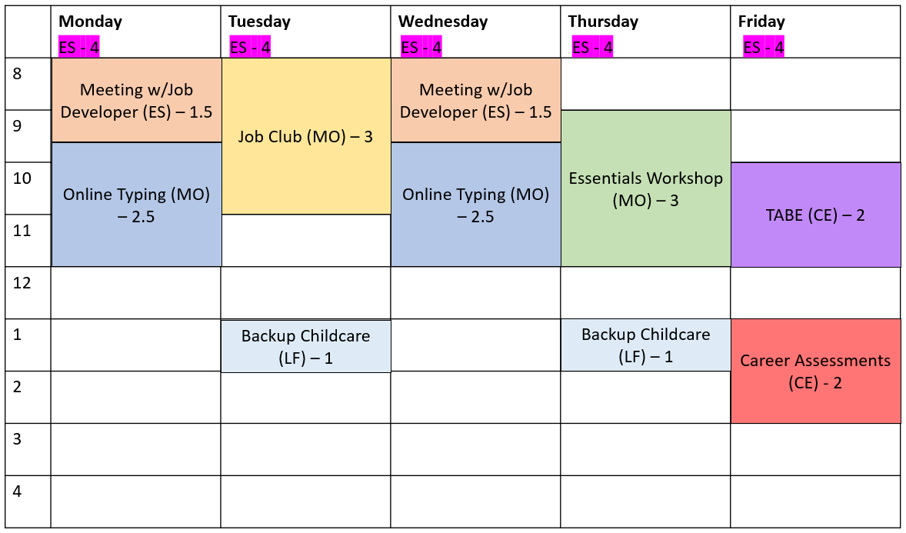

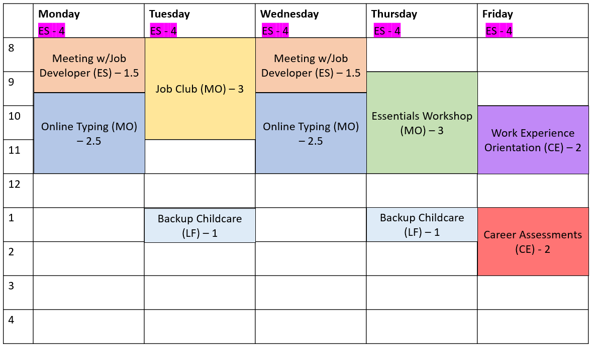

Employability Plan
- Learner shouldn’t have submitted the EP.
  - If they did and they don’t need to make edits, tell them they shouldn’t have submitted the EP, and remind them that during training, don’t submit the EP until a trainer instructs them to do so.
  - If they did and they need to make edits, send them the Correcting a Submitted EP document.

Supportive Services
- Expense Type: Transportation
  - Expense Details: Gas vouchers provided to complete assigned activities
  - Amount: $25.00
  - Issuance Date: today’s date
- Learners can update this information only the same day they enter it.

PIN Comments
- Learners can edit comments only the same day they enter them.
- Employability Plan
  - Participant Contact: SC
  - Comment Type: Employability Plan/Activity Assignment, Supportive Services
  - Must include:
    - Ana’s Primary Employment, Secondary Employment, Other Program, Long Term Career, and Personal Goals.
    - The activities Ana is assigned and why they assigned those activities/how those activities will help Ana reach her goals.
    - Provided gas voucher for Ana to complete her W-2 activities.

**After all EP entries are correct and complete, instruct learners to submit Ana’s EP and reply after it has been submitted.**

Brittany – Initial EP

Participation Status
- Status: FA – Formal Assessment Pending
- Begin Date: today’s date; End Date: Current
- Details: Brittany reported a personal barrier. Referred her for a Formal Assessment. See Participant Barriers page for more information.

Employability Plan Overview
- EP Begin Date: today’s date
- EP End Date: learner discretion
- EP without activities: No
- Notes: N/A
  - If the learner has something entered in the Notes field, it must be information specifically for the parent. If it isn’t, make them change it.

Goals
- Primary Employment Goal
  - Goal Name: Manufacturing or Accounts Payable/Receivable Clerk
  - Goal Description: learner discretion
    - Learner must include enough details to remind Brittany why she has the goal and that she wants part-time work.
  - Goal Steps: learner discretion
    - Based on Brittany’s scenario, there are several things she’ll need to do in order to get a job. Learners must have at least one Goal Step for this goal. However, encourage them to add several Goal Steps.
- Secondary Employment Goal
  - Goal Name: Manufacturing or Accounts Payable/Receivable Clerk
  - Goal Description: learner discretion
    - Learner must include enough details to remind Brittany why she has the goal and that she wants part-time work.
  - Goal Steps: learner discretion
    - Based on Brittany’s scenario, there are several things she’ll need to do in order to get a job. Encourage the learner to add several Goal Steps.
- Other Program Goal
  - Goal Name: Finish Accounting Degree or something similar
  - Goal Description: learner discretion
    - Learner must include enough details to remind Brittany why she has the goal.
  - Goal Steps: learner discretion
    - Based on Brittany’s scenario, there are several things she’ll need to do in order to finish her degree. Encourage the learner to add several Goal Steps.
- Long Term Career Goal
  - Goal Name: Become an Accountant
  - Goal Name: Finish Accounting Degree or something similar
  - Goal Description: learner discretion
    - Learner must include enough details to remind Brittany why she has the goal.
  - Goal Steps: learner discretion
    - Based on Brittany’s scenario, there are several things she’ll need to do in order to finish her degree. Encourage the learner to add several Goal Steps.
- Personal Goal
  - Goal Name: Something related to Brittany’s mental health
  - Goal Description: learner discretion
    - Learner must include enough details to remind Brittany why she has the goal.
  - Goal Steps: learner discretion

Employments
- Brittany isn’t working.

Activities
- Activity: LF – Life Skills or PA – Parenting Skills; Activity Description: Attend Baby and Me group or something similar
  - Activity Location: Off-site
  - Business Name: YMCA; Location: learner discretion; Street Address/Zip: learner discretion; Phone Number: learner discretion
  - Start Date: today’s date; Recurring: Yes
  - Frequency: learner discretion
    - Learner must enter a realistic frequency, such as once or twice a week.
  - Planned End Date: matches EP end date
  - Hours Per Day: learner discretion
    - To be realistic, this shouldn’t be more than 2.0 hours.
  - Begin Time/End Time: Learner discretion
    - If the learner doesn’t have times entered, encourage them to add times for Brittany. However, don’t require it.
- Activity: CE – Career Planning & Counseling; Activity Description: Complete career assessments or something similar
  - Activity Location: On-Site
  - Business Name: learner’s agency; Location: learner’s city/state; Street Address/Zip: learner’s agency address; Phone Number: learner’s phone number
  - Activity Contact: learner discretion
  - Start Date: today’s date; Recurring: Yes
  - Frequency: learner discretion
    - Learner must enter a realistic frequency, such as once a week.
  - Planned End Date: matches EP end date
  - Hours Per Day: learner discretion
    - To be realistic, this shouldn’t be more than 3.0 hours.
  - Begin Time/End Time: Learner discretion
    - If the learner doesn’t have times entered, encourage them to add times for Brittany. However, don’t require it.
- Activity: CM – Mental Health Counseling; Activity Description: Attend weekly counseling appointments or something similar
  - Activity Location: Off-site
  - Business Name: learner discretion; Location: learner discretion; Street Address/Zip: learner discretion; Phone Number: learner discretion
  - Activity Contact:
    - Contact Title: Treatment/Assessment Provider
    - Name: Jane Jones; Email: jonesj@communitypartners.org; Phone: 952-555-144
    - You cannot see if learners listed Jane as a contact unless you complete the Elevated Access page.
  - Start Date: today’s date; Recurring: Yes
  - Frequency: learner discretion
    - Learner must enter a realistic frequency, such as once a week.
  - Planned End Date: matches EP end date
  - Hours Per Day: learner discretion
    - To be realistic, this shouldn’t be more than 2.0 hours.
  - Begin Time/End Time: Learner discretion
    - If the learner doesn’t have times entered, encourage them to add times for Brittany. However, don’t require it.
- Activity: AM – Mental Health Assessment; Activity Description: Meet with your provider for your Mental Health Report form or something similar
  - Activity Location: Off-site
  - Business Name: learner discretion; Location: learner discretion; Street Address/Zip: learner discretion; Phone Number: learner discretion
  - Activity Contact:
    - Contact Title: Treatment/Assessment Provider
    - Name: Jane Jones; Email: jonesj@communitypartners.org; Phone: 952-555-144
    - You cannot see if learners listed Jane as a contact unless you complete the Elevated Access page.
  - Start Date: today’s date; Recurring: No
  - Hours Per Day: learner discretion
    - To be realistic, this shouldn’t be more than 1.0 hours.
  - Begin Time/End Time: Learner discretion
    - If the learner doesn’t have times entered, encourage them to add times for Brittany. However, don’t require it.
- Other potential activities suggested, but not required, in the scenario:
  - Establishing child care for Ella (CC)
  - Meeting with Mason’s doctors (FC, once a week)
- Look to goal steps for anything that is supposed to happen within the next month as potential activities.
- Brittany should be assigned at least 10 hours a week and no greater than 20 hours a week.

Employability Plan
- Learner shouldn’t have submitted the EP.
  - If they did and they don’t need to make edits, tell them they shouldn’t have submitted the EP, and remind them that during training, don’t submit the EP until a trainer instructs them to do so.
  - If they did and they need to make edits, send them the Correcting a Submitted EP document.

Supportive Services
- Expense Type: Transportation
  - Expense Details: Bus pass provided to complete assigned activities or something similar
  - Amount: $25.00
  - Issuance Date: today’s date
- Learners can update this information only the same day they enter it.

PIN Comments
- Learners can edit comments only the same day they enter them.
- Employability Plan
  - Participant Contact: SC
  - Comment Type: Employability Plan/Activity Assignment, Supportive Services
  - Must include:
    - Brittany is volunteering to complete W-2 activities.
    - Brittany’s Primary Employment, Secondary Employment, Other Program, Long Term Career, and Personal Goals.
    - The activities Brittany is assigned and why they assigned those activities/how those activities will help Brittany reach her goals.
    - Provided bus pass for Brittany to complete her W-2 activities.
  - Cannot include any confidential information about Brittany or Mason.

**After all EP entries are correct and complete, instruct learners to submit Brittany’s EP and reply after it has been submitted.**

Chantelle – Initial EP

Employability Plan Overview
- EP Begin Date: today’s date
- EP End Date: learner discretion
- EP without activities: No
- Notes: N/A
  - If the learner has something entered in the Notes field, it must be information specifically for the parent. If it isn’t, make them change it.

Goals
- Primary Employment Goal
  - Goal Name: Something related to working in an office setting
    - Learner must include a specific career, such as Receptionist or Data Entry Clerk.
  - Goal Description: learner discretion
    - Learner must include enough details to remind Chantelle why she has the goal.
  - Goal Steps: learner discretion
    - Learners must have at least one Goal Step for this goal. However, encourage them to add several Goal Steps.
- Secondary Employment Goal
  - Goal Name: Something related to customer service
    - Learner must include a specific career, such as Customer Service Representative.
  - Goal Description: learner discretion
    - Learner must include enough details to remind Chantelle why she has the goal.
  - Goal Steps: learner discretion
    - Encourage the learner to add at least one Goal Step.
- Other Program Goal
  - Goal Name: Degree or Certificate in Human Services
  - Goal Description: learner discretion
    - Learner must include enough details to remind Chantelle why she has the goal.
  - Goal Steps: learner discretion
    - Based on Chantelle’s scenario, there are several things she’ll need to do in order to get a degree or certificate. Encourage the learner to add several Goal Steps.
- Long Term Career Goal
  - Goal Name: Become an Administrative Manager or Office Administrator
  - Goal Description: learner discretion
    - Learner must include enough details to remind Chantelle why she has the goal.
  - Goal Steps: learner discretion
    - Based on Chantelle’s scenario, there are several things she’ll need to do in order to finish her degree. Encourage the learner to add several Goal Steps.
- Personal Goal
  - Goal Name: Something related to learning to read/write Spanish
  - Goal Description: learner discretion
    - Learner must include enough details to remind Chantelle why she has the goal.
  - Goal Steps: learner discretion
    - Learning another language is a large goal. Encourage the learner to break the goal down into smaller, more manageable steps for Chantelle.

Employments
- Chantelle isn’t working.

Activities
- Activity: CE – Career Planning & Counseling; Activity Description: Complete career assessments or something similar
  - Activity Location: On-Site
  - Business Name: learner’s agency; Location: learner’s city/state; Street Address/Zip: learner’s agency address; Phone Number: learner’s phone number
  - Activity Contact: learner discretion
  - Start Date: today’s date; Recurring: Yes
  - Frequency: learner discretion
    - Learner must enter a realistic frequency, such as once a week.
  - Planned End Date: matches EP end date
  - Hours Per Day: learner discretion
    - To be realistic, this shouldn’t be more than 3.0 hours.
  - Begin Time/End Time: Learner discretion
    - If the learner doesn’t have times entered, encourage them to add times for Chantelle. However, don’t require it.
- Activity: CE – Career Planning & Counseling; Activity Description: Complete the Test of Adult Basic Education (TABE)
  - Activity Location: On-Site
  - Business Name: learner’s agency; Location: learner’s city/state; Street Address/Zip: learner’s agency address; Phone Number: learner’s phone number
  - Activity Contact: learner discretion
  - Start Date: today’s date; Recurring: No
  - Hours Per Day: learner discretion
    - To be realistic, this shouldn’t be more than 3.0 hours.
  - Begin Time/End Time: Learner discretion
    - If the learner doesn’t have times entered, encourage them to add times for Chantelle. However, don’t require it.
- Activity: PR – Physical Rehabilitation; Activity Description: Attend physical therapy appointments or something similar
  - Activity Location: Off-site
  - Business Name: learner discretion; Location: learner discretion; Street Address/Zip: learner discretion; Phone Number: learner discretion
  - Activity Contact: Learner discretion
  - Start Date: next week; Recurring: Yes
  - Frequency: Weekly; Days: Monday, Wednesday
  - Planned End Date: matches EP end date
  - Hours Per Day: 1.5
  - Begin Time: 8:00 am; End Time: 9:30 am
- Other potential activity suggested, but not required, in the scenario:
  - Meeting with the Job Developer to refresh resume/interview skills (ES or MO)
- Keep in mind:
  - Even though Chantelle sees a medical provider, her condition is expected to last less than 6 months, so learners cannot assign MP.
  - Chantelle would need to take several steps before she could enroll in school, so she shouldn’t be assigned TT or TC at this point.
- Look to goal steps for anything that is supposed to happen within the next month as potential activities.
- Based on Chantelle’s scenario, it is realistic for her to be assigned at least 20 hours a week and no greater than 40 hours a week.

Employability Plan
- Learner shouldn’t have submitted the EP.
  - If they did and they don’t need to make edits, tell them they shouldn’t have submitted the EP, and remind them that during training, don’t submit the EP until a trainer instructs them to do so.
  - If they did and they need to make edits, send them the Correcting a Submitted EP document.

Supportive Services
- Up to learner discretion (Chantelle takes the bus or walks)
  - The scenario doesn’t specifically say learners must provide Supportive Services. If they don’t, recommend they add one for Chantelle, but don’t require it.
- Learners can update this information only the same day they enter it.

PIN Comments
- Learner can edit comments only the same day they enter them.
- Employability Plan
  - Participant Contact: SC
  - Comment Type: Employability Plan/Activity Assignment, Supportive Services (if the learner provided Supportive Services)
  - Must include:
    - Chantelle’s Primary Employment, Secondary Employment, Other Program, Long Term Career, and Personal Goals.
    - The activities Chantelle is assigned and why they assigned those activities/how those activities will help Chantelle reach her goals.
    - Supportive Services, if provided.
    - If learner did not assign Chantelle 40 hours a week of activities, they must include why they didn’t assign her 40 hours in their comment.
  - Cannot include any confidential information about Chantelle.
      - Learner cannot state Chantelle has a broken wrist. They state she has an injury.

**After all EP entries are correct and complete, instruct learners to submit Chantelle’s EP and reply after it has been submitted.**

Additional Feedback that may be used for specific issues:

Employability Plan
Goals – It is best practice to develop SMART goals (Specific, Measurable, Attainable, Relevant, and Time-Based) to help gain participant buy-in, help participants stay on track, and help participants become more likely to achieve their goals.

- Goal Name – Title of the goal
- Goal Description - This summary includes background information regarding why it is important to the participant, and an overall timeline for this goal. You also can use this field to incorporate some of the SMART goal criteria.
- Goal Steps - Goal Steps are smaller, individual steps or tasks parents need to complete to reach their goal. They do not need to mirror activities, but rather map out the journey they need to take to get to their goal. It is best practice to add at least one Goal Step for every goal.
- Types:
  - Primary Employment Goal – Parent’s chosen field of interest; is attainable within the program.
    - Examples:
      - Office Assistant - Sue has attention to detail and likes assisting others. She wants full-time, first shift work. Her career assessment results show her workstyles and interests are a good match for this type of work.
      - Mechanic – Bob likes working on vehicles. He has experience fixing cars and likes working with his hands
  - Secondary Employment Goal - Parent’s back-up field of interest; is attainable within the program.
    - Examples:
      - Cashier/Customer Service - Sue is willing to take a job as a cashier or in the customer service field. She likes to work with people and has good customer service skills.
      - Factory Worker - Bob wouldn’t mind working in a factory if he can move around and doesn’t have to stay in the same place all the time.
  - Long-Term Career Goal - Aligns with parent’s career assessment results and career pathway; likely achieved beyond their program participation.
    - Examples:
      - Sue would like to become an accountant in the future. She knows she will need to complete several other steps before this can happen, including going back to school to complete her degree.
      - Bob would like to own an auto repair shop someday. He thinks he would be a good and fair boss. He needs to learn more about being a small business owner and save money for business start-up.
  - Other Program Goal - Goals related to education, skills or training, and overcoming barriers for parents to move in the direction of their employment goals; achievable while enrolled in the program.
    - Examples:
      - Obtain Driver’s License – Sue has never had a DL and wants one because the bus takes too long. She would like to pass the temporary licensing test by the end of next month.
      - Complete an automotive certificate course – Bob would like to complete the Automotive Quick Service Technician certificate offered by the local tech college, as he knows this important for his future.
  - Personal Goal - Not required for program participation; helps strengthen the family and empower the parent.
    - Examples:
      - Sue knows she has a lot of stress in her life and needs to find ways to deal with it. She will try various coping strategies, such as drawing, journaling, yoga, and exercise to reduce her stress levels.
      - Bob would like to improve his health. He will exercise 30 minutes every day.

Quia Activities

Knowledge Check: 06 Initial EP
Learners must get all answers correct to mark this as complete. When giving feedback, point learners to W-2 Manual references and other resources in the Learning Center as needed to help them find the correct answer.

- According to the W-2 Manual, what is an Employability Plan (EP)?
A written agreement between the FEP and the parent that outlines how the parent will achieve a specific employment goal, or, if appropriate, a goal to obtain SSI or SSDI benefits. (W-2 Manual 6.1)

- How often must you review and update a parent’s EP?
At least every six months (W-2 Manual 6.2.2)

- What are the three parts of an EP?
Goals, employment, activities. You may also accept Supportive Services as the W-2 Manual still lists it as part of the EP. (W-2 Manual 6.1.1)

- What are the five goal types?
Primary Employment Goal, Secondary Employment Goal, Other Program Goal, Long Term Career Goal, Personal Goal (W-2 Manual 6.1.1.1)
You can accept “Primary” and “Secondary,” but then give feedback of the actual names.

- Where do you go in the W-2 Manual to read more about activity code definitions and the types of activities you could include under a code?
Activity Codes Appendix

- What are Participation Statuses?
Factors that impact a parent’s ability to do their assigned activities. (W-2 Manual 6.4.1)

- List four Participation Statuses.
CD Caring for Disabled Child, CF Caring for Other Family Member, EC Child Care for Employment Skills Training, EI Employer Intervention Services, FA Formal Assessment Pending, SD SS(D)I Advocacy/Application (W-2 Manual 6.4.1)

06 Initial Employability Plan Completed: Next Steps

Requesting the Next Curriculum
Email the learner to prepare them for the next curriculum.

Email Text - FEP
CC: Reg Staff, ATL, PTTTrainingSupp@wisconsin.gov
Subject Line: Next Steps: 07 Ongoing Case Management Curriculum

You’ve finished Initial Employability Plan. Next, you work with your cases on an ongoing basis.

Your next assigned curriculum is 07 Ongoing Case Management.

In the next curriculum, you’ll explore topics related to ongoing case management, including caseworker policy assistant, worker tasks, and more on program security and confidentiality. You’ll also complete a CBT on W-2 participation policy and tracking. Use what you learn from that CBT to process participation tracking for Ana, Brittany, and Chantelle.

As you complete your entries, submit your PINs to the Partner Training Team for review. If you have any questions or have any problems, contact PTT at PTTTrainingSupp@wisconsin.gov.

