New Worker Tracking

Spreadsheet Guide

One spreadsheet has been created to house both New Worker Tracking and the NWT Navigator Rotation so that all information will be in one easy to access place. The rotation tab was created to ensure that all New Workers are being dispersed among the NWT Navigators appropriately. The tracking tabs of the sheet were created in order to reduce the duplication of effort and the amount of time trainers spend verifying that all necessary curriculums, quizzes, and entries have been completed.

To access the New Worker Tracking spreadsheet:

- Go to your Google Drive

- Click “Shared with Me” on the left-hand side of the page. The spreadsheet will be shared with everyone doing NWT.
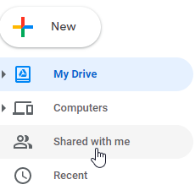

- Double click on the New Worker Tracking spreadsheet. This will open the spreadsheet in another tab.

NWT Navigator Rotation
When a New Worker is assigned to NWT training, they will be assigned to a NWT Navigator no matter what track (FEP or RS) they are assigned. When an email is received from RegStaff indicating that a New Worker is being assigned to NWT, the trainer covering NWT for that day will need to assign a NWT Navigator. To assign a NWT Navigator, open up the New Worker Tracking spreadsheet.

- Click the NWT Navigator Rotation tab. It should be the first tab at the bottom of the page.

- Enter the New Worker’s name onto the spreadsheet. The spreadsheet is already blocked off to show the appropriate number of slots for each NWT Navigator. Make sure that each column is filled in completely prior to moving onto the next.

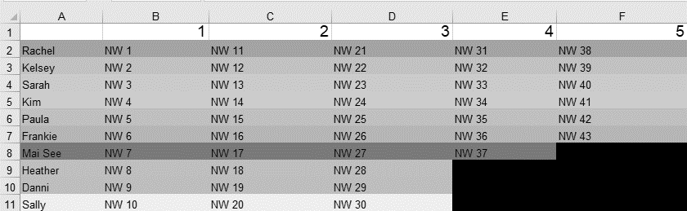

- Google Sheets will automatically save the spreadsheet and everyone with access will always have the most up to date version as long as they are connected to the internet.

If all slots are filled:
- Enter a new column to the right of the last column

  - Right click in the column, then click “Insert column”
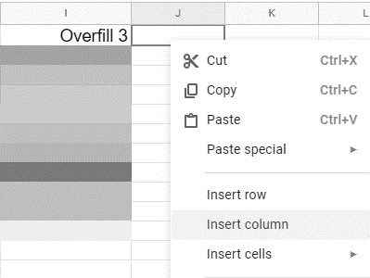

  - Click in the new cell and type in Overfill to name that column.
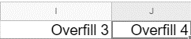

- Add the New Workers’ names in that column in the same order (top to bottom).

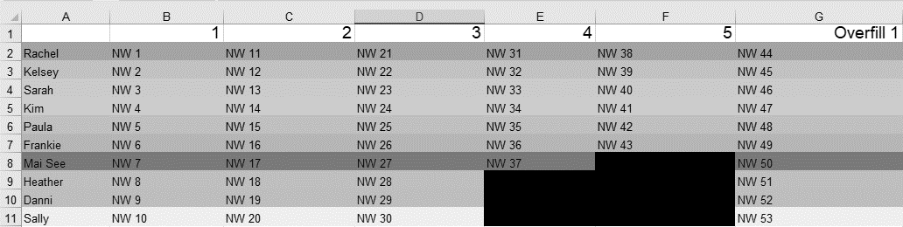

  - If there is an opening in columns 1-5, fill those first before continuing to fill the overfill column.

- Repeat this process to add another column if the overfill column gets full.

To remove a New Worker:
When a New Worker graduates or is no longer with their NWT Navigator, it is the NWT Navigator’s responsibility to remove that New Worker’s name from their row on the spreadsheet. The slot will then be filled as appropriate when another New Worker is assigned to NWT.

- Click the box the New Worker’s name is in.

- Hit the Backspace or Delete button. This will cause that cell to become empty.
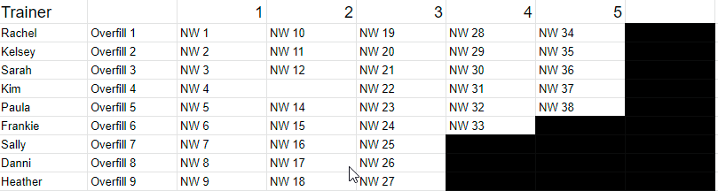

NOTE: Since all New Workers will be assigned to a NWT Navigator for six months regardless of their role, it is likely that New Workers will be removed in order (starting with column one). The only exception to this would be if that New Worker would leave the agency prior to the six months ending, or if the New Worker is choosing not to participate in the Navigator program.

New Worker Tracking
Each trainer is responsible for updating the tracking sheets when they are assigned to NWT for the day. It is best practice to update the sheet as a New Worker is given a complete for an entry or Quia activity. At a minimum, it is required to be updated at the end of the day.

- The spreadsheet is sorted by agency. Select the tab for the agency the new worker is a part of at the bottom of the screen. This will open that agency’s tab.

- Find the New Worker’s name on that page. FEPs are located at the top half of the spreadsheet and RSs are located at the bottom half.
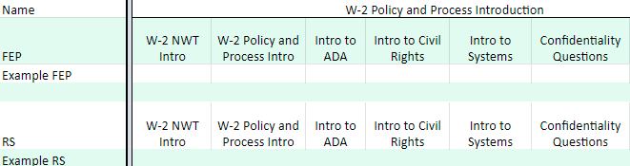

- Indicate which curriculum, quiz, activity, and/or entry that the New Worker has completed.

  - All curriculums are listed in order they are assigned starting with Policy and Process Intro and ending with NWT Completion. If the curriculum that was completed is not shown by default, use the scroll bar at the bottom of the screen to navigate to the appropriate curriculum.

    - The names of the New Workers will stay in place as you navigate to ensure you are indicating completions for the correct New Worker.

To add a New Worker:
- When an email comes in from RegStaff with a New Worker, go to the New Worker Tracking spreadsheet.

- Select the appropriate agency tab from the bottom of the page.

- From RegStaff’s email, determine if that new worker is on the FEP or RS track.

- Enter that New Worker’s name under the appropriate track on the agency page.

- Color code the New Worker based on who was assigned to be his/her NWT Navigator.

  - Click the number to the immediate left of the New Worker’s Name. This will highlight the entire row.
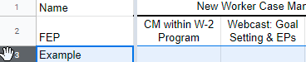

  - Click the paint can at the top of the sheet and choose the appropriate color based on the NWT Navigator.
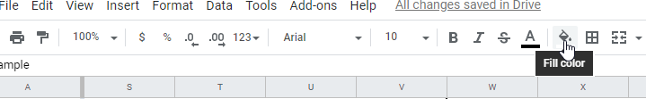

The colors are to be assigned as follows:
Rachel – Light Red Berry 2
Kelsey – Light Red 2
Sarah – Light Orange 2
Kim – Light Yellow 2
SH
Paula – Light Green 2
Frankie – Light Cyan 2
Mai See – Dark Magenta 1
Heather – Light Purple 2
Danni – Light Magenta 2
Sally – Light Gray 2
DG
HS
FC
PH
KS
SL
KC
RH

MX

When a New Worker completes NWT:

- Once the New Worker has completed NWT and the confirmation from RegStaff has been received, go to the New Worker Tracking spreadsheet and select the appropriate agency tab from the bottom of the page.

- Click the number to the immediate left of the New Worker’s Name. This will highlight the entire row.

- Right click and select Cut or hit Ctrl + X on your keyboard.

- Click in the next available slot in column A under the “Completed”.

- Right click and select Paste or hit Crtl + V on your keyboard. This will move the new worker and all of their information to the completed section.

NOTE: Do not move the New Worker from the NWT Navigator Rotation tab. The assigned NWT Navigator will remove the New Worker from that tab once his/her six months are up.

When a New Worker Gets an Incomplete:
- Once you get a notice from RegStaff stating that the New Worker has left an agency/is getting an incomplete, look up who that New Worker’s Navigator is on the New Worker Tracking spreadsheet.

- Notify the Navigator via email that the New Worker will no longer be completing NWT.

- Move the New Worker’s folder to the Incomplete section of the NWT inbox.

- Select the appropriate agency tab from the bottom of the page based on that New Worker’s agency. Click the number to the immediate left of the New Worker’s Name. This will highlight the entire row.

- Click the delete button or right click and select delete row.

- Navigate back to the NWT Navigator Rotation tab. Delete the name of the New Worker who received the incomplete to open up that spot in the rotation.

NOTE: If a New Worker is no longer participating in the Navigator program due to no contact or loss of contact, right click on the New Worker’s name on the agency tracking sheet and click Add Comment. Type “No Navigator” as the comment.

