New Worker Profile Assessment
When a New Worker (NW) is assigned to NWT training, they will be asked to complete a NW Profile Assessment that is housed in Google forms.

To access the New Worker Profile form:
- Go to your Google Drive

- Click “Shared with Me” on the left-hand side of the page. The form will be shared with everyone doing NWT.
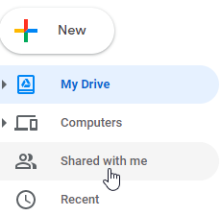

- Double click on the New Worker Profile form. This will open the form in another tab.

To send the form to a NW:

- Click the “Send” button in the top right of the screen.

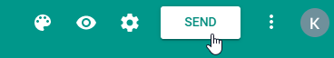

- Click the second icon to get the link to the form and check the box to shorten the URL.
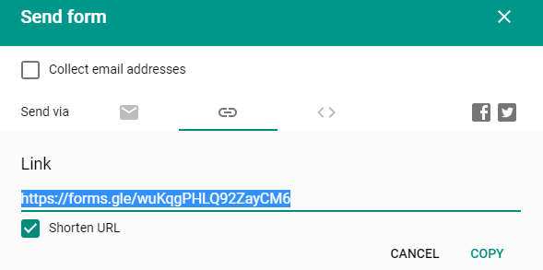

- Copy the URL and paste it into the email you are sending to the NW.

To view responses:

- Click on “Responses” to the right of “Questions”

- Google Forms automatically shows a summary of all responses. To view specific results, click “Individual”.
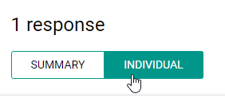

- Use the arrows to navigate to the assessment results of your NW.
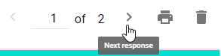

- Download or print the results and then delete it from the form by selecting the trash icon.

To view previous assessment results:

- Click the Google Sheets icon. This will open the Google Sheet in a different tab with all of the previous responses from the New Worker Profile form, even if the results have been deleted.
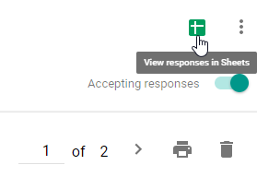

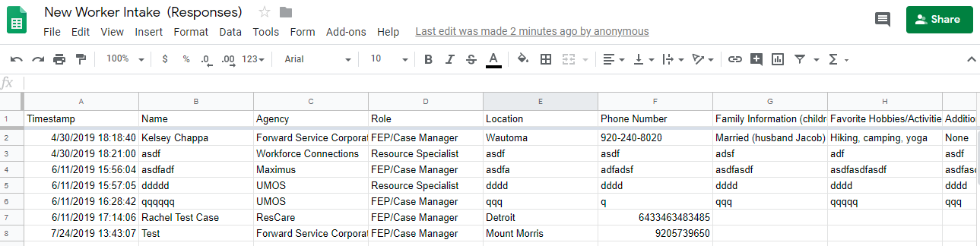

To edit the New Worker Profile form:
- Scroll to the section of the form that you would like to edit.

- Click in the section you would like to update and start updating. It will automatically save and display when the link is sent to a NW.

