W-2 Case Management:
Assessment and Employability Plans

Trainer Toolkit

Class Dates: ___ - ___

Zoom Link:

Table of Contents
Training Team Preparation Checklist 3
PIN Assignments Worksheet 4
Information for the Producer 5
Information for the Support Trainer 6
Information for Main Trainers 7
Training Day Technology Tips and Tricks 8
General Tips 8
WWP Troubleshooting 8
PowerPoint (PPT) Troubleshooting 8
Toggling Between Applications During Screen Sharing 9
Zoom-Specific Features 11
Post-Training Debrief Questions 14
Trainer Breakout Day 1 15
Trainer Breakout Day 2 16
Trainer Breakout Day 3 17

Training Team Preparation Checklist

Training Team Readiness
☐Determine roles (producer, support trainer, trainer(s))
☐Clarify role expectations
☐Create trainer breakout for the course
☐Schedule prep and debrief sessions

Trainer Prework
☐ Complete trainer prework as outlined in the course
☐ Complete scenario in TN Appendix 2-3 working days prior to class.
☐ Update self-facilitated introduction slide on the PPT
☐ Prep Zoom platform for class needs (closed captioning, breakout rooms, etc.)
☐ Polling questions
☐ Save a copy of the course TN, PG, and PPT to your computer to open on day of
training
☐ Printing the TN is recommended

Polling Questions

Create in Zoom prior to class
Polling Question 1: Case Management Process Model
Which portion of the Case Management Process Model are you most comfortable with?
- Assessment
- Planning
- Connecting with Resources
- Follow-Up
- Documenting

Polling Question 2: Job Readiness Page
On a scale of 1 to 10, with 10 being the most valuable, how valuable is it to collect this job readiness information?
- 1
- 2 or 3
- 4 or 5
- 6 or 7
- 8 or 9
- 10

Polling Question 3: “BEST’ Approach
Which aspect of the “BEST” approach do you feel you are a rockstar at?
- Balance
- Exploration
- Sensitivity
- Trust
- I might be a star, but not quite a rockstar yet.

Polling Question 4: Pick Your Assessment
If you had to choose only one assessment to complete with participants, which assessment would you choose?
- Informal
- Job Readiness
- Career
- Education Needs
- Vocational
- Formal

Polling Question 5: Goal Types
What type of goal are you most comfortable creating with participants?
- Primary Employment Goal
- Secondary Employment Goal
- Other Program Goal
- Long Term Career Goal
- Personal Goal

Polling Question 6: Activities
How many new activities did you think of and/or see that you would like to take back to the office with you?
- 1-2
- 3-4
- 5+

Polling Question 7: All About the Informal Assessment
Which page of the Informal Assessment ‘Rocks your socks’?
- Work History
- Educational History
- Post-secondary Education
- Participant Barriers

Polling Question 8: Comments
What key piece of information must be included in PIN Comments?
- Your rational
- Summary of current situation
- Participant progress
- All the above

Information for the Producer

To Add in the Chat
Closed Captioning
To hide subtitles, click on Live Transcript and choose Hide Subtitle.

Renaming Instructions
If your display name is not correct, rename yourself by clicking on the more button (…) next to your display name.

If you called in by phone, please rename your phone number to match your login name.

Annotation Tools - Stamp
View Options – Annotate – Stamp

Annotation Tools - Text
View Options – Annotate – Text

Link to Participant Guide

You Tube Videos

Evaluation
Please complete the eval at:

Break Timers
Nature scenes: https://www.youtube.com/watch?v=l8o3F3YiV3M
Productivity Arrows: https://www.youtube.com/watch?v=PHJWV1SmPTc
Cute Puppies: https://www.youtube.com/watch?v=MKLr_Aw391U
Among Us: https://www.youtube.com/watch?v=xYmG0a5CC-I
House Mix: https://www.youtube.com/watch?v=OPyjgRp-Rb8

BWF Work Programs Help Desk
Email: bwfworkprogramshd@wisconsin.gov; Phone: (608) 422-7900

Breakout Rooms
Day 1
  - Group 1 -
- Group 2 -
- Group 3 -
- Group 4 -
Day 2
- Group 1 -
- Group 2 -
- Group 3 -
- Group 4 -
Day 3
  - Group 1 -
  - Group 2 -
  - Group 3 -
- Group 4 –
Day 4
  - Group 1 -
  - Group 2 -
  - Group 3 -
- Group 4 –

Information for the Support Trainer

Fill-Ins for the PG to Put in the Chat
Assessment Process Model (TN 16, PG 7)
~ Collection
~ Evaluation
~ Action
~ Documentation

“BEST” Approach (TN 36, PG 20)
~ Balance
~ Exploration
~ Sensitivity
~ Trust

Participation Status (TN 46, PG 26)
~ CD – Caring for Disabled Child
~ CF – Caring for Disabled Family Member
~ EC – Child Care for Employment Skills Training (2 year)
~ EI – Employer Intervention Services
~ FA – Formal Assessment Pending
~ SD – SS(D)I Advocacy/Application

Assessment – Putting it Together (TN 52, PG 28)
~ Assessment is a process, not a solution.
~Assessment should impact case management.
~W-2 policy requires formal and informal assessments.
~Informal assessment is not an interrogation.
~Good informal assessment engages the participant.
~The end product of an assessment is information.
~Assessment is more than what is on a form.
~Assessment should be done when there is a need for information.
~Always document the differences that assessment results make in case management.
~Assessment is ongoing.
~A participant cannot be sanctioned for failing to cooperate with a formal assessment.
~The success of assessment is not just getting the information, but what you do with the information.

System Documentation (TN 78, PG 37)
Employment:
~ Always check the box

Elapsed Activities:
~ It is not best practice to backdate an EP.

~ Can backdate an EP up to 10 calendar days.

Training Day Technology Tips and Tricks

General Tips
- Turn off other Wi-Fi devices. Use an ethernet cord to plug into your modem directly for internet. This increases your chances of a stable connection during training.
- Use Ctrl + to zoom in and Ctrl – to zoom out when working in WWP.
- Remember to use breakout rooms as needed.
  - Trainers can use breakout rooms to quickly discuss something.
  - Support trainers can use breakout rooms to work with a learner.

PowerPoint (PPT) Troubleshooting
- If your PPT uses the zoom feature, don’t start the slide show from a slide in the middle. Always start with slide one.
- Be aware of moving your mouse between monitors when running the PPT. If you move your mouse to the monitor that is not sharing the PPT in slideshow mode, you must make an initial click back on the screen with your PPT. Then click a second time to move to the next animation or slide.

Toggling Between Applications During Screen Sharing

Prior to Screen Sharing
- Have everything open that you plan to share, such as the program system, PowerPoint, etc.
- If using two monitors, move everything you plan to share to one monitor. When you share your screen, choose to share that monitor and not just a window. This means anything you switch to on that monitor will display. It is best practice to use the monitor that is bigger and doesn’t have your webcam.
  - You can have the PPT open and in slide show mode on that monitor and minimize the presenter view on your main monitor.
- Remember to share your computer audio from the screen share dialog box.

Using Alt+Tab
- While sharing your screen, Press Alt+Tab on your keyboard to display a window that show all your open applications.
- Take your finger off the Tab key and tap the Tab key to move through the applications until you get to the one you want to display.
- The application will display on whatever screen you previously used to display the application.

Using Your Task Bar
- Another option for switching between applications while screen sharing is to use your task bar. To do this you must change your computer settings to display the task bar on your main computer and not your second monitor.
- Right click on your task bar at the bottom of the screen and select Taskbar Settings.
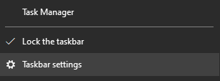

- Scroll down to the multiple displays section, and turn off the setting for Show taskbar on all displays.
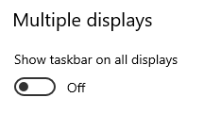

- The taskbar only displays on your main monitor and you can use it, like you usually would, to switch between applications. Again, the applications will display on the screens you originally used to display the application.
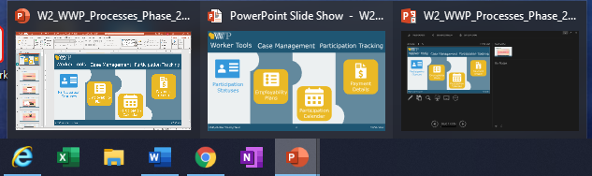

Zoom-Specific Features
Renaming Learners
- Encourage learners to rename themselves first.
- If you need to rename a participant, click on More > next to their name and choose Rename. Then, type in the correct name.
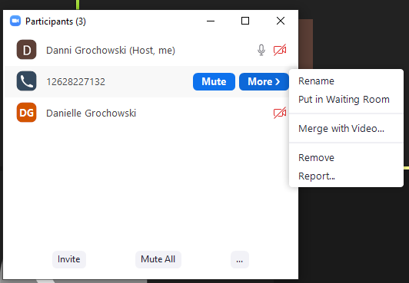

Connecting phone number with a learner’s video
- It’s important to match learners who call in by phone with their video profile so that both end up in the same breakout room.
- If it is not obvious who the phone number belongs to, ask learners who called in by phone to rename their phone number so you can match it.
- In the Participants box, click on More > next to the phone number. Choose Merge with Video.

- Zoom displays any learners who are logged in, but didn’t connect to audio through their computer. Select the name you want, and click Merge.
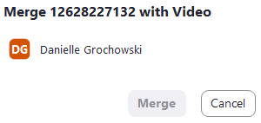

Breakout Rooms – auto send and auto end
- When setting up breakout rooms, always choose to set up the rooms manually. This allows you to move learners to different rooms, but leave the trainers and notetaker in the main room.
- When setting up breakout rooms for the first time, click on options.
- Check the option to Automatically move all assigned participants into the breakout rooms. This saves a step of having learners click a button to join.
- Use the options to have breakout room automatically close after a certain amount of time and to display a countdown timer. In the example below, the countdown timer of 60 seconds will start after the 4 minutes. This means learners will have a full 5 minutes in the room.
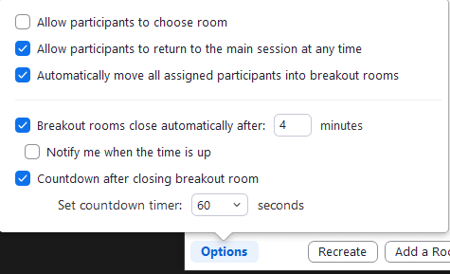

- These setting will remain for all future breakout rooms unless you change them (even in future sessions).

Moving Text Annotations
- When learners use the text annotation to type on the screen, only the trainer sharing their screen can move the text boxes elsewhere on the screen.
- Open your annotation toolbar, and choose the Select tool. Then, click on the annotation you move and move it elsewhere on the screen.

Exit Full Screen Mode
- When another trainer shares their screen, it automatically displays in full screen mode, messing up your set up with the chat box, etc.
- Press the ESC button to put everything back into a frame and out of full screen. You should still see what they display and have your other dialog boxes open as well as access to your computer’s task bar.

Pause Your Screen Share
- If you need to access other applications on the monitor you are sharing, but don’t want learners to see you can pause what you’re sharing. This keeps the same thing on the screen for learners, but allows you to move around to other things.
- Click Pause Share (next to New Share) on your Zoom control panel.
- Zoom displays a message that your screen is paused. Remember to click Resume Share when your ready to share everything again.

Enable Closed Captioning (CC)
- At the beginning of each class, the host must turn on the CC feature.
- Click on Live Transcript from the Zoom control panel. Then, click Enable Auto-Transcription. This turns on CC for everyone and starts it immediately.
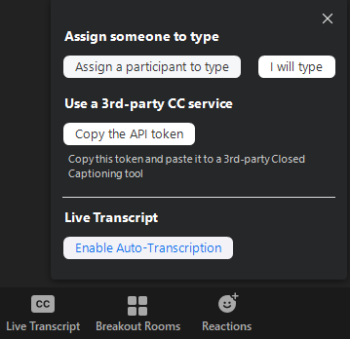

- To turn the CC off on your display only, click the carrot (^) on the Live Transcript button and select Hide Subtitle.
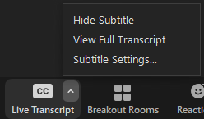

Post-Training Debrief Questions
The goal of the post-training debrief is to reflect, process, and collaborate regarding the training delivery. It includes:
- Discussing the training delivery from the learners’ perspective, ensuring they have the skills needed to work with families.
- Discussing the individual and team dynamics while delivering the training.

- What was the most effective moment in training today?

- What did we do well as a team that promoted a positive learning experience for learners?

- What did we do well as a team that promoted a positive training experience for us?

- In what ways did you successfully complete the tasks of your assigned role(s) during the delivery of the course?

- What were some important lessons we learned?

- Where do you feel we are getting stuck as a team?

- Where do you feel you are getting stuck individually?

- Where do you think learners are getting stuck?

- Which content or activity may need to be strengthened to be more effective?

- What can we do to ensure a successful experience (for learners and us) moving forward?

- What can you do to ensure successful course delivery moving forward?

Trainer Breakout Day 1
Producer: ________________

Topic | Talking | Sharing | Support | Planned Time | Actual Time | Producer and *Support Trainer Notes
Opening/Welcome |  |  |  | 10 min
Six Word Memoir |  |  |  | 20 min
Learning Objectives |  |  |  | 5 min
Case Management is a Process |  |  |  | 10 min
Assessment, Sit/Stand Energizer |  |  |  | 10 min
Assessment Process Model, PSA Activity |  |  |  | 35 min
Break |  |  |  | 15 min
Informal Assessment |  |  |  | 10 min
Informal Assessment Driver Flow |  |  |  | 20 min
Informal Assessment Inventory Jeopardy |  |  |  | 30 min
Lean In/Lean Out Energizer, Career Assessment and Job Readiness Pages |  |  |  | 10 min
Job Readiness Activity |  |  |  | 20 min
Day 1 Wrap-Up |  |  |  | 10 min

Trainer Breakout Day 2
Producer: ________________

Topic | Talking | Sharing | Support | Planned Time | Actual Time | Producer and Support Trainer Notes
Day 2 Welcome, Wisconsin Says |  |  |  | 10 min
Conversational Interviewing, “BEST” Approach, |  |  |  | 20 min
River of Jobs |  |  |  | 45 min
Break |  |  |  | 15 min
Formal Assessment |  |  |  | 20 min
Accommodations, Race to Accommodate, Documenting Accommodations |  |  |  | 20 min
Eyeball Yoga, Participation Statuses, Name that Status |  |  |  | 20 min
Practicing Assessment |  |  |  | 30 min
Assessment – Putting it Together, Day 2 Wrap-Up |  |  |  | 20 min

Trainer Breakout Day 3
Producer: ________________

Topic | Talking | Sharing | Support | Planned Time | Actual Time | Producer and *Support Trainer Notes
Day 3 Welcome |  |  |  | 15 min |  | *Clear annotations
Goal Setting, How to Formulate SMART Goals, Personal Practice |  |  |  | 20 min
Goals within the W-2 Program, Goal Steps, Goal Steps Energizer |  |  |  | 10 min
Goal Setting Practice Scenario |  |  |  | 40 min
Break |  |  |  | 15 min
Employments, Engagement in Activities, Tying Goals to Activities |  |  |  | 10 min
Activities, Find Something That… Energizer |  |  |  | 10 min
Activities, Activities, Activities, |  |  |  | 30 min
Supportive Services, Day 3 Wrap-up |  |  |  | 15 min

Trainer Breakout Day 4
Producer: ________________

Topic | Talking | Sharing | Support | Planned Time | Actual Time | Producer and *Support Trainer Notes
Day 4 Welcome, Colleague Q&A |  |  |  | 15 min |  | *Clear annotations
Practicing EPs |  |  |  | 45 min
Energizer, EP Summary, Keys with EPs |  |  |  | 20 min
Break |  |  |  | 15 min
System Documentation, Assessment Documentation |  |  |  | 20 min
Employability Plan Documentation, Energizer |  |  |  | 45 min
PIN Comment Documentation, Comment Types Activity |  |  |  | 15 min
Changes to Arya’s Situation |  |  |  | 20 min
Day 4 Wrap-Up, Closing Activity |  |  |  | 20 min

