Subject: Reporting Issue: Missing EA Access Appointment Data in Two Webi Reports

Our team recently discovered an issue with EA Inbox Request Appointment data. It was found that certain data has not been loading since November 2023 which impacts some of our reports. More details below. **Note that this will not impact EA processing or any EA reports; it only impacts what displays in the two Access reports below**.

If you use either of the following two reports, there will be approximately 5,500 records created or updated since November 2023 that will not display in those reports.

We will send out an update once the fix has been made. Please use the BAR Request Form <https://dcf.wisconsin.gov/form/bar-report-research-information-> if you have any questions.

Report Details:

**Folder Path:**

*Public Folders / DCF / WISDOM / Employment Programs / W-2 Monitoring / Application and Assessment*

**Reports Impacted:**

*Access EA: Application Weekly Summary*

*Access EA: Applications Inbox Transaction History*

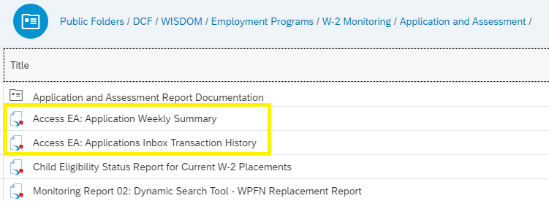

**Business Processes Impacted:**

*Access EA: Application Weekly Summary*

* Used for W-2 agencies to anticipate workload and allocate EA worker staffing levels to meet 5-day timely processing requirement in EA policy.

*Access EA: Applications Inbox Transaction History*

* Situational report to assist EA workers in answering possible questions from EA applicants inquiring about what happened to the status of their application submitted through Access.