October Maintenance Meeting Agenda
CAR-45006: SWICA discrepancies assigned to IM with W2 details

Meeting Purpose: | Discuss conversion requirements for CAR-45006
Date: | 08/02/2018
Start Time: | 1:00pm
End Time: | 2:00pm
Location: | DHS CR 1WW B167C seats 8-8
Call-In Information: | DHS AV BEPS Conf5: 877-820-7831 ACCESS Code: 813013

Individuals Invited
X | Bakunowicz, Nicholas J - Deloitte | X | Sadanandan Angel, Yamuna - Deloitte
X | Yang, Nhialee - DHS | X | Palese, Kelly M - DCF
X | Schmidt, Jean P - DCF | X | Riley, Elizabeth R - DCF
X | Lezama, Alma D - DHS |  | Stebbeds, Marcie - DCF
X | David, Rebecca M - DHS | X | Karnati, Bipin C - Deloitte

Agenda

- Introductions

Key Dates | Date
Begin System Testing | 08/17/2018
Begin UAT Testing | 09/17/2018
Production Deployment | 10/27/2018

- Recap high-level requirements

- Confirm conversion requirements

Recap of Requirements

Creating Discrepancies

A separate SWICA discrepancy and accompanying work item should be created for each of the following program areas: IM, W-2, and CC. For example, if there is both an IM and CC discrepancy, one IM discrepancy and one CC discrepancy will be created, each with their own work item.

Assigning Discrepancies

For IM and CC Program areas
IM and CC discrepancy work items should be assigned to a worker in the following hierarchy:

- If the primary worker is an IM worker and is active and has update access to the case, the work item will be assigned to the primary worker.

- If the primary worker is a FEP worker or there is a FEP worker assigned to the case that is active and has update access to the case, the work item will be assigned to the FEP worker.

- If there is a FEP worker on the case, but he/she is not active or doesn’t have update access to the case, the work item will be assigned to default county FEP of the case.

- If there is no FEP worker on the case, the work tem will be assigned to transfer coordinator of the office of the case.

For W2 Program areas
W2 discrepancy work items should be assigned to the FEP assigned to the case, assuming the following conditions are met:

  - A FEP has been assigned to the case (on the W-2 Request page) at the time of discrepancy creation.

  - The FEP assigned to the case is active and currently has update access to the case.

If the above conditions are not met, then the work item will be assigned to the default FEP for that county, which will be obtained from a reference table.

Displaying Discrepancies

Going forward, each magnifying glass should point to the respective program area details. For example the IM discrepancy magnifying glass should bring up the IM discrepancy details and the W2 discrepancy magnifying glass should bring up the W2 discrepancy details.

Discrepancy Dashboard panel
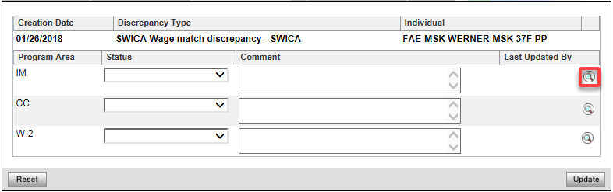

Discrepancy History Results page
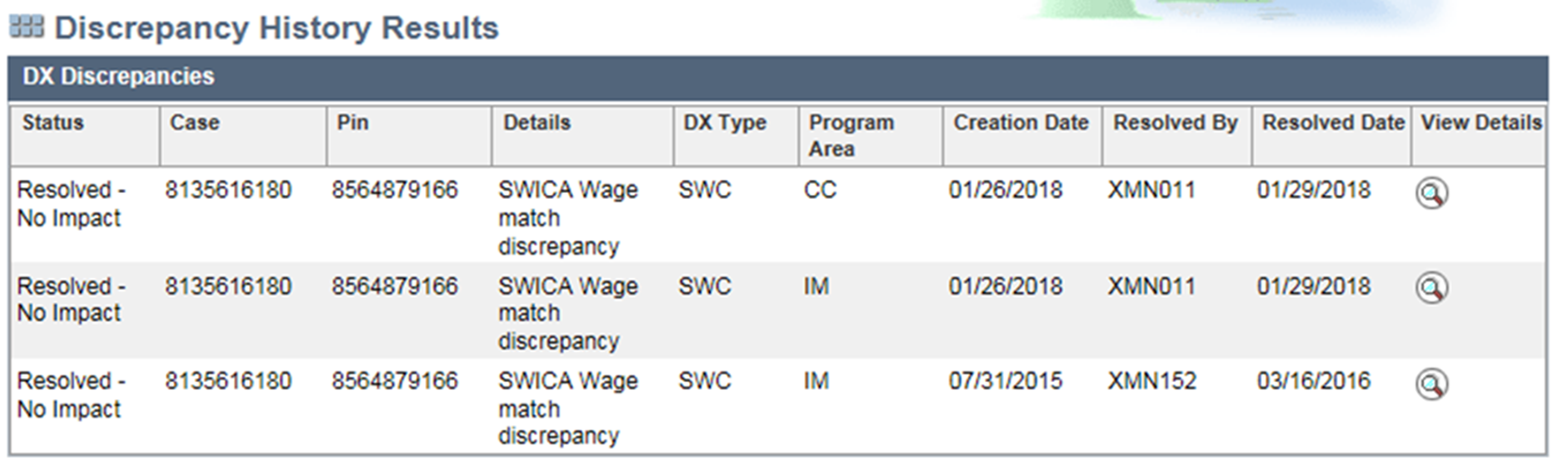

Conversion

Removing Extra Work Items

It was previously decided that in scenarios where discrepancy details exist for only one program, but multiple discrepancies were created, the orphaned discrepancy (discrepancy with no details) can be deleted.

Example
If an IM and W2 discrepancy and work item were created and only W2 discrepancy details exist, the IM discrepancy and work item should be removed

Question: Should an update be made to already resolved discrepancies, or just unresolved discrepancies?

Displaying Already Resolved and Already Created Discrepancies

Once the discrepancy display logic has been updated in October, already resolved and already created discrepancies may show different details according to the new display logic.
At the previous meeting the group felt the best option for displaying already resolved and already created discrepancies was to use the new logic to determine which discrepancy details to display.

 | Discrepancy Created | Discrepancy Details Created | Currently Displayed on Details page | To be Displayed on Details page | Comments
1 | IM & W2 | IM (Most) & W2 | IM & W2 | IM IM (Most)
 |  |  |  | W2 W2
2 | IM & W2 | W2 | W2 | IM W2 | Orphan discrepancy to be deleted.
 |  |  |  | W2 W2
3 | IM | IM (Most) & CC | IM (Most) | IM IM (Most)
4 | IM & CC | IM (Most) & CC | IM (Most) | IM IM (Most)
 |  |  |  | CC CC
5 | IM | IM (Most) & W2 | IM (Most) and W2 | IM IM (Most) | CMF Placement Scenario
6 | W2 | IM (Most) & W2 | IM (Most) and W2 | W2 W2 | Only 4 in Production
7 | IM | CC | CC | IM CC
8 | W2 | IM | IM | W2 IM
9 | ‘ ‘ | IM | IM | IM IM
(Most): The most restrictive in terms of FPL limit.

For some of these already created and resolved discrepancies, no details will exist to be displayed (bolded in the table above).
  - Option 1: Show most restrictive.
  - Option 2: Show all details.
  - Option 3: Convert the discrepancy to match the details.

Meeting Minutes

The group recapped the requirements for creating IM, W-2 and CC discrepancies and creating work items corresponding to the discrepancies and assignment of the work items to IM primary worker/FEP worker/ Default county FEP or Transfer coordinator of the office of the case according to the hierarchy (given in the ‘Assigning Discrepancies’ section of this meeting agenda).

- The group recapped and confirmed that if there are multiple IM programs with discrepancies, and if FoodShare is one of the programs with a discrepancy, then FoodShare details are always displayed in the discrepancy details along with most restrictive AG of HealthCare AGs.
  - If two healthcare AGs have same FPL limit and if an individual is eligible/counted in both the AGs, then any one of the two AGs are shown on the discrepancy details.

- The group recapped and confirmed that, going forward, on the Discrepancy History Results page, where resolved discrepancies are displayed, and on the dashboard, where unresolved discrepancies are displayed, each magnifying glass should point to the respective program area details.

- In regards to the change in displaying of discrepancy details, the group requested screenshots showing discrepancy and the discrepancy details for the purpose of worker training program.

Action Item: Deloitte will provide screen shots of the display changes.

Conversion options

The group reviewed the outcome of the previous discussion and discussed the different options for displaying already resolved discrepancies and already created discrepancies.

- It was mentioned that if the already resolved discrepancies were updated, this may change information in reports that are generated for the discrepancies.

  - In other words, if new discrepancies were created to match existing discrepancy details, this might affect the counts for the number of discrepancies in the past.

  - It was also stated that discrepancy details for a program area could not be created for existing discrepancies without details since no discrepancy was determined at the time.

  - The group decided not to create a discrepancy or discrepancy details for the already resolved discrepancies so as not to affect any reports that are generated.

- The group discussed what should be displayed for already resolved and already created discrepancies when the discrepancy does not have details for that program.

  - Two options were discussed—display the most restrictive program detail or display all program details (IM, CC, or W2) for that individual for that match date.

  - The group decided to err on the side of displaying all of the program details for that individual and match date when there are no details to display for a discrepancy program area. This may include IM, CC, and/or W2, regardless of restrictiveness. Note: See scenarios 7-9 below for examples.

- It was noted that based on the above decision once the discrepancy display logic has been updated in October, already resolved and already created discrepancies may show different details compared to what is displayed currently in production.

Conversion options
The group reviewed the scenarios provided for already resolved discrepancies and already created discrepancies and confirmed the following outcomes.

Scenario 1

- The group agreed that when the W2 discrepancy is selected, the W2 details should display.

 | Discrepancy Created | Discrepancy Details Created | Currently Displayed on Details page | To be Displayed on Details page
1 | IM & W2 | IM (Most) & W2 | IM & W2 | IM IM (Most)
 |  |  |  | W2 W2

Scenario 2

- Resolved Discrepancies - The group agreed to display W2 details upon clicking on IM magnifying glass as there are no IM details to display.

- Already Created Unresolved Discrepancies - It was decided that for discrepancies that are already created and not yet resolved, the IM discrepancy would be systematically deleted.

 | Discrepancy Created | Discrepancy Details Created | Currently Displayed on Details page | To be Displayed on Details page
2 | IM & W2 | W2 | W2 | IM W2
 |  |  |  | W2 W2

Scenario 3

- The CC discrepancy details are not currently being displayed and would not be displayed after the changes.

 | Discrepancy Created | Discrepancy Details Created | Currently Displayed on Details page | To be Displayed on Details page
3 | IM | IM (Most) & CC | IM (Most) | IM IM (Most)

Scenario 4

- It was mentioned that the CC discrepancy details are not currently displayed, but would be displayed going forward.

 | Discrepancy Created | Discrepancy Details Created | Currently Displayed on Details page | To be Displayed on Details page
4 | IM & CC | IM (Most) & CC | IM (Most) | IM IM (Most)
 |  |  |  | CC CC

Scenario 5

- It was stated that this scenario could occur when a CMF Placement discrepancy was incorrectly created and later deleted. The W2 details will not display in this scenario.

- The group was reminded that with the proposed changes for this JIRA item, for any new discrepancies received after the go live of the new functionality, no CMF Placement W2 discrepancy will be created in the first place if it meets the discussed criteria.

- A question was posed to the group: should the new changes also apply to CMF+ Placements? In other words, should a discrepancy not be created if the individual is in a CMF+ Placement and meets the previously discussed criteria?

Action Item: DCF will check with the team and respond to the group.

 | Discrepancy Created | Discrepancy Details Created | Currently Displayed on Details page | To be Displayed on Details page
5 | IM | IM (Most) & W2 | IM (Most) and W2 | IM IM (Most)

Scenario 6

- The group agreed to display W2 details in this scenario as W2 discrepancy has matching details. Currently both IM and W2 details are displayed in this scenario.

- It was mentioned that there were very few of these identified.

 | Discrepancy Created | Discrepancy Details Created | Currently Displayed on Details page | To be Displayed on Details page
6 | W2 | IM(Most) & W2 | IM(Most) & W2 | W2 W2

Scenario 7

- The group agreed to display CC details upon clicking on IM magnifying glass as there are no IM details to display.

- The scenario follows the system requirement that when there are no program details to display for a created discrepancy, any discrepancy details for that individual and SWICA match date should display.

 | Discrepancy Created | Discrepancy Details Created | Currently Displayed on Details page | To be Displayed on Details page
7 | IM | CC | CC | IM CC

Scenario 8

- This scenario is similar to Scenario 7. The group agreed to display IM details since there are no W2 details to display.

 | Discrepancy Created | Discrepancy Details Created | Currently Displayed on Details page | To be Displayed on Details page
8 | W2 | IM | IM | W2 IM

Scenario 9

- It was mentioned that conversion could take place to update the discrepancy to match the details for these already resolved discrepancies. For example, in the below scenario, the discrepancy (1st column) would be updated to read “IM” since IM details exist for this individual and match date.

  - The group agreed with this approach.

- The group decided that if there is no program area for a discrepancy, all the discrepancy details of that PIN for that matching date will be displayed.

 | Discrepancy Created | Discrepancy Details Created | Currently Displayed on Details page | To be Displayed on Details page
9 | ‘ ‘ | IM | IM | ‘ ‘ IM

Action Items

No. | Action Items | Assigned To | Due Date
1 | Provide screenshots of discrepancy history results page and the discrepancy details page that are displayed upon clicking on magnifying glasses. | Deloitte
2 | Verify whether SWICA discrepancies should be created for W2 when there is a CMF+ placement and the existing criteria used for not creating discrepancies for CMF placements are met. | DCF | After the meeting, an email follow-up clarified that the same should apply to CMF+ placements.

