 Be a Local Child Care Champion
Get the Facts on [COMMUNITY] Child Care

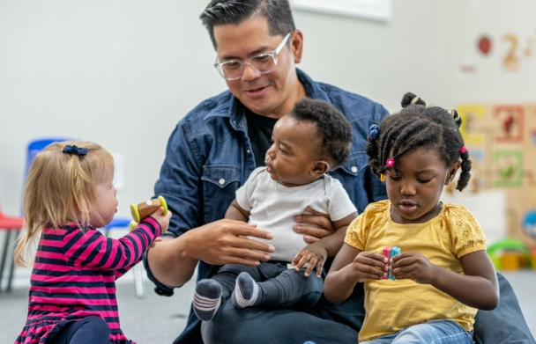
Child Care Resource & Referral Agency
- Website
- Phone number
- Email
- Street Address
Regional Family Resource Center
(If different from CCR&R)
- Website
- Phone number
- Email
- Street Address
Regulated Child Care Providers
[PROGRAM NAME]
- Website
- Phone number
- Email
- Street Address
Other Local Child Care Resources
[PERSON OR PROGRAM NAME]
Specializing in [THEIR AREA OF EXPERTISE]
- Website
- Phone number
- Email
- Street Address

For more child care resources and information, check out the Wisconsin Department of Children and Families’ Child Care Resource Guide for Families at dcf.wisconsin.gov/childcare/parents/resource-guide or reach out to us at [GROUP EMAIL ADDRESS] today!
The Department of Children and Families is an equal opportunity employer and service provider. If you have a
disability and need to access services, receive information in an alternate format, or need information translated
to another language, please call the Division of Early Care and Education at 608-422-6002. Individuals who are
deaf, hard of hearing, deaf-blind or speech disabled can use the free Wisconsin Relay Service (WRS) – 711 to
contact the department.
Our community has many dedicated child care supporters who are working hard to understand and address our child care needs. Want to learn more about local child care challenges and resources? Connect with the people and programs that are making a difference for [COMMUNITY] children and families.
Making sure our kids have safe, nuturing places to learn and grow can strengthen our whole community—improving heaslth, lowering crime, raising incomes, and more!

- For every $1 spent improving child care, communities get $9 back in benefits
- Working parents are attracted to communities with high-quality child care options
- Reliable child care helps more of our neighbors join the workforce
- Child care benefits improve employee satisfaction and make it easier for local businesses to recruit and retain skilled workers
- High quality care gives children a great start and makes graduating from high school and earning a higher income later in life more likely

