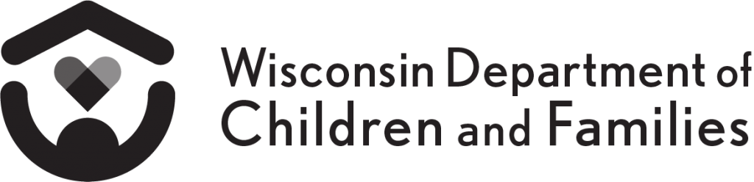
Division of Management Services Bureau of Regional Operations
YOUR RIGHTS

- You may not be treated differently because of your RACE, COLOR, NATIONAL ORIGIN, DISABILITY, AGE, or SEX (GENDER).

- You have the right to receive information in a language that you understand at no cost to you.

- If you have a disability and need program information in an alternate format, you have the right to receive it at no cost to you.

If you feel you have been treated differently by this agency because of your race, color, national origin, disability, political affiliation, religion, citizenship, age, or sex, you may file a complaint with:

(Name and Title of Civil Rights Coordinator)

(Agency)

Address:

Telephone Number: , TTY Number:

Fax: , Email:

You can file a complaint in person or by mail, fax or email. If you need help filing a complaint, (Name and Title of Civil Rights Coordinator) is available to help you.

If you are dissatisfied with the local agency’s resolution, the offices below have been designated to receive discrimination complaints at the state and federal levels.

Civil Rights Officer  Wisconsin Department of Children and Families  Division of Management Services  P.O. Box 8916  Madison, WI 53708-8916  (608) 422-6889 (Voice)  Wisconsin Relay Service (WRS) - 711 | Office for Civil Rights  U.S. Department of Health and Human Services Region V  105 W. Adams St., 16th Floor  Chicago, IL 60606  (312) 886-2359 (Voice)  (305) 353-5693 (TDD)

Your complaint must include the time, date, place, and circumstances of the alleged discrimination. There are time limits for filing a discrimination complaint that may differ with each program.

The Department of Children and Families is an equal opportunity employer and service provider. If you have a disability and need to access services, receive information in an alternate format, or need information translated to another language, please call the Civil Rights Unit at 608-422-6889. Individuals who are deaf, hard of hearing, deaf-blind, or speech disabled can use the free Wisconsin Relay Service (WRS) – 711 to contact the department.

