ebtEDGE Provider Portal Account Instructions
New Providers: If you do not currently receive subsidy funds from the state, please start at step 2 below to get ebtEDGE access. You will submit the necessary contract and ACH payment information within the ebtEDGE portal to get emergency funds from the state.
Existing providers: If you are an existing provider currently receiving subsidy payment and your bank account information on file with FIS is up to date, you do not need to access ebtEDGE to receive emergency funds. You can check the status of your emergency payment via the DCF provider portal.
If you are an existing provider currently receiving subsidy funds and you need to update your bank account information please fill out the attached provider bank information change form and submit via email: Merchant.Services.Support@fisglobal.com, Fax: 1-414-341-7085 or mail to the address listed at the top of the form.
If you would like to regain access to ebtEDGE if locked out, please start with step 1 below.
If you have not used your account in 90 days---your account is locked and cannot be reset! (FIS cannot reset ebtEDGE accounts even for the account admin OR the director). If this has occurred, you must create a new account using a new email address.
If you are attempting a password reset and the system is not accepting a password reset for your username/account, it is easiest to create a new account. You must use a new email address to register a new account.
If you are having trouble accessing your FIS account, first try to reset your current account:
- Visit ebtEDGE here: https://www.ebtedge.com/gov/portal/ProviderLogon.do
Click on “Did you forget your password?”
Follow the steps to reset your password

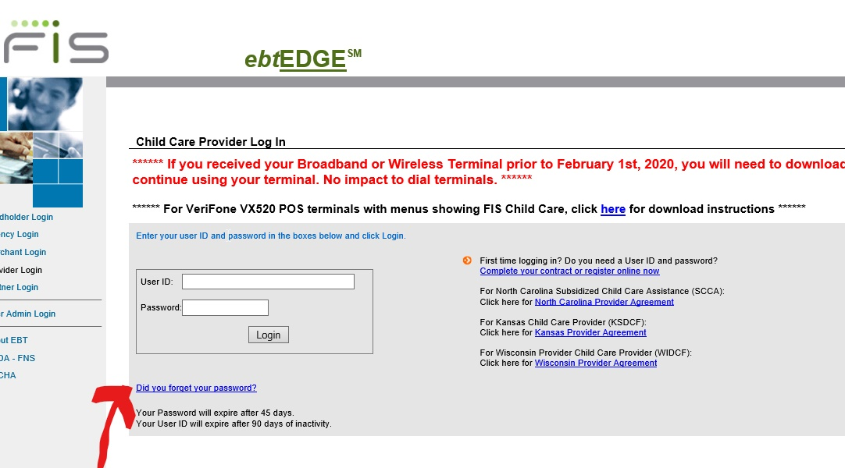
*If the reset your password function does not work for you, you need to create a new account. Follow the steps below to set up a new account:
- If you are the account admin, or have been authorized to create an account for the account admin, create an account on ebtEDGE provider login site by visiting:
https://www.ebtedge.com/gov/portal/ProviderLogon.do

(On the right side) click complete your contract or register online now
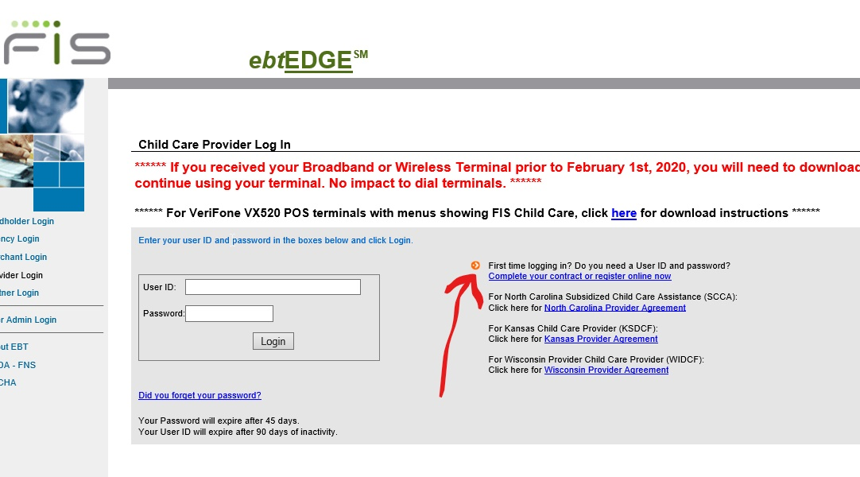

- It will take you to the Provider Registration page
- FIS Provider ID
- Phone number you used to register with the state (Provider Phone #)
- State or Program: Select MyWIChildCare-Add New User ID
- Enter & Re-enter User ID (Email address you access frequently) It cannot be an email address of the account that got locked due to 90 days of inactivity. It must be new.
- Password (One Uppercase-One Lowercase-NO special characters, at least one number) Minimum 8 characters, no more than 14.
- Re-enter password
- Answer ALL three security questions
- Select continue
- Follow next instructions to finalize set-up
- Navigate through EBT Edge!

If you continue to have issues after following the above steps, please contact the DCF Child Care Call Center: ChildCare@wisconsin.gov

