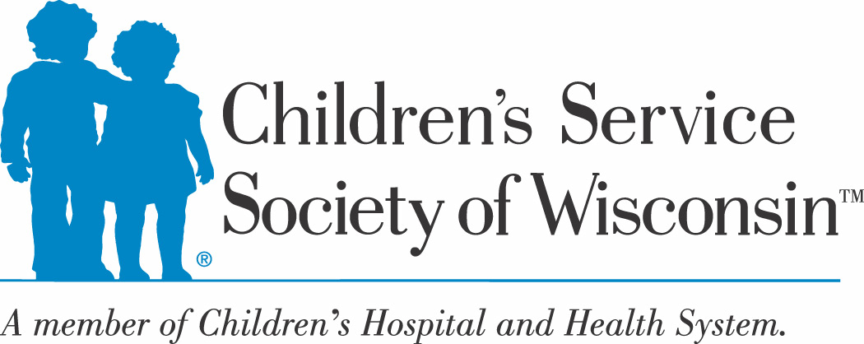



In Memory of Robyn Hitchman

The Robyn’s Nest Form

The Robyn’s Nest is located at the south east corner of the parking lot behind the office building at 620 S. 76th Street. Please enter the parking lot at 74th and Main for easiest access.

**_______________________________________________________________________________________________**

**Section A: 76th Street Employees ONLY**

Date:       Employee Name:

Please check your dept: Counseling Family Preservation FCM  FSS

Licensing & Placement Recruitment  TFC Well-being

______________________________________________________________________________________________________

**Section B: Off-Site Employees ONLY**

Date:       Employee Name:

Please check your dept**:** CCHP Community Navigators School Nurses Project Ujima

Clinical Navigators

For **Children’s Hospital of Wisconsin Social Workers** only:

Client will call Lona Long Velasco to set up an appointment

**Section C: Community Partners ONLY**

Date:       CHWCS Foster Parent Name:

Name of worker with the Foster Parent

Foster Parent made an appointment with Lona Long Velasco

DMCPS Initial Assessment Worker Name:

Worker requests this appointment date and time with Lona Long Velasco

SaintA Ongoing Case Manager Name:

Foster Parent Name:       Biological Parent Name:

Worker requests this appointment date and time with Lona Long Velasco

**\* Please note appointment dates and times scheduled are subject to the availability of Lona Long Velasco**

**Section D**: **ALL MUST COMPLETE THIS SECTION**

Number of Children in the Family being served:       Number of Adults being served:

Items Requested (include gender and size):

Reason for Request (ex: new placement detained with no clothing, needs seasonal clothing, etc):

**_______________________________________________________________________________________________**

**Email requests to Lona Long Velasco at Llongvelasco@chw.org**

**For emergency requests, call Lona at desk 414-231-4820 or work cell 414-758-4629 or Laura at 414-231-4871**