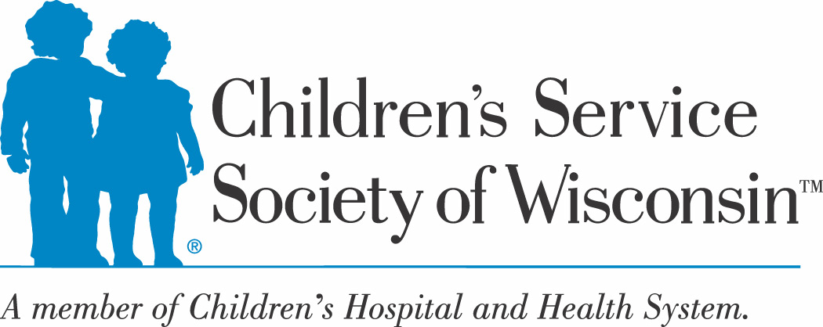

The Robyn’s Nest
Resource Request Form
620 S. 76th St. In Memory of Robyn Hitchman

Please complete one form for each child

Date of Request:

Employee Making Request:

Employee Phone/Email:

Employee Organization/Program/Region:

Items Requested (include gender and size):

Family/Child Name:

Reason for Request (ex: detained with no clothing):

Select one:

Worker will pick up at CSSW 76th St. front desk on (date)

Worker will come and select items on (date)

Worker will bring client to select items on (date)

Email requests to Laura Goba at Laura.Goba@cssw.org
For emergency requests, call Laura at 414-231-4871

