DCF Application Form

Use of form: Use of this form is mandatory. If the requested information is not provided, the department will be unable to process your application. Personal information you provide may be used for secondary purposes [Privacy Law, §.15.04(1)(m), Wisconsin Statutes].

Application #  437002-G22-0001920 | Title  Partner Up! Grant Program
The Department of Children and Families is an equal opportunity employer and service provider. If you have a disability and need to access this information in an alternate format, need it translated to another language, or need other accommodations, please contact dcfprocurement@wisconsin.gov.

Introduction:
The Wisconsin Department of Children and Families (DCF) Division of Early Care and Education (DECE) is awarding funding to expand access to high-quality, affordable care, allowing Wisconsinites to enter and remain in the workforce. Using Child Care and Development Fund (CCDF) discretionary funds available through the Coronavirus Response and Relief Supplemental Appropriations Act (CRRSA) and the Preschool Development Grant (PDG), DCF is providing child care assistance to families and supporting child care providers with additional funds to prevent, prepare for, and respond to COVID-19. Specifically, DCF is using CRRSA funds to launch the Partner Up! Grant Program (the “Partner Up! Program”). The Partner Up! Program is designed to encourage businesses in essential workforce sectors to secure slots for their employees at local regulated child care providers. Under the Partner Up! Program, essential workforce businesses that secure slots for their employees will have their contributions matched by DCF.

DCF is soliciting applications from either a single government or non-profit organization, or from collaborating government or non-profit organizations, to become the Grant Administrator(s) of the Partner Up! Program. One Grant Administrator will be selected for each of the five child care regions. (A map of the five child care regions is included as Appendix A.) The Grant Administrator(s) will create partnerships between Wisconsin businesses in essential workforce sectors and existing regulated child care providers.

In addition, selected Grant Administrator(s) will be responsible for administering the program using DCF guidelines, including, but not limited to:
- selecting participating essential businesses,
- connecting essential businesses with existing regulated child care providers,
- managing contracts,
- providing technical assistance to essential businesses and child care providers, and
- making payments to the selected child care providers.

The Grant Administrator(s) will enter into agreements with the selected essential businesses and regulated child care providers. Through these agreements, the essential businesses will secure child care slots at a pre-determined monthly amount for pre-determined lengths of time from regulated child care providers. Regulated child care providers will receive payment for the slots as determined in the contract. DCF will contribute up to 75% of the true cost of care for each child care slot, with the businesses contributing a minimum of 25% of the true cost of care, as further described in the Budget below. The contracts for slots may be for a maximum of 12 months, with the possibility of a renewal year.

Funds are also available to Grant Administrator(s) to strengthen public-private partnerships through the creation of Business-Child Care Advocate positions. The selected Grant Administrator(s) for each of the five child care regions, will employ a Business-Child Care Advocate to conduct outreach for the Partner Up! Program to essential businesses, connect essential businesses and regulated child care providers, and provide technical assistance to essential businesses interested in supporting their employees with access to high-quality child care.
__________________________________________________________________________________________________________________
Program Objective:
DCF will award Partner Up! Grants to assist low to middle income essential workers with child care support through partnerships between regulated child care providers and essential businesses. Funding will be available to support Business-Child Care Advocates to conduct outreach for the Partner Up! Program to essential businesses, connect essential businesses and regulated child care providers, and provide technical assistance to essential businesses interested in supporting their employees with access to high-quality child care.
__________________________________________________________________________________________________________________

Grant Administrator Role and Responsibilities:

The selected Grant Administrator(s) will work with essential businesses and existing regulated child care providers starting January 3, 2022 through September 30, 2023, with the possibility of limited renewal options as described below in Contract Terms.

The Grant Administrator(s) will be allocated a pre-determined amount of the total Partner Up! Program funding. Funding amounts for each region are shown in the Budget and Allocation of Funds section below. The Grant Administrator(s) will be responsible for making monthly payments for the child care slots to the participating child care provider. This monthly payment will include the DCF contribution and essential business contribution of the monthly cost for the child care slots. The Grant Administrator(s) will invoice and collect the monthly amount that the essential business has agreed to contribute, as defined in the contract. DCF will reimburse the Grant Administrator monthly the costs associated with the administration of the program.

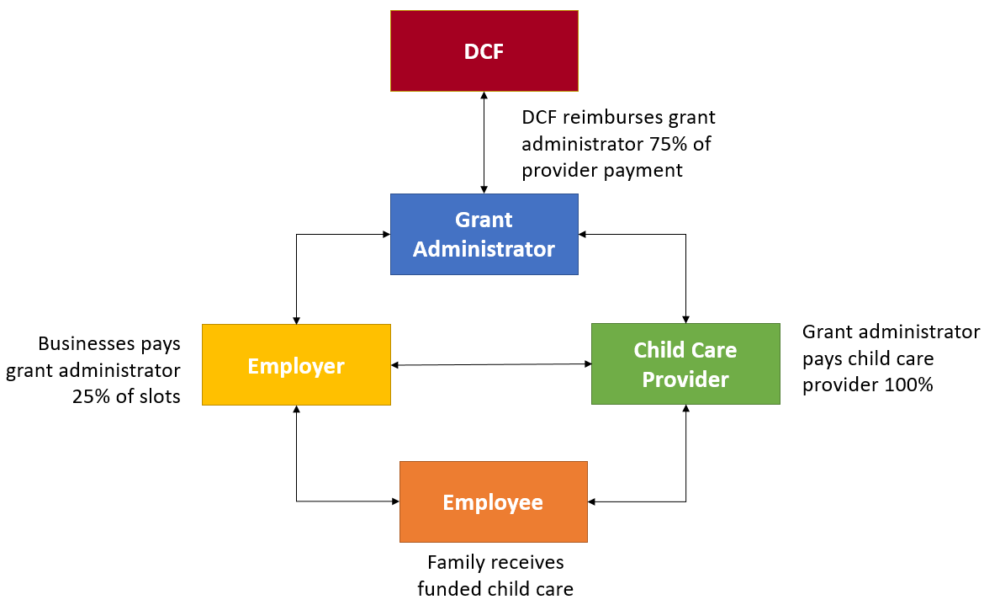

The cost of the child care slots will be set by DCF, as detailed in the Budget and Allocation of Funds section below and is reflective of the true cost of providing high-quality care. The Grant Administrator(s) will be responsible for monitoring and collecting documentation from child care providers for the quality enhancement portion of the funding.

Eligibility requirements for the Grant Administrator(s) include, but are not limited to:
- Experience administering a grant program, including the ability to describe each process in the administration.
- Regional presence in economic development or workforce development.
- Working relationships with businesses and regulated child care providers to connect these groups to fill child care slots.
- Experience with contract administration, including making payments in a timely manner to child care providers or other businesses.
- Experience running a clear and transparent grant process, including soliciting applications, evaluating applications, and making final awards.

The Grant Administrator(s) must consider certain eligibility requirements in soliciting essential businesses to participate in this program including, but not limited to:
- This program will be available to employees, contractors and other support staff working in essential workforce sectors and other workers deemed essential by public officials during the response to COVID 19.
- The target population will be low to middle-income essential worker families and does not include families currently participating in the Wisconsin Shares child care subsidy program. Participating essential businesses will be required to determine employee eligibility.

Essential businesses are defined in Appendix B.

Contract Terms:
DCF will contract with the selected Grant Administrator(s) in each region starting January 3, 2022 through September 30, 2023, with the anticipated start date of the Grant Administrator’s contracts with the essential business and regulated child care providers, beginning April 1, 2022 through September 30, 2023. A one-year renewal may be an option, subject to satisfactory performance and continued federal grant extension period. All work must be completed during this time.

Budget and Allocation of Funds:
The total amount of funding for the Partner Up! Grant is $10,000,000. In addition, a total of $1,000,000, or up to $200,000 per region, may be allocated for the Business-Child Care Advocate.

Funding will be distributed to the five child care regions statewide as shown in the following table and may be reallocated among those regions, based on needs. At least one award will be made to the top scoring applicant in each of the five regions. If applicants are interested in providing services in more than one region, they must complete a separate application for each region.

Program | Western | Southern | Northeastern | Northern | Southeastern | Total
Grant Administrator | $1,500,000 | $2,000,000 | $2,500,000 | $1,000,000 | $3,000,000 | $10,000,000
Business-Child Care Advocate | $200,000 | $200,000 | $200,000 | $200,000 | $200,000 | $1,000,000
Total | $1,700,000 | $2,200,000 | $2,700,000 | $1,200,000 | $3,200,000 | $11,000,000

*This allocation of funding is based on the number of privately owned establishments reported to the Bureau of Labor Statistics in 2020. DCF reserves the right to reallocate funding from any region that is unable to award their full allocation during the time allotted.

DCF will contribute up to 75% of the true cost of care for a child for approximately 12 months. The essential business will contribute the remaining portion of the true cost of care at a minimum of 25%.

Applicants must include their costs for administering this program when creating their budgets. The monthly true cost of care amounts below are estimates and should be used by applicants to create their budgets. These costs are subject to change at the time of contracting:

Age Group | Monthly True Cost of  Full-Time Care
0-1 year, 11 mos. | $1,800
2-year old | $1,400
3-year old | $1,100
4 & 5-year old | $1,000
6+ year old | $900

The selected Grant Administrator(s) will be responsible for contract management between the essential business and the regulated child care providers. The maximum number of child care providers that an essential business can contract with will be determined by the number of slots secured, as outlined in the table below. These numbers are subject to change and will be finalized in the DCF contract with the Grant Administrator(s).

Slots Secured | Maximum Number of Regulated Child Care Providers
1-9 slots | 3 providers
10-25 slots | 6 providers
26-50 slots | 10 providers
51-75 slots | 15 providers
76-100 slots | 20 providers
101+ slots | 25 providers

Application Requirements:
In your application, please address the following (maximum 7 pages). Application responses should be submitted in a separate Microsoft Word document from this application with 10 point Arial font, single-spaced, 1- inch margins on top, bottom, left and right. Answers should be numbered with corresponding requirements (1-6) listed below. Requirement 7 will be a separate document:

- Local data (20 points): Utilize data to describe the needs in your community. Data should include a focus on the number of essential worker families that have child care needs.
- Business Engagement (20 points): Describe how you will engage businesses in essential sectors, including how your organization will build awareness in the business community about the need for greater access to high-quality child care, conduct outreach to businesses to apply for the Partner Up! Program, and provide technical assistance to businesses interested in the Partner Up! Program.
- Equity (20 points): Describe how you will market and administer the program using an equity lens centered around community needs, to ensure grant services are accessible to all community members, and particularly to underserved populations.
- Activities (40 points): Detail the major activities you will complete to meet your community’s needs. Activities should be written as SMARTIE (Specific, Measurable, Achievable, Relevant, Time-Scaled, Inclusive, Equitable) objectives and deliverables.
  - Specific and Measurable: Define how many essential businesses, child care providers, families, and children will participate in the Partner Up! Program in your region.
  - Achievable: Describe why you believe you can achieve each activity (consider your experience, your relationships, other strengths, and resources you bring to the implementation of the activity, etc.)
  - Relevant: All applicants will be chosen based on identified local needs and how plans address those needs; connection to access, affordability, quality, and workforce.
  - Time-Scaled: Detail how you will establish contracts in 3 months and a plan for how it will be sustained during the grant period.
  - Inclusive and Equitable: Describe how services will be targeted towards low- and middle-income essential worker families while utilizing an equity lens centered around community needs.
- Collaboration (20 points): Describe how you will collaborate with businesses in essential workforce sectors and regulated child care providers. Include relationships with regional economic development organizations, workforce development boards, chambers of commerce, or other diverse business interest groups, and a description of the collaboration efforts.
- Budget Response (20 points): Describe how funds will be used for greatest impact. Include a description of current resources, both financial and personnel, available for the project. Include estimated cost to be passed through to child care providers. Note: Detailed expenses will be included in the Budget Narrative Form and do not need to be included here.
- Budget Narrative (not scored): Applications must use the provided Budget Narrative Form, Appendix C. Using the form, detail the costs associated with your plan that the Partner Up! Grant funds will directly support. As noted above, the Budget Narrative will be a separate document that is required to be submitted with the Grant Application response and will not be counted towards the 7-page maximum length. Please make sure to fill out both the Budget Proposal and Narrative tabs in Appendix C.

All seven (7) sections must be answered in your application to be considered for the Partner Up! Grant.
____________________________________________________________________________________________________________________
Reporting Requirements:
Grant Administrator(s) must report the following information monthly in a format to be provided, and submit a final report at the end of the grant period:
- Number of essential businesses and child care providers contracted with
- Monthly amount of funding dispersed to child care providers
- Monthly amount of funding spent on program administration
- New and strengthened partnerships
- New or improved processes and procedures
- Number of businesses, children, and families served
- Lessons learned
Additional reporting measures may be negotiated and dependent on the program.

Evaluation:
Applications will be evaluated through a point scale given to the 6 individual application sections based on the Application Requirements listed. Applications will be evaluated and graded by a team of evaluators. The applicant with the highest score in each region (Northern, Northeastern, Southeastern, Southern, and Western) will be funded.
Issue Date  November 15, 2021 | Due Date  December 3, 2021

DCF Contact Name  Luke Reible | DCF Contact Phone  608-422-6389 | DCF Contact Email  dcfprocurement@wisconsin.gov
Grantees will be expected to sign a contract. Most will be signing the DCF Standard Contract. For situations where the Standard Contract is not required, the DOA Standard Terms and Conditions will apply. Some awarded applicants may be asked to establish their financial stability. Samples of all can be found on our DCF Grant Opportunities Page. https://dcf.wisconsin.gov/doingbusinesswith/applications

APPLICANT INFORMATION

Legal Applicant/Organization Name |  |  | Telephone Number
Applicant Contact Name |  |  | DUNS Number
Applicant/Organization Mailing Address (Street, City, State, Zip Code)

Applicant Contact Email Address

We certify that everything in the application is true to the best of our knowledge and we will adhere to the requirements of the application and the resulting contract.
Name of Authorized Company Representative: | Title of Company Representative: | Phone of Company Representative:
Signature of Company Representative: | Date Signed | Email of Company Representative:

