Child Care Counts: Stabilization Payment Program Round 2 Program C: Promoting Inclusive Spaces Spending Tool
Child care providers are encouraged to use this document to help track spending of the Child Care Counts Program C payment. The Program C payment must be completely spent within 180 days of the date the Payment Letter. This is different than Programs A and B, which must be spent within 120 days of the Payment Letter.
This document can be filled out using Word, Google Docs, or by printing and filling it in by hand. To use this document, you will need the March 2023 Payment Letter. This can be found in your Child Care Provider Portal.
An example for how this document could be filled out, is provided below. This is an optional tool to help you track spending. You must save all receipts for how funding was spent. If selected for an audit, those will be needed as proof that funds were spent according to terms and conditions and within the spending time frame.
Please see the Child Care Counts Round 2 Spending Tool in the “Resources - Videos, Guides, and Tools” section of the Child Care Counts webpage to track any payments for Program A and B.

EXAMPLE: Payment Program C: Promoting Inclusive Spaces
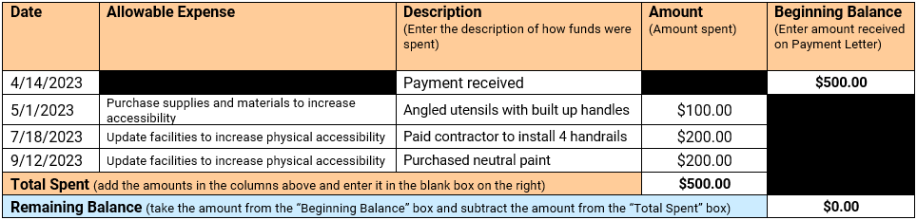

March 2023 Payment Program C
Note: All Child Care Counts Program C funds received for the March payment, must be spent by October 11, 2023.
Scroll down in the worksheet to view the sum of the total amounts spent and your remaining balance.
Date | Allowable Expense  (See Terms & Conditions for a full list of allowable expenses) | Description  (Enter the description of how funds were spent) | Amount  (Amount spent) | Beginning Balance  (Enter amount received on Payment Letter)
4/14/2023 |  | Payment received
Total Spent (add the amounts in the columns above and enter it in the blank box on the right)
Remaining Balance (take the amount from the “Beginning Balance” box and subtract the amount from the “Total Spent” box)
March 2023 Payment Program C Tracking Page 1/1

