ANNUAL REPORT: CHILD CARE LICENSING AND CERTIFICATION ACTIVITY
January – December 2019

The mission of the Bureau of Early Care Regulation (BECR) is to promote and protect the health, safety and welfare of children in child care settings. BECR works to ensure licensing requirements are met through inspections of licensed family and group child care centers, day camps, license exempt public school programs, and certified child care programs in Milwaukee County. BECR provides training and consultation to child care certifiers employed by counties, tribes and subcontracted agencies outside of Milwaukee County.

Types of regulated child care include:
- Certified Family Child Care (care for up to 3 children under age 7, but may care for a group maximum of 6 that includes day care children ages 7 and older and/or the provider’s own/related children under the age of 7)
- Licensed Family Child Care (up to 8 children under the age of 7)
- Licensed Group Child Care (9 or more children under the age of 7)
- Day Camp (seasonal program for 4 or more children ages 3 and up)
- License exempt public school child care programs (operated by or under contract with public school districts)

Together, licensed, certified and license exempt public school child care programs served over 266,000 children in Wisconsin in 2019.

Highlighted Accomplishments in 2019
- BECR conducted over 8,700 on-site visits to monitor over 4,000 licensed and license exempt public school facilities. Licensing staff verified compliance with administrative rules and provided technical assistance, completed over 1,400 complaint investigations of licensed and unlicensed programs, and reviewed and closed over 1,500 self-reported incidents and injuries involving a child in licensed care.
- BECR issued over 1,250 enforcement actions.
- Over 480 certified child care providers received over 1,000 on-site visits by certifiers and BECR Southeastern Regional Office staff.
- BECR licensing specialists reviewed over 1.4 million rules at licensed child care centers. Approximately 98% of the rules reviewed by BECR were met by licensed centers, with less than 2% resulting in a violation.
- BECR continues to monitor child care centers for compliance with health and safety rules annually as required by the federal Child Care and Development Block Grant. In 2019 99% of child care centers were monitored for all health and safety rules.
- BECR completed and implemented an emergency rule revision to ensure the Department’s licensing and certification rules complied with the health and safety requirements found in the Child Care and Development Block Grant (CCDBG) Reauthorization Act of 2014. The revision also regrouped rules that addressed the same topics in different places, eliminated duplicative revisions, corrected errors, incorporated state statutory requirements, and clarified language to ensure consistent implementation and administration of the health and safety requirements.
- BECR staff completed 33,858 FBI background checks to comply with the expanded CCDBG requirements, a 2,000% increase in the number of background checks completed compared to the previous year.
- BECR continues to collect feedback from child care license applicants, current licensees and closed providers through customer satisfaction surveys. In 2019, 362 child care applicants and licensees completed the voluntary survey. The results of the survey speak positively about the quality of the services BECR delivers, with 95% of respondents indicating their licensing specialist identified the purpose of the visit, was professional and courteous, and clearly explained the results of the visit.
- Ten computer-based training modules for licensing staff are now being offered on the internal DCF training website. Topics include use of authority, vehicle safety alarms, complaint investigations and enforcements. Additional training addressing background checks is accessible on the public-facing Child Care Background Check website.

The remainder of this report provides information on numbers of regulated child care centers, capacity, estimated number of children served, monitoring, complaint and enforcement activity, frequently cited violations and background checks.
Licensed Providers, Capacity and Estimated Enrolled Children

As of December 31, 2019, there were 3,902 licensed child care centers and day camps in Wisconsin. Of the 3,902 licensed centers, 57% (2,246) were licensed group centers, 40% (1,551) were licensed family centers and (3%) 105 were licensed day camps. The overall number of licensed child care facilities operating in 2019 decreased by close to 2% compared to the number of facilities operating in 2018 (3,975). The number of group child care centers decreased by 1% between 2018 and 2019, while the number of family child care centers dropped by 3% during this same period. The number of day camps remained nearly the same during this period.

An estimated 232,847 children were served in licensed child care centers and day camps in 2019. The following charts show the number of licensed providers and capacity in 2019, estimated enrolled children, and the change over time in number and total capacity of providers.

 | Total No. of Providers | Total Daytime Capacity | Total Night-time Capacity | Estimated Number of Enrolled Children*
Licensed Group | 2,246 | 143,092 | 8,648 | 201,814
Licensed Family | 1,551 | 12,317 | 848 | 17,509
Licensed Day Camps | 105 | 10,168 | 0 | 13,523
TOTAL | 3,902 | 165,577 | 9,496 | 232,846
*The estimated number of enrolled children in licensed care is calculated by multiplying licensed capacity by 1.33. Due to part-time care, licensed slots are often filled by more than one child.
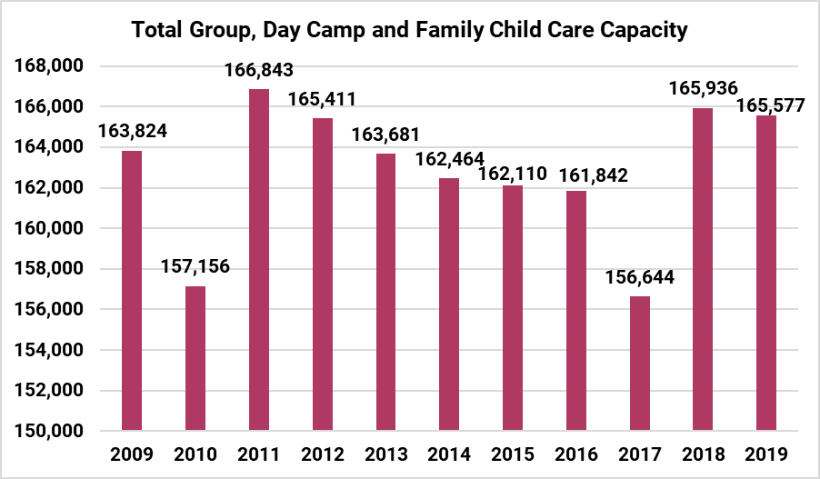
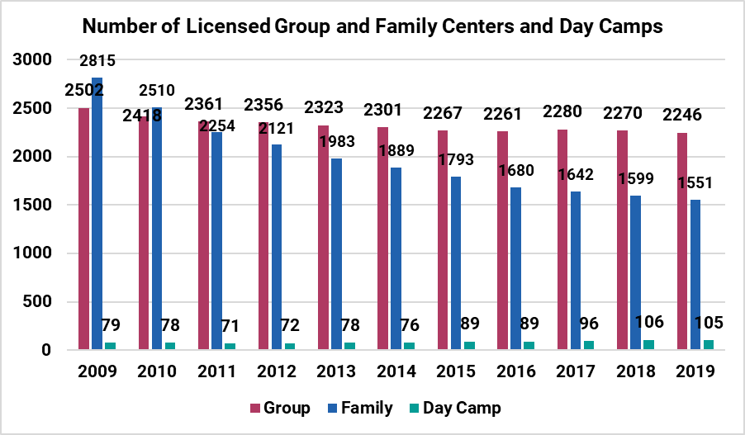

License Exempt Public School Programs

Wisconsin’s license exempt public school programs are child care programs operated by or under contract with public school districts. Pursuant to Wis. Stat. § 120.13(14), a child care program established and provided by a school board is not required to be licensed but must comply with the applicable child care licensing standards governing the operation of licensed group child care centers. BECR is the designated state agency responsible for monitoring license exempt programs receiving Wisconsin Shares. As of December 31, 2019, there were 182 license exempt programs subject to annual monitoring by BECR licensing specialists. These programs had a capacity of 22,842 and served approximately 30,380 children in 2019.

Serious Injuries and Deaths in Child Care

There were 1,378 serious injuries (injuries that required medical evaluation and/or treatment) in licensed, license exempt and certified child care centers during 2019. There were 1,254 injuries in group child care, 63 injuries in family child care, 36 in day camps, 20 in license exempt public school programs and 5 in certified care. During the same year, there were one death in licensed child care centers and one death in certified care.

Eighteen referrals for child protective services investigation resulted in a substantiated finding of child abuse or neglect. All eighteen substantiations occurred while the child was in the care of a licensed child care center.

New Applications

During 2019, the BECR regional office staff received and processed 233 new applications for licensure, a decrease of nearly 8%. Of these applications, BECR approved 192 of them (82%). There were 171 applications to provide certified care during this same time period, a decrease of nearly 15%. Of these applications, 119 applications (70%) were approved.

Licensing Monitoring Activities

There are 54 BECR licensing/certification specialists (51.3 full-time equivalent) responsible for monitoring licensed centers, license exempt programs and certified providers in Milwaukee County. Each specialist’s caseload includes a mix of providers. As of December 2019, the average caseload is 80 child care programs per specialist.

Throughout the year, BECR staff is involved in opening new and relocated licensed child care centers, closing licensed centers and conducting routine monitoring of others. Child care centers and camps must be visited at least once per year by a licensing specialist to monitor for compliance with the administrative rules. In practice, the average number of visits to centers is nearly two per year. Licensing specialists also complete an annual review of all health and safety rules identified in ten areas designated critical to the protection of children in care.

BECR conducted 9,322 visits to licensed centers and license exempt public school programs to monitor, provide technical assistance, verify compliance, review accident/incident reports and investigate complaints. An additional 211 visits were made to unregulated child care locations in response to allegations of unlicensed care. In addition, licensing specialists attempted 602 visits in which they were unable to gain entry during the center’s licensed hours of operation.

The following table shows the number of visits/reviews of child care providers in 2019, by reason type.
Purpose of the Visit/Review | Number
Monitoring for Licensing | 5,888
Complaint Regarding Licensed Center | 1,545
Initial Licensing Study | 504
Other Contact/No Site Visit | 487
Technical Assistance for Licensed Facility or License Exempt Program | 313
Complaint Regarding Unlicensed Center | 211
Offsite Record Review | 206
Enforcement Action Compliance Verification | 114
License Amendment | 101
Verification of CFS-294 | 98
Vehicle Alarm Check Only | 55
Pre-licensing Technical Assistance | 11
TOTAL NUMBER OF VISITS/REVIEWS | 9,533

Licensing Complaints

BECR received 1,232 complaints concerning licensed child care centers in 2019. This compares to 1,448 complaints in 2018, a decrease of 15% between 2018 and 2019.

In 2019, BECR substantiated 677 complaints regarding licensed child care, while 470 complaints were unsubstantiated. A complaint is considered substantiated when at least one of the allegations contained in the complaint results in issuance of a rule violation.

BECR received 283 complaints alleging unlicensed child care in 2019. BECR closed 257 of these complaints, with 168 unsubstantiated and 89 substantiated.

The following two charts reflect the number and status of complaints, and the variation in number of complaints over time.

 | Received | Closed | Substantiated | Unsubstantiated
Licensed Complaints | 1,232 | 1,147 | 470 (41%) | 677 (59%)
Unlicensed Complaints | 283 | 257 | 89 (35%) | 168 (65%)

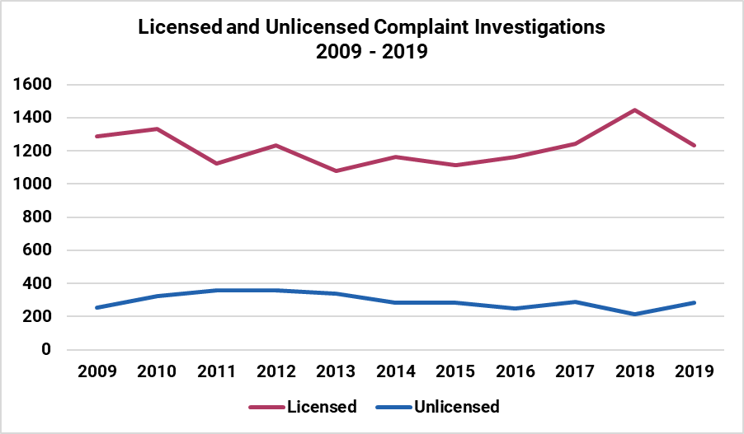

Enforcement Activity with Licensed Centers

Enforcement actions are initiated when, because of the severity of violations and/or a pattern of repeated violations, the health, safety and welfare of children in care is at risk. Progressive enforcement refers to a series of actions taken to gain compliance with administrative rules when previous efforts, such as citing the violation or providing technical assistance, have not worked. Enforcement actions are authorized in statute and can ultimately lead to revocation of a license.

In 2019, there were 1,252 enforcement actions. The following two charts show total number of licensing enforcement actions since 2009 and the types of enforcement actions issued in 2019.

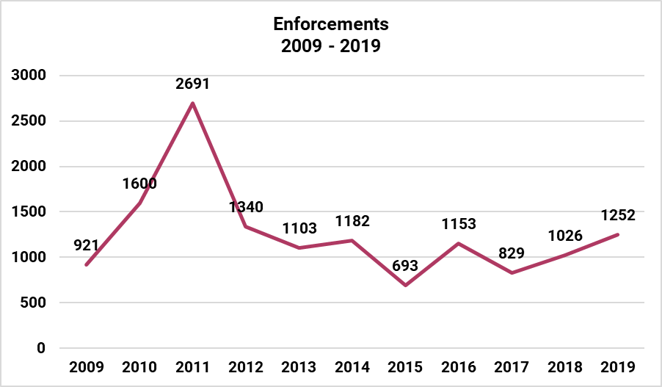
Note: Warning Letters issued to licensees for failing to submit an annual Background Information Disclosure form, a new statutory requirement at that time, caused the significant spike in 2011.

Licensing Enforcements Issued in 2019
Warning Letters | 421
Orders/Stop Operating Orders | 384
Forfeitures/Direct Forfeitures | 275
Revocations | 122
Second Probationary License Due to Noncompliance | 29
Denials | 19
Summary/Temporary Suspensions | 2
TOTAL | 1,252

Most Frequently Cited Licensed Child Care Rule Violations

In 2019, the top five most frequently cited rule violations in licensed family child care centers were:
- Current, Accurate Daily Attendance Record
- Child Record – Enrollment and Health History Forms
- Biennial Training – Child Abuse and Neglect
- Access to Materials Potentially Harmful to Children
- Potential Source of Harm on Premises

In 2019, the top five most frequently cited rule violations in licensed group child care centers were:

- Biennial Training – Child Abuse and Neglect
- Cardiopulmonary Resuscitation Training
- Child Tracking Procedure
- Child Record – Enrollment Information
- Current, Accurate Daily Attendance Record

In 2019, the top five most frequently cited rule violations in day camps were:

- Compliance with Laws
- Child Tracking Procedure
- Staff File – Pre-Camp Training
- Cardiopulmonary Resuscitation Training
- Accessible Toxic Substances

Attachment A provides a listing of the twenty most frequently cited licensed child care rule violations in family and group centers and day camps in 2019.

Number and Capacity of Certified Child Care Centers

As of December 31, 2019, there were 482 certified family child care providers. This is a 17% decrease in certified providers, compared to 2018. An estimated 2,892 children were served in certified child care in 2019.

The following table shows the number of certified child care centers and estimated number of children enrolled in certified care in 2019.
 | Total No. of Providers | Maximum Group Size | Allowable Number of Children Under the Age of 7 | Estimated Number of Enrolled Children*
Certified Family | 482 | 6 | 3 | 2,892
* The estimated number of enrolled children in certified family care is calculated by multiplying the number of providers by the maximum group size of 6.

Certified Provider Monitoring

Monitoring of certified family child care is conducted by BECR licensing specialists (for Milwaukee County certified programs) and certifiers employed by the counties, tribes and subcontracted agencies in the balance of the state.

Certifiers completed 1,015 on-site visits of certified centers in 2019 to monitor, provide technical assistance, verify compliance and investigate complaints. All certified providers must receive one unannounced monitoring visit each year.

In addition to 1,015 visits/reviews of certified centers in 2019, certifiers made 163 attempted visits to centers throughout the year but were unable to gain access.

The following table shows the number of visits made to certified child care centers in 2019, by reason type. Certifiers also conducted 162 desk reviews.

Purpose of the Visit | Number
Annual Visit/Monitoring/294 Verification/Other | 550
Re-Certification Visit | 174
Initial Provider Visit | 160
Technical Assistance Visit | 43
Complaint Visit | 38
Relocation Visit | 27
Vehicle Alarm Check | 12
Expired Re-Certification Visit | 11
TOTAL | 1,015

The following table shows the enforcement actions issued to certified programs in 2019.
Certification Enforcements Issued in 2019
Revocations | 14
Warning Letters | 14
Suspensions | 5
Denials | 5
TOTAL | 38

Child Care Background Checks

As of October 1, 2018, the BECR Child Care Background Unit (CBU) implemented new background check provisions required under the federal Child Care Development and Block Grant Reauthorization Act of 2014. Under the new requirements, all caregiver and noncaregiver child care employees and household members age 18 or older must undergo a DCF fingerprint-based background check every five years to be eligible to operate, work at, or reside in a child care center. To meet these new responsibilities, the number of CBU staff devoted to process and review background checks has been increased to 33 contract staff, 2 LTE staff, and 11 FTE staff. During 2019, the CBU completed 33,858 FBI background checks and 646 name-based Wisconsin Department of Justice background checks. This compares to 1,610 FBI background checks and 5,650 Department of Justice background checks completed in 2018.

Attachment A

Twenty Most Frequently Cited Family Child Care Violations – 2019

Violation Code | Description | Total
250.04(6)(b) | CURRENT, ACCURATE DAILY ATTENDANCE RECORD | 278
250.04(6)(a)1. | CHILD RECORD - ENROLLMENT & HEALTH HISTORY FORMS | 247
250.04(8)(b) | BIENNIAL TRAINING - CHILD ABUSE & NEGLECT | 214
250.06(2)(c) | ACCESS TO MATERIALS POTENTIALLY HARMFUL TO CHILDREN | 181
250.06(2)(e) | POTENTIAL SOURCE OF HARM ON PREMISES | 179
250.06(3) | PRACTICE OF WRITTEN EMERGENCY PLANS | 154
250.06(4)(a) | SMOKE DETECTORS | 150
250.06(2)(k) | DETERIORATING OR TOXIC PAINT | 145
250.05(1)(b)5. | PROVIDER TRAINING - CARDIOPULMONARY RESUSCITATION | 141
250.04(5)(d) | STAFF FILE - DAYS, HOURS WORKED | 135
250.07(6)(L)2. | HEALTH EXAM - CHILD AGE OVER AGE 2 | 120
250.07(6)(L)1. | HEALTH EXAM - CHILD UNDER AGE 2 | 115
250.06(5) | PREMISES, FURNISHINGS, EQUIPMENT - CONDITION & REPAIR | 108
250.04(6)(a)4. | CHILD RECORD - IMMUNIZATION HISTORY, PHYSICAL EXAM | 103
250.05(1)(b)4. | PROVIDER TRAINING - CONTINUING EDUCATION | 86
250.06(2)(a) | ELECTRICAL OR HOT SURFACE PROTECTION | 83
250.04(2)(a) | COMPLIANCE WITH LAWS | 75
250.05(3)(L) | PROCEDURE - NUMBER, NAMES, WHEREABOUTS KNOWN AT ALL TIMES | 72
250.07(5)(d) | MEALS & SNACKS - RECORDS | 69
250.09(4)(b) | INFANT & TODDLER - DIAPER CHANGING SURFACE - DISINFECTION | 69

Twenty Most Frequently Cited Group Child Care Violations – 2019
Violation Code | Description | Total
251.04(8)(b) | BIENNIAL TRAINING - CHILD ABUSE & NEGLECT | 379
251.05(1)(c) | CARDIOPULMONARY RESUSCITATION TRAINING | 367
251.05(3)(f) | CHILD TRACKING PROCEDURE | 322
251.04(6)(a)1. | CHILD RECORD - ENROLLMENT INFORMATION | 302
251.04(6)(b) | CURRENT, ACCURATE DAILY ATTENDANCE RECORD | 299
251.09(1)(c) | INFANT & TODDLER - DOCUMENTING CHANGES IN DEVELOPMENT | 287
251.06(2)(d) | ACCESS TO MATERIALS POTENTIALLY HARMFUL TO CHILDREN | 286
251.04(2)(a) | COMPLIANCE WITH LAWS | 281
251.04(5)(a)5. | STAFF FILE - REGISTRY CERTIFICATE, EDUCATIONAL QUALIFICATIONS | 269
251.05(1)(L)1. | STAFF HEALTH EXAMINATION - REQUIREMENTS | 268
251.07(6)(j)9. | REVIEWING INJURY RECORDS | 255
251.06(2)(a) | POTENTIAL SOURCE OF HARM ON PREMISES | 250
251.04(5)(a)4. | STAFF FILE - PHYSICAL EXAMINATION REPORT | 236
251.06(9)(d)2.a. | FOOD STORAGE - DRY FOOD | 233
251.07(6)(f)1.a. | MEDICATION ADMINISTRATION - PARENT AUTHORIZATION | 220
251.06(5)(b)1. | DETERIORATING PAINT | 213
251.04(5)(a)1. | STAFF FILE - STAFF RECORD INFORMATION | 202
251.06(5)(a) | CONDITION OF PREMISES | 198
251.05(1)(b) | SHAKEN BABY SYNDROME PREVENTION TRAINING | 178
251.07(6)(f)6. | CURRENT AUTHORIZATIONS FOR MEDICATIONS ON PREMISES | 178

Twenty Most Frequently Cited Day Camp Violations – 2019
Violation Code | Description | Total
252.41(1)(a) | COMPLIANCE WITH LAWS | 19
252.42(3)(g) | CHILD TRACKING PROCEDURE | 13
252.41(3)(a)5. | STAFF FILE - PRE-CAMP TRAINING | 11
252.42(2)(e) | CARDIOPULMONARY RESUSCITATION TRAINING | 11
252.43(2)(a)6. | ACCESSIBLE TOXIC SUBSTANCES | 11
252.44(6)(e)1.a. | MEDICATION ADMINISTRATION - PARENTAL AUTHORIZATION | 11
252.41(1)(L) | MONITORING RESULTS, STIPULATIONS, CONDITIONS, EXCEPTIONS POSTED | 10
252.42(3)(a) | SUPERVISION OF CHILDREN | 10
252.05(1)(b)2. | LICENSE CONTINUATION - TIME FRAME TO SUBMIT MATERIALS | 9
252.41(4)(a)1.a. | CHILD RECORD - ENROLLMENT INFORMATION | 9
252.44(6)(h) | RECORD OF IMMUNIZATIONS | 9
252.41(4)(a)6. | CHILD RECORD - HEALTH HISTORY | 8
252.41(4)(b)2. | MEDICAL LOG - REQUIREMENTS | 8
252.43(3)(a)5. | GARBAGE CONTAINERS, STORAGE & DISPOSAL | 8
252.44(6)(e)4. | MEDICATION STORAGE - CURRENT AUTHORIZATION | 7
252.41(3)(a)1. | STAFF FILE - STAFF INFORMATION | 6
252.41(3)(a)2. | STAFF FILE - TRAINING & CERTIFICATIONS | 6
252.41(4)(a)8. | CHILD RECORD - SWIMMING ABILITY ASSESSMENT | 6
252.43(3)(a)4. | PAINTED SURFACES - LEAD FREE & MAINTAINED | 6
252.44(6)(f)2. | RECORDING & REVIEWING THE RECORD OF INJURIES | 6

