BWF System and Reporting Subcommittee Meeting Agenda
Meeting Purpose: | Discuss system changes and reporting updates
Date: | Wednesday September 9, 2026
Start Time: | 1:00 PM
End Time: | 1:50 PM
Location: | TEAMS
Call Information: | Meeting Link Meeting ID 259 955 769 385 4; Passcode: nz6Qh7fL  Dial in by phone: +1 608-571-2209 Passcode: 537271251#

Attendees
X | Basken, Nicholas-DCF |  | Blada, Holly-DCF |  | Bozich, Adam
x | Buscon, Devon-DCF |  | Camacho, Nestor-DCF | x | Chase, Michael-DCF
x | Dinakaran, Bhavani-BITS | x | Doudna, Denise-DCF |  | Doudna, John-DCF
 | Downing, Charlotte |  | Edwards, Kimberly-DCF | X | Evert, Audrey-DCF
 | Fawcett, Jamie-DCF |  | Fornes, Joseph-DCF |  | Foster, Brianna- DCF
X | Geisler, Samantha-DCF |  | Girard, Justine-DCF |  | Girard, Justine-DCF
x | Griffith, Jake-DCF | x | Hammes, Heidi-DCF | x | Hagemann, Trina- BITS
 | Harms, Katherine-DCF |  | Horn, Patara-DCF |  | Hauer, Zulema-DCF
 | Jones, Sasha-BSO | x | Kahl, Jane-DCF |  | Kristiansen, Tonya-DCF
 | Lee, Jordan-DCF |  | Mealy, Stephanie | X | Milligan, Luke-BITS
 | Moss, Jessica-DCF | X | Nartowicz, Joseph-DCF | x | O’Connell, Rober-DCF
 | Olmsted, Morgan-DCF | x | Orcholski, Tiffany-DCF |  | Purcell, Maureen- DCF
x | Raemisch, Audrey-DCF |  | Scott, Luz-DCF |  | Seery, Ginger-DCF
X | Sperber, Roxanne-DCF |  | Theo, Gina-DCF |  | Thompson, Tonja-DCF
 | Thor, Neng-DCF | x | Thornton, Tony-DCF | x | Tessmann, Abby- DCF
X | Tucker, Monica-DCF | X | Westbury, John- BITS | X | Whitehead, Robert-DCF
 | Wisneski, Xong-DCF | x | Xiong, Mai Yee-DCF | x | America Workers
x | Equus | x | FSC |  | Maximus
x | ROSS | x | UMOS | x | WCI
x | WRI | x | Chappa, Kelsey-DCF | x | Haase, Rachel-DCF
x | Hilsgen, Sally-DCF | x | Anumula, Dinesh-BITS | x | Chakravarthy, Karthik-BITS
x | Azad, Amie- DCF | x | Marmon, Meena- DCF

Agenda

Roll Call

Report Updates (Bureau of Analytics and Research (BAR))-Rob O’Connell
- WebI update-first week of November 2026
- Communication will be sent out when it happens.
- If agencies have not replied to survey that Molly sent out, please try to complete survey for BAR to get a better understanding of what is in the folders
  - Survey was sent out week of 9/7/2026
- Team is doing initial testing with the reports for the migration and everything is going smoothly

System Updates-Automation Team-Automation Team

WWP October Release: 10/30/2026
- Add replacement check number search to Payment Issuance Search
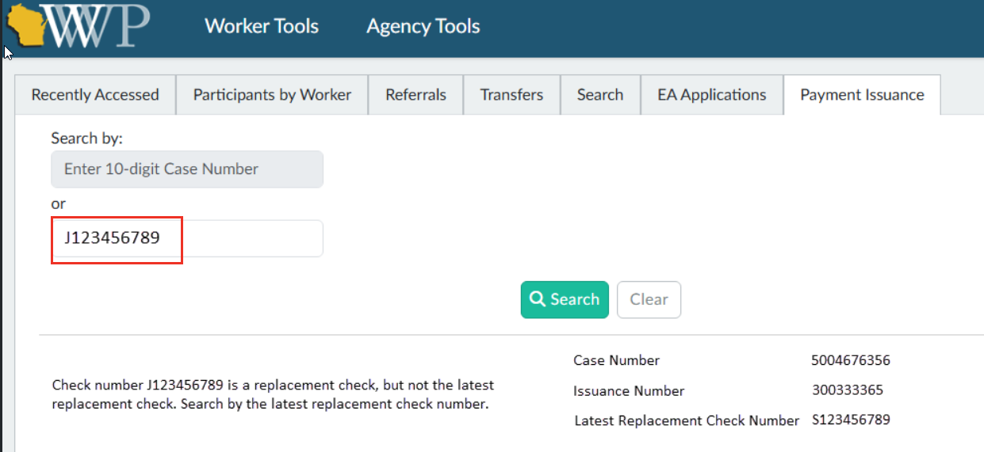
- Refugee Page-yellow alert message language updated
“This participant may be eligible to apply for Refugee Medical Assistance, depending on their circumstances. Information on RMA and the RMA application process may be found in the Bureau of Refugee Programs Policy Manual.”

Discussion Items

MyWisconsin ID-Mai Xiong
- WWP moved to MyWI ID 8/27/2026
  - Users will have from 8/27-2026-10/28/2026
  - WWP User Access Request form has been updated to reflect the change:
    - DCF Forms Repository link: https://dcf.wisconsin.gov/files/forms/doc/5212.docx
  - August System Update has links to help users to migrate their WAMS to MyWisconsin ID accounts
    - Link: August 2026 BWF System Update
- WWP Demo (BITS team)
  - Demo of linking WWP WAMS to MyWisconsin ID
    - With MyWisconsin ID account
    - User does not have a MyWisconsin ID account yet
- ACCESS ID
  - Migration of ACCESS/MyACCESS accounts away from WAMS
  - Migration will start: 12/12/2026-4/22/2027
  - Communication plan:
    - IM agencies will have messaging in the call line, when members call in
    - Question for agencies: Are there any agencies who have call lines, where participants get put into a call queue and then get routed to an actual worker for assistance?
      - Plan is to provide scripts to the agency to add messaging into the call queue mid-January 2027 (after contract changes)
    - Requested for agencies to indicate if they use a IVR type call queue and put their name in Teams chat.

New W-2 region-level access to WebI reports in WWP-Heidi
- Two Scenarios for Disenrolled Participants:
- After a PIN is disenrolled, any new system generated worker tasks will go to the FEP who was last assigned to the participant before disenrollment. If the assigned FEP is no longer with that agency, who should the worker task be generated to?
        - Tasks must be generated to a role (not a specific person). For example all W-2 Supervisors in that region or all W-2 QC in that region.
- When new contracts are implemented on 1/1/27, any new system generated worker tasks for a participant who was previously disenrolled (before 1/1/27) must go to someone at the agency currently serving the region where the participant was last enrolled. If a new agency is serving this region, who should the worker task be generated to?
        - Tasks must be generated to a role (not a specific person). For example all W-2 Supervisors in that region or all W-2 QC in that region.
    - Recommendation:
Based on votes, the recommended approach is to send the worker tasks is to the QC/QA team (for both scenario #1 and #2)

WWP Worker Task Clean-Up-Heidi
Cleaning up old uncompleted system generated worker tasks before 01/01/227
- Worker Tasks
  - Currently there is no functionality to delete system generated worker tasks if the worker does not “complete” the task in WWP
    - Proposing system change to clean up this issue
          - System auto delete all worker tasks who is inactive
          - System auto-delete after a period of time
- Agency recommendations/feedback on each option:
- No concerns with option 1
- 6 months is an ideal period
- Concern expressed: if a worker is still active, why is there a worker tasks incomplete for 6 months? Recommendation: QC should really be taking a look at these cases/worker
- Plan for production: 01/01/2027

Walk on items

The following link will bring you to minutes and attachments discussed in our meetings: https://dcf.wisconsin.gov/w2/partners/toolbox/systemsubcommittee

