BWF System and Reporting Subcommittee Meeting Agenda
Meeting Purpose: | Discuss system changes and reporting updates
Date: | Wednesday September 9, 2026
Start Time: | 1:00 PM
End Time: | 1:50 PM
Location: | TEAMS
Call Information: | Meeting Link Meeting ID 259 955 769 385 4; Passcode: nz6Qh7fL  Dial in by phone: +1 608-571-2209 Passcode: 537271251#

Attendees
 | Basken, Nicholas-DCF |  | Blada, Holly-DCF |  | Bozich, Adam
 | Buscon, Devon-DCF |  | Camacho, Nestor-DCF |  | Chase, Michael-DCF
 | Dinakaran, Bhavani-BITS |  | Doudna, Denise-DCF |  | Doudna, John-DCF
 | Downing, Charlotte |  | Edwards, Kimberly-DCF |  | Evert, Audrey-DCF
 | Fawcett, Jamie-DCF |  | Fornes, Joseph-DCF |  | Foster, Brianna- DCF
 | Geisler, Samantha-DCF |  | Girard, Justine-DCF |  | Girard, Justine-DCF
 | Griffith, Jake-DCF |  | Hammes, Heidi-DCF |  | Hagemann, Trina- BITS
 | Harms, Katherine-DCF |  | Horn, Patara-DCF |  | Hauer, Zulema-DCF
 | Jones, Sasha-BSO |  | Kahl, Jane-DCF |  | Kristiansen, Tonya-DCF
 | Lee, Jordan-DCF |  | Mealy, Stephanie |  | Milligan, Luke-BITS
 | Moss, Jessica-DCF |  | Nartowicz, Joseph-DCF |  | O’Connell, Rober-DCF
 | Olmsted, Morgan-DCF |  | Orcholski, Tiffany-DCF |  | Purcell, Maureen- DCF
 | Raemisch, Audrey-DCF |  | Scott, Luz-DCF |  | Seery, Ginger-DCF
 | Sperber, Roxanne-DCF |  | Theo, Gina-DCF |  | Thompson, Tonja-DCF
 | Thor, Neng-DCF |  | Thornton, Tony-DCF |  | Tessmann, Abby- DCF
 | Tucker, Monica-DCF |  | Westbury, John- BITS |  | Whitehead, Robert-DCF
 | Wisneski, Xong-DCF |  | Xiong, Mai Yee-DCF |  | America Workers
 | Equus |  | FSC |  | Maximus
 | ROSS |  | UMOS |  | WCI
 | WRI

Agenda

Roll Call

Report Updates (Bureau of Analytics and Research (BAR))-Rob O’Connell

System Updates-Automation Team-Automation Team

WWP October Release: 10/30/2026
- Add replacement check number search to Payment Issuance Search
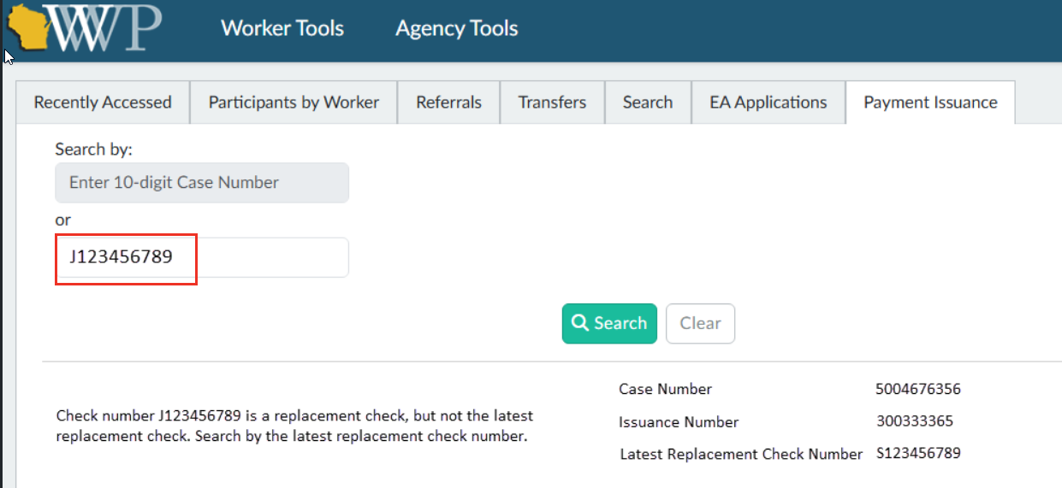
- Refugee Page-yellow alert message language updated

Discussion Items

MyWisconsin ID-Mai Xiong
- WWP moved to MyWI ID 8/27/2026
  - Users will have from 8/27-2026-10/30/2026
  - WWP User Access Request form has been updated to reflect the change:
    - DCF Forms Repository link: https://dcf.wisconsin.gov/files/forms/doc/5212.docx
  - August System Update has links to help users to migrate their WAMS to MyWisconsin ID accounts
    - Link: August 2026 BWF System Update
- WWP Demo (BITS team)
  - Demo of linking WWP WAMS to MyWisconsin ID
    - With MyWisconsin ID account
    - User does not have a MyWisconsin ID account yet
- ACCESS ID
  - Migration of ACCESS/MyACCESS accounts away from WAMS
  - Migration will start: 12/12/2026-4/22/2027
  - Communication plan:
    - IM agencies will have messaging in the call line, when members call in
    - Question for agencies: Are there any agencies who have call lines, where participants get put into a call queue and then get routed to an actual worker for assistance?
      - Plan is to provide scripts to the agency to add messaging into the call queue mid-January 2027 (after contract changes)

New W-2 region-level access to WebI reports in WWP-Heidi

WWP Worker Task Clean-Up-Heidi

Walk on items

The following link will bring you to minutes and attachments discussed in our meetings: https://dcf.wisconsin.gov/w2/partners/toolbox/systemsubcommittee

