Wisconsin Head Start State Supplement Grant
Grant Application 437002-G27-0002766
  - Your Federal Program Schedule

Steps to download your Federal Program Schedule
- Log in to HSES à Click Financials Tab à Click View under Non-Competing Continuation in the Applications section
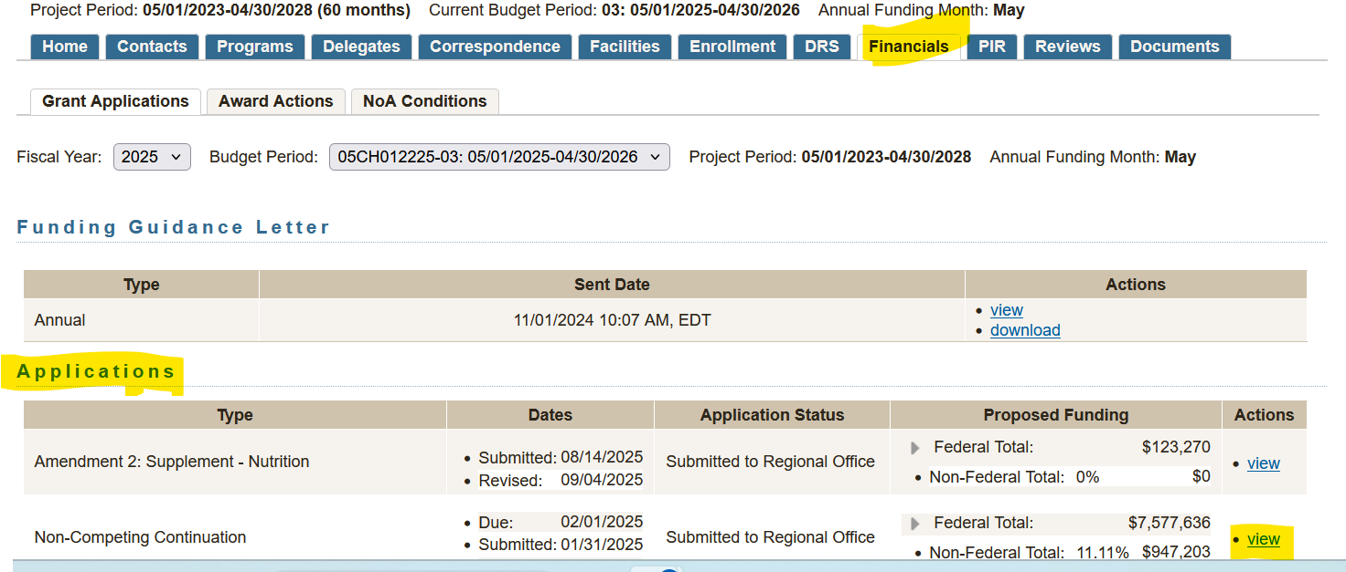
- Click on the Program Schedule tab à you should see the breakdown of enrollment and schedule for your program
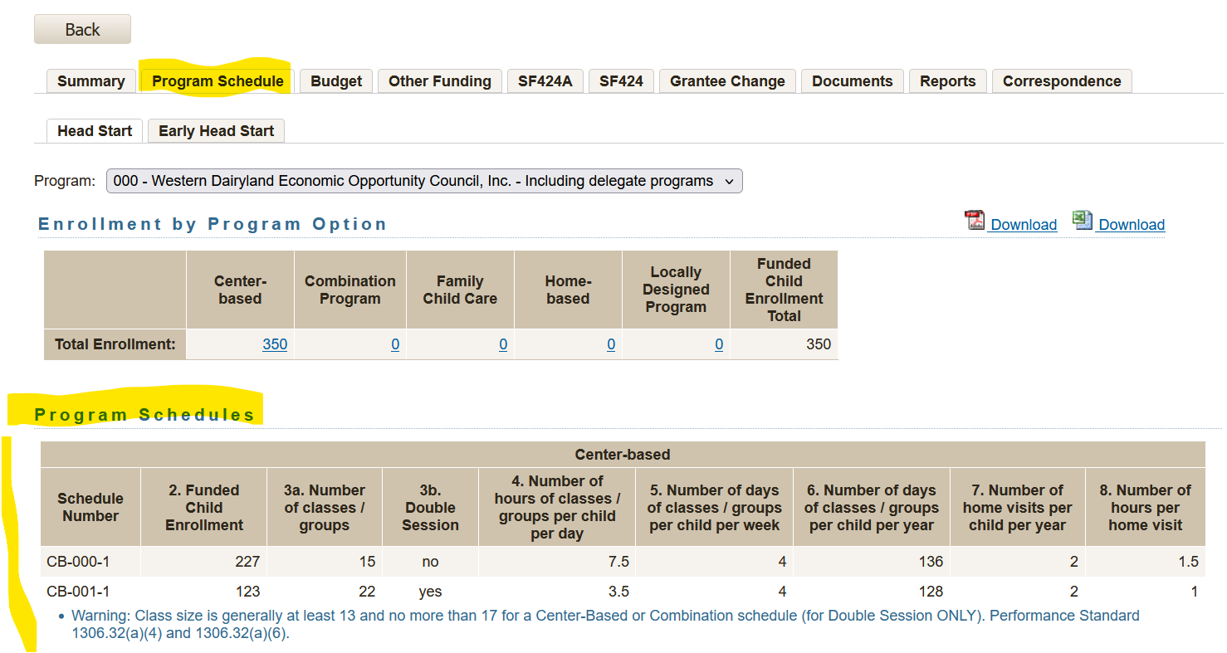
Please download the pdf version for submission with your HSSS application.

