2027-2028

Children First

Program Guide



State of Wisconsin
Department of Children and Families
Division of Family and Economic Security
Bureau of Child Support
PO Box 7935
Madison, WI 53707-7935
Table of Contents
Introduction 4
Background 4
Program Administration 4
Program Eligibility and Court Orders 5
Participation Requirements 6
Travel Reimbursement for Children First Participation 7
Children First Referral and Registration 7
Children First Data Entry and Tracking 7
Registration and Enrollment 7
Orientation 8
Assessment and Employability Plan 8
Activities 8
Activities Without CARES Codes 9
Child Support Payment Tracking 9
Documenting Case Information/Comments 9
Co-Enrollment 9
Children First Program Non-Compliance 9
Fact-Finding Procedure 10
Program Completion 11
Out-of-County NCPs 11
Children First Forms 11
Program Monitoring by DCF 11
Children First Program Funding 12
Expense Reporting 12
Expense Reporting Line Changes 13
Child Support Agency Responsibilities 14
Appendices 15
Wisconsin Statute Chapter 49.36 15
Wisconsin Statute Chapter 767.55 17
CHILDREN FIRST PROGRAM REGISTRATION FORM 18
Children First Initial Appointment Notice 19
YOUR RIGHTS AND RESPONSIBILITIES FORM 20
CHILDREN FIRST FACT-FINDING APPOINTMENT NOTICE 22
CHILDREN FIRST RECONCILIATION AGREEMENT 23
NOTIFICATION OF NON-COMPLIANCE WITH CHILDREN FIRST PROGRAM 24
Affidavit of Non-Compliance with Children First Program 25
Affidavit of Successful Completion of Children First Program 26

Introduction
Children First was developed to provide employment and job search services for noncustodial parents (NCPs) who are not paying child support due to being unemployed or underemployed. Children First participation and program requirements are explained in Wis. Stats. §§ 49.36 and 767.55. Copies of these statutes are included as attachments in this Program Guide. Research shows that when child support is paid, NCPs are more likely to be involved in the lives of their children. In addition, child well-being may be increased when both parents are involved in the life of the child. The Children First program provides services and support to encourage noncustodial parents to participate in the lives of their children.
Although the Children First program has a “work first” philosophy, a combination of job search activities as well as other services may be provided to promote self-sufficiency and responsible parenting. Per Wis. Stat. § 767.55, the NCP successfully completes the Children First program when he/she makes timely payment in full for three consecutive months or participates in the Children First program for 16 weeks, whichever occurs first.
Participation in the Children First program is court-ordered. In cases where an NCP is unable to meet a child support obligation, the court may order participation in Children First. The primary goal of the program is to improve the ability of the NCP to pay court-ordered support.
The table below provides a list of the 2025-2026 Children First counties:
Counties with 2025-2026 Children First Programs

Calumet | Outagamie
Dane | Portage
Kenosha | Racine
Marathon | Rock
Milwaukee | Sheboygan
Oneida | Walworth

Background
Children First, or the Work Experience Program for NCPs, was authorized by 1987 Wisconsin Act 413. The Children First program was implemented in 1990 in Racine and Fond du Lac counties as part of the welfare reform plan for Wisconsin. For 2025-2026, the program included 12 counties. The program guide has a map on page three of the Children First programs.

Program Administration
The Children First program is administered through the Department of Children and Families (DCF), Division of Family and Economic Security (DFES). Within DFES, the Bureau of Child Support (BCS) has oversight responsibilities for the program that include policy development and interpretation, program planning, and contract funding.
Wis. Stat. § 49.36(2) permits DCF to contract with any county agency, tribal governing body, or Wisconsin works agency to administer the program. Children First contracts are issued as separate contracts. The contract agency may elect to subcontract with other private or public agencies to conduct all or part of the Children First program activities and may direct the Children First participant to participate in other appropriate community activities. The contract agency must designate a contract administrator who is responsible for all DCF communications related to the Children First program.
Contract agencies are allowed flexibility in designing their program structure. However, all programs must comply with state statutes and state policies and procedures in administering the program. This Program Guide sets current policies and procedures.
Operation of the Children First program requires a formal partnership at the county or tribal level between the child support agency, the county/tribal judicial system, and often the W-2 agency. Partnerships are essential for the success of the program.
Consortium and/or partnership arrangements are encouraged. The contract agency must be designated as the lead agency and is responsible for the consortium or partnership. Tribal governing bodies may provide services to NCPs who reside on tribal lands and/or to other tribal members who do not reside on tribal lands.

Program Eligibility and Court Orders
Per Wisconsin statutes, participation in the Children First program must be court-ordered. In addition, the NCP must be ordered to pay current support.
Wis. Stats. §§ 767.55 and 49.36 provide the eligibility requirements for the Children First program. Copies of these statutes are found as attachments to this Program Guide. The court may order an NCP to participate in the program provided all of the following criteria are met (Wis. Stat. § 767.55) and the criteria are included as findings of the court in the court order:
- The parent is legally able to work full-time.
- The parent works an average of less than 32 hours per week and is not participating in an employment and training program.
- The parent earns less than he/she could earn or has an actual weekly gross income of less than 40 times the federal minimum hourly wage.
- The parent resides in a county with a work experience and job training program under Wis. Stat. § 49.36 and that county agrees to enroll the parent.
- The court order must establish support in the amount the parent was ordered to pay in the most recent determination of support or an amount equal to the amount determined by applying the percentage standard.
- The court order must provide that, after the obligation to make payments ordered under Wis. Stat. § 767.55 ceases, the parent must make payments calculated under Wis. Stats. §§ 767.511 (1j) or (1m).
The Kids Information Data System (KIDS) contains a Children First Court Order (EN28) document that contains all the findings/language needed to comply with the statutes as well as other documents that reference the Children First program.
Remedial Contempt Order (EN10) | path 09,13,01,03
Affidavit for Contempt (EN22) | path 09,13,01,07
Order to Show Cause (EN23) | path 09,13,01,08
Stip/Order for Contempt (EN25) | path 09,13,01,10
Children First Order (EN28) | path 09,13,01,13
Compliance Enforcement Letter (EN31) | path 09,13,02,13
Paternity Judgment-Long (PE16) | path 09,07,12
Stip/Judgment of Paternity (PE25) | path 09,07,13
Paternity Judgment-Default (PE38) | path 09,07,18
Order-Amending Judgment (RA14) | path 09,11,13
Stip/Order-Amending Judgment (RA15) | path 09,11,14
Stip/Order for Support (SE06) | path 09,09,05
Order for Support (SE07) | path 09,09,06
Participation in the Children First program does not reduce or eliminate the NCP’s child support liabilities. If the NCP fails to make payments as ordered, the unpaid amount accrues as a debt and interest is calculated.

Participation Requirements
Per Wis. Stat. § 49.36, the following restrictions are placed on NCP participation in the Children First program:
- An NCP may not be required to participate for more than 32 hours per week in the Children First program.
- An NCP may not be required to participate for more than 16 weeks during each 12-month period.
- If the NCP is employed, he/she may not be required to participate for more than 80% of the difference between 40 hours and the number of hours worked in the unsubsidized job during that week.
- Children First participants may be co-enrolled in other work programs if they meet that program’s specific eligibility criteria. If a person is required by a governmental agency to participate in another work or training program, the NCP may not be required to participate in the Children First program in a week for more than 32 hours minus the number of hours he/she is required to participate in the other program.
If the NCP misses hours (or days) of assigned activity during the 16-week period, the missed time may be added to the 16-week period until the total obligation is satisfied. The 16 weeks of required participation in the Children First program do not necessarily need to be consecutive. If participation is interrupted, the employment and training agency may allow re-entry into the program.

Travel Reimbursement for Children First Participation
Pursuant to Wis. Stat. § 49.36(6), the Children First program shall reimburse up to $25.00 per month for travel expenses for Children First participants. This funding is provided by the Children First agency or other programs, no additional funding from the State is provided.

Children First Referral and Registration
The child support agency is responsible to act as a liaison between the courts and the Children First program by identifying individuals who meet the eligibility requirements outlined in Wis. Stat. § 767.55, and to recommend to the court that eligible NCPs be court-ordered to participate in the program. The child support agency is responsible to ensure that for each noncustodial parent referred to the Children First program, an appropriate court order is executed, including appropriate findings pursuant to Wis. Stat. § 767.55.
The child support agency must complete the “Children First Registration Form,” obtain the signature of the NCP, and send the Registration Form to the agency providing the Children First services. All Children First programs must use the Children First Registration Form found in the attachment section of this Program Guide as it contains the information that must be entered into WWP to begin the enrollment process.
Children First programs may request that the child support agency inform the NCP of the date, time, and location of the Children First orientation or appointment. This information can be included on the Children First Registration Form or on the Children First Court Order found in KIDS.

Children First Data Entry and Tracking
The state online case management system, Wisconsin Works Program (WWP), is used for data entry and tracking. Children First case managers are expected to complete Clearance, Request for Assistance, Referral/Enrollment, Informal Assessment, and Work history in Wisconsin Works Program (WWP). More information can be found at the WWP Help Center.
Entry of participant information in CARES and WWP is crucial for program evaluation and planning purposes. This documentation is also important for tracking and viewing previous work program history on NCPs for Children First case managers.

Registration and Enrollment
Upon receipt of the Children First Registration Form, the agency providing the Children First services must enroll the NCP by entering the participant demographic information and Children First enrollment information in WWP.
New Children First case managers may sign-up for Children First case management training and for training to enter case data in WWP.
Upon completion of the enrolment process in WWP, the participant is considered “enrolled” in Children First, and the 16-week Children First calendar begins.

Orientation
All Children First program participants must receive orientation. At a minimum, orientation must provide an overview of the Children First program, an overview of the activities offered by the program, and the expectations for program participation. The participant must sign a “Rights and Responsibilities” form. A sample form is attached to this Program Guide. Details related to Orientation must be documented in CARES.
Please note that as of March 7, 2016, all Children First participants must complete a drug screen using a DCF approved drug screening process.

Assessment and Employability Plan
In cooperation with the NCP, an Assessment regarding barriers to employment and an Employability Plan (EP) must be completed.
Assessment information regarding education, employment history, barriers and goals must be entered in WWP.
An Employability Plan is completed on CARES screens WPJS and WPAS. The Employability Plan must include the assigned activities and hours of participation. The EP should be updated any time there is a change in activities. Every attempt should be made to have the Children First participant sign the EP. Attempts should be documented. If a participant fails to sign the EP, it is still valid.

Activities
Children First participants may be involved in activities up to 32 hours per week. Children First services provide NCPs with an opportunity to improve their ability to pay court-ordered support and to provide overall support for their children. Services may include case management, to assist the NCP in finding and maintaining employment, skills training, and parenting skills services to promote self-sufficiency and responsible parenting. Individual Children First programs may design services to enhance program outcomes, such as fatherhood and/or peer support services. However, only activities pertaining to employment are allowable costs for Children First funding.
Assigned activities (also referred to as components) must be entered on CARES screen WPCS once the Employability Plan has been completed. After entering activities, information may be viewed, updated, and closed on CARES screen WPCH. All the activities available for the Children First program are described in detail as work program components CARES Guide, Section 2: Work Programs, Appendix 01: Definition of Components and Statuses.
Upon completion of assigned activities, activity completion codes and dates must be entered in CARES.

Activities Without CARES Codes
For fatherhood–focused services, mediation, family formation services, or other activities that are not included among the activity code definitions, please enter CARES code PL (Parenting/Life Skills) and include an explanation in the Case Comments regarding what type/s of activities/services are being provided and the number of participation hours. Non-participation should also be recorded as specified below under “Children First Program Non-Compliance.”

Child Support Payment Tracking
Per Wisconsin statutes, NCPs may successfully complete the Children First program by completing 16 weeks of employment and training activities, or by making timely child support payments in full for three consecutive months. Children First case managers must monitor (in KIDS) child support payments made by NCPs enrolled in the program. Case managers may track child support payments by going into the KIDS system and checking the IV-D Case Account Statement screen (FAA-Case, path 05, 10, IV-D#). If the Children First case manager does not have access to KIDS, they may contact the child support agency for information about payments. Or, the NCP may provide information from the Child Support On-line System, CSOS as documentation of their payment history.
Child support payments may also be documented in CARES simultaneously as an activity along with other activities. Please refer to CARES Guide, Section 2: Work Programs, Appendix 01: Definitions of Components or Statuses.

Documenting Case Information/Comments
Case comments are a formal record of case action or program-related information for an individual. Workers should record comments immediately to ensure a sequential history. When comments are warranted, they must be made no later than 24 hours after the action or contact with a participant. CARES screen CMCC is one of the most important screens to be completed on the Work Programs side of the CARES system.

Co-Enrollment
Subject to the limitations in Wis. Stat. § 49.36, co-enrollment in other employment and training activities is an option for Children First participants provided the NCP also meets that program’s specific eligibility criteria.

Children First Program Non-Compliance
The NCP is in non-compliance if he/she refuses or fails (without Good Cause) to cooperate with the Children First program requirements. Use the WPNH-Non-Participation History screen in CARES to record incidences of non-participation. Record any missed activities on this screen; also record Good Cause here.
Enter the CARES Non-Compliance code while the NCP is in this status. Non-compliance with the Children First program involves either:
- Refusal or failure to participate in Orientation, Assessment and Employability planning and/or,
- Refusal or failure to participate in assigned activities and/or,
- Refusal or failure to participate in a drug screen, drug test, or drug treatment when required.
Notify the child support agency of the non-compliance.

Fact-Finding Procedure
Children First programs must have a fact-finding procedure for participants in non-compliance. The following model may be used if local procedures are not available. Sample forms are included in the attachment section of this Program Guide.
- If the NCP does not appear for the initial orientation appointment, the appointment must be rescheduled within two weeks.
- The second appointment should include a fact-finding to identify the reasons for non-compliance and to help resolve the problem so the NCP can participate in the program.
- A Reconciliation Agreement should be signed by the NCP during the Fact-Finding appointment.
- If an agreement cannot be reached, or the NCP fails to appear, a Notice of Non-Compliance must be mailed to the NCP, with a copy sent to the child support agency (CSA). The notice must include information on the right to an Administrative Review hearing.
In the Children First program, the Administrative Review is conducted by either the agency providing the Children First services or the child support agency. The Administrative Review is conducted following the agency’s normal administrative review process under DCF 101.22. The NCP must be given reasonable notice of the review process and the agency must conduct the review, render a decision as soon as possible after review (interpreted to mean within 15 business days) and notify the NCP of the decision by certified letter with a copy to the CSA. No enforcement action will be taken until the Administrative Review decision is rendered. However, the Children First court order will remain in effect, and arrearages and interest will continue to accrue during this process.
If the response is negative, the NCP may request a departmental review (fair hearing), within 15 days of the date of the certified letter, which is conducted by the State of Wisconsin Department of Administration (DOA). Requests for a hearing must be made in writing to the Division of Hearings and Appeals, P.O. Box 7875, Madison, WI 53707-7875. The review request form is available at the Department of Administration Hearing Request Forms or by calling (608) 266-7709. The email contact is DHAmail@wisconsin.gov.
If the NCP does not respond or participate in the fact-finding process, or comply with the Children First program requirements, the child support agency must be notified of the non-compliance in the form of an Affidavit. Sample Affidavit forms can be found in the attachment section of this Program Guide.

Program Completion
Per Wis. Stat. § 767.55, to successfully complete the Children First program, the NCP must make timely payment of the court ordered support in full for three consecutive months, or complete 16 weeks participation in employment and training activities, whichever occurs first.
Case managers must notify the child support agency of the successful completion or of non-compliance in the form of an Affidavit. Components (activities) must be closed on CARES screen WPCH and a completion code entered on WPWI, followed by the disenrollment process in WWP.

Out-of-County NCPs
Wisconsin Stat. §. 767.55, addresses the issue of an NCP who resides in a county other than the county where the court action takes place. It is understood that the statute is also meant to address situations where a tribal jurisdiction may be involved. The use of the word “county” is not meant to exclude the possibility of tribal jurisdiction.
Effective April 1, 2016, Wis. Stat. § 767.55 (2) 1.1m, was amended to read: “The parent resides in a county, or resides within a reasonable driving distance, as determined by the court from a county, that has a work experience and job training program under Wis. Stat. § 49.36 and that county agrees to enroll the parent in the program.
A court in a county with a Children First program may now order a parent to participate in a Children First program in the county in which they live or in another county, if that county is within a reasonable driving distance as determined by the court, and that county agrees to enroll the participant in its program.
In all cases of crossing over county boundaries, only one agency may claim reimbursement. The administrative agencies involved in cross county/tribal services may negotiate reimbursement arrangements between themselves.

Children First Forms
The Children First Registration Form is mandatory for every Children First program. This is because the WWP data entry will be done using the information on this form. In addition, court orders for participation in Children First must include findings pursuant to Wis. Stat. § 767.55.
Other forms for program operations are subject to local agency discretion.

Program Monitoring by DCF
DCF will monitor compliance with state statutes and policies governing the administration of the Children First program. CF agencies must enter enrolment information in WWP.
Children First agencies are also required to complete and submit a monthly survey which provides the number of CF participants screened, tested, and referred for drug treatment.
Program and policy reviews within child support agencies will be completed by Regional Administrators and will occur during regularly scheduled on-site visits. In addition, DCF may monitor financial records and case records related to Children First expenditures. Children First and partner agencies are expected to comply with review requests.

Children First Program Funding
Program funding for Children First is state general-purpose revenue (GPR) that is used as Maintenance of Effort (MOE) funds for the Temporary Assistance for Needy Families (TANF) Program. The State Budget for the Children First Program is established by the Legislature. Allocations are calculated on the number of NCP participants, or “slots” that a Children First agency may need in comparison to the availability of funds in the State Budget. Children First agencies may also use other appropriate funding sources, and/or other available agency or community resources to serve Children First participants. Federal matching funds are available for case management activities as noted in the Expense Reporting section.
Wisconsin statute restricts Children First reimbursement to not more than $800.00 per participant in a 12-month period. Children First funding is to be used for employment services and activities. Children First funds may not be used for services authorized under Title IV-D of the Social Security Act for the administration of the child support program or to meet the federal match requirements of the child support program.
The DCF may de-obligate unexpended funds allocated for Children First programs when the contract amount is underspent by 20% or more on a year-to-date basis. These funds may be redistributed to other participating Children First agencies.

Expense Reporting
DCF uses the grant reporting system SPARC (System for Payment and Reports of Contracts) for Children First reimbursement. Participating Children First agencies must follow DCF procedures and use the SPARC system portal to request program reimbursement. Expenditures reported after the due date are reimbursed the following month or quarter depending upon the program expenditure type.
The following table illustrates the SPARC schedule by agency type:
Agency Type | SPARC Reporting and Payment Schedule
County | Monthly; Expenditures due 28th for Payment 5th of the next month
Child Support | Monthly; Expenditures due 23rd for quarterly payment
W-2 | Monthly; Expenditure and payment timing consistent with  W-2 calendar
Please note that agencies must document all Children First Activities - in WWP and CARES before claiming payment for services provided.
SPARC Line 0700 is for reporting Children First expenditures related to employment activities. Agencies are to report on the line that corresponds to your agency type.
SPARC Line 0701 is for reporting Children First Program case management activities, which are eligible for federal financial participation (FFP) reimbursement at 66%. Agencies are to report on the line that corresponds to your agency type. DCF claims these costs on the federal OCSE-396 Quarterly Child Support Expenditure Report. The following case management activities may contribute to improving child support outcomes:
- Identifying noncustodial parents who are unemployed or experiencing other social and/or family circumstances that impede the parent’s ability to pay child support.
- Making referrals to other service agencies.
- Tracking and monitoring child support payments.
- Follow-up and tracking noncustodial parents where the court issued an order directing a noncustodial parent to attend a work program.
- Collecting and analyzing data, as well as entering documentation in the state child support system or WWP/CARES.
- Conducting timely reviews and modifications.
- Providing specialized enforcement.
- Drug screening.
SPARC Line 0702 is for reporting Drug Testing costs, which are reimbursed by the state at 100%. Agencies are to report on the line that corresponds to your agency type.
SPARC Line 0703 is for reporting Drug Treatment costs, which will be reimbursed 100% if state approval is granted. To receive reimbursement for Drug Treatment costs, each agency must obtain prior approval from the Bureau of Child Support for any cost associated with placing an individual in a drug treatment facility. Agencies are to report on the line that corresponds to your agency type.
If you have any questions or need more information about drug testing or drug treatment, please contact the Bureau of Child Support at bcsinfo@wisconsin.gov .

Expense Reporting Line Changes
Due to changes starting with the CY2021 contracts, new lines were created for each agency type. An additional alpha was added to each line to represent the agency type; C is for a county agency, S is for a child support agency, and W is for a W-2 agency.
New Line Codes & Description
County Agency | Child Support Agency | W-2 Agency
0700C CF Children First | 0700S CF Children First | 0700W CF Children First
0701C CF Children First Case Management | 0701S CF Children First Case Management | 0701W CF Children First Case Management
0702C CF Children First Drug Testing | 0702S CF Children First Drug Testing | 0702W CF Children First Drug Testing
0703C CF Children First Drug Treatment | 0703S CF Children First Drug Treatment | 0703W CF Children First Drug Treatment

Child Support Agency Responsibilities
- Act as liaison between the courts and the Children First program.
- Identify and recommend individuals who meet the eligibility requirements outlined in Wis. Stats. § 767.55 to the court.
- Work with the Child Support Liaison in your county to identify individuals who may be eligible for CF services.
- Ensure that each NCP referred to the Children First program has an appropriate court order, including appropriate findings pursuant to Wis. Stats. § 767.55.
- Complete the “Children First Registration Form”, obtain the signature of the NCP, and send the Registration Form to the agency providing the Children First services. You do not need to submit a copy of the court order with the Children First Registration Form.
- If requested by the Children First program, inform the NCP of the date, time, and location of the Children First orientation or appointment.
- Enter the Children First order in KIDS on the Court Order Entry screen (FOC, path 05, 04, IV-D#, F6). Set the end date of the order for one year.
- When a Children First agency notifies the CSA of NCP program completion, either by compliance or noncompliance, update the court order entry screen with the order end date.
- Review BCS report of underpaying NCPs who may be appropriate for CF services.

Appendices
The following appendices include sample documents, forms, notices, and statutory references provided for informational purposes. Sample documents are intended as examples only and may be adapted by counties to meet local needs. They are not intended to be completed electronically within this guide.

Wisconsin Statute Chapter 49.36
CHAPTER 49.36 Work experience program for noncustodial parents.

- In this section:
- “Custodial parent” means a parent who lives with his or her child for substantial periods of time.
- “Tribal governing body” means an elected tribal governing body of a federally recognized American Indian tribe or band.
- The department may contract with any county, tribal governing body, or Wisconsin Works agency to administer a work experience and job training program for parents who are not custodial parents and who fail to pay child support or to meet their children’s needs for support as a result of unemployment or underemployment. The program may provide the kinds of work experience and job training services available from the program under s. 49.193, 1997 stats., or s. 49.147(3) or (4). The program may also include job search and job orientation activities. The department shall fund the program from the appropriation under s. 20.437 (2) (dz) and (k).
- (a) Except as provided in par. (f) and subject to sub (3m), a person ordered to register under s. 767.55(2)(am) shall participate in a work experience program if services are available.
(b) A person may not be required to participate for more than 32 hours per week in the program under this section.
- A person may not be required to
participate for more than 16 weeks during each 12-month period in a program under this section.
(d) If a person is required by a governmental entity to participate in another work or training program, the person may not be required to participate in a program under this section in a week for more than 32 hours minus the number of hours he or she is required to participate in the other work or training program in that week.
(e) If a person is employed, the person may not be required to participate in a program under this section in a week for more than 80 percent of the difference between 40 hours and the number of hours actually worked in the unsubsidized job during that week.
(f) A person who works, on average, 32 hours or more per week in an unsubsidized job is not required to participate in a program under this section.
(3m) A person is not eligible to participate in a program under this section unless the person satisfies all of the requirements related to substance abuse screening, testing, and treatment under s. 49.162 that apply to that individual.
- When a person completes 16 weeks of participation in a program under this section, the county, tribal governing body, or Wisconsin works agency operating the program shall inform the clerk of courts, by affidavit, of that completion.
- A person participating in work experience as part of the program under this section is considered an employee of the county, tribal governing body, or Wisconsin works agency administering the program under this section for purposes of worker’s compensation benefits only.
- A county, tribal governing body, or Wisconsin works agency administering the program under this section shall reimburse a person for reasonable transportation costs incurred because of participation in a program under this section up to a maximum of $25 per month.
- The department shall pay a county, tribal governing body, or Wisconsin works agency not more than $400 for each person who participates in the program under this section in the region in which the county, tribal governing body, or Wisconsin works agency administers the program under this section. The county, tribal governing body, or Wisconsin works agency shall pay any additional costs of the program.
History: 1987 a. 413; 1989 a. 31; 1991 a. 39; 1993 a. 16; 1995 a. 27 ss. 2135 to 2142; 1995 a. 289; 1997 a. 27; 1999 a. 9; 2001 a. 16; 2005 a. 443 s. 265; 2007 a. 20; 2013 a. 20; 2015 a. 55.

Wisconsin Statute Chapter 767.55
CHAPTER 767.55 Child support: employment−related orders.

(1) GENERALLY. In an action for modification of a child support order under s. 767.59 or an action in which an order for child support is required under s. 767.511 (1), 767.805 (4), or 767.89 (3), the court may order either or both parents of the child to seek employment or participate in an employment or training program.
(2) NONCUSTODIAL PARENT.
(a) In this subsection, “custodial parent” means a parent who lives with his or her child for substantial periods of time.
(am) In an action for modification of a child support order under s. 767.59, an action in which an order for child support is required under s. 767.511 (1), 767.805 (4), or 767.89 (3), or a contempt of court proceeding to enforce a child support or family support order in a county that contracts under s. 49.36 (2), the court may order a parent who is not a custodial parent to register for a work experience and job training program under s. 49.36 if all of the following conditions are met:
- The parent is able to work full time.
1m. The parent resides in a county, or resides within a reasonable driving distance, as determined by court, from a county, that has a work experience and job training program under s. 49.36 and that agrees to enroll the parent in the program.
2. The parent works, on average, less than 32 hours per week, and is not participating in an employment or training program which meets guidelines established by the department.
3. The parent’s actual weekly gross income averages less than 40 times the federal minimum hourly wage under 29 USC 206 (a) (1) or the parent is earning less than the parent has the ability to earn, as determined by the court.
(b) Under this subsection, the parent is presumed to be able to work full time. The parent has the burden of proving that he or she is not able to work full time.
(c) If the court enters an order under par. (am), it shall order the parent to pay child support equal to the amount determined by applying the percentage standard established under s. 49.22 (9) or equal to the amount of child support that the parent was ordered to pay in the most recent determination of support under this chapter. The child support obligation ordered under this paragraph continues until the parent makes timely payment in full for 3 consecutive months or until the person participates in the program under s. 49.36 for 16 weeks, whichever occurs first. The court shall provide in its order that the parent shall make child support payments calculated under s. 767.511 (1j) or (1m) after the obligation to make payments ordered under this paragraph ceases.
History: 2005 a. 443 ss. 40, 41, 107, 108, 135, 136, 223; 2007 a. 20; 2015 a. 331.

CHILDREN FIRST PROGRAM REGISTRATION FORM
CHILDREN FIRST REGISTRATION FORM
This form MUST be completed by the child support agency and sent to the agency providing the Children First services.
CF Participant Name (First, Middle Initial, Last)  Enter First, Middle Initial, Last Here | Social Security Number  Enter Social Security Number Here
Mailing Address (Number, Street, City, State, Zip Code)  Enter Mailing Address Here | Date of Birth (Month/Day/Year)  Enter Date of Birth Here
Gender: Please indicate Male or Female  Enter Gender Here | Race (Optional)  Enter Race (Optional) Here
Work Program Appointment Information: Location, Date, Time (If available - Optional)
If information is not available – the Work Program office will mail an appointment to the participant.
Enter Work Appointment Information Here
The Children First program is administered through the Department of Children and Families (DCF), Division of Family and Economic Security (DFES). Within DFES, the Bureau of Child Support (BCS) has oversight responsibilities for the program, which include policy development and interpretation, program planning, and contract funding.
County/Tribe Where Court Ordered  Enter County/Tribe Where Court Ordered Here | Court Order Effective Date  Enter Court Order Effective Date Here
IV-D Case Number  Enter IV-D Case Number Here | Current order for support? (Please Indicate Yes/No) Enter Yes or No for Court Order for Support
CSA Contact  Enter CSA Contact Here | Phone Enter Phone Number Here
CSA Address (Street, City and Zip)
Enter CSA Address Here

Children First Initial Appointment Notice
***SAMPLE***
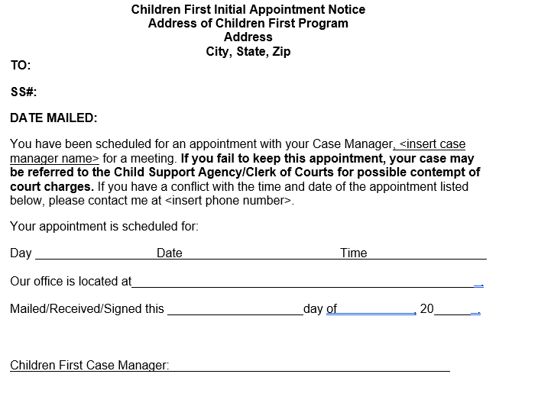

YOUR RIGHTS AND RESPONSIBILITIES FORM
**SAMPLE***
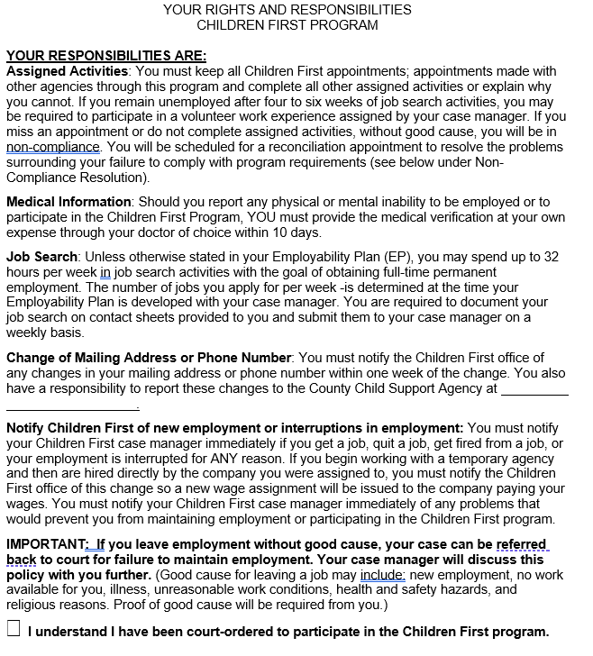
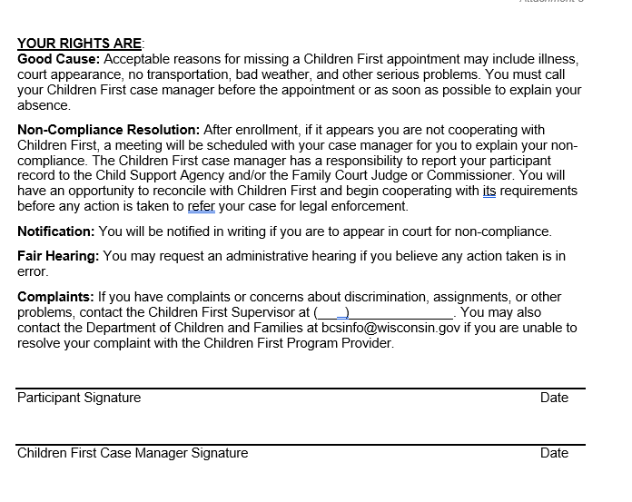

CHILDREN FIRST FACT-FINDING APPOINTMENT NOTICE
***SAMPLE***
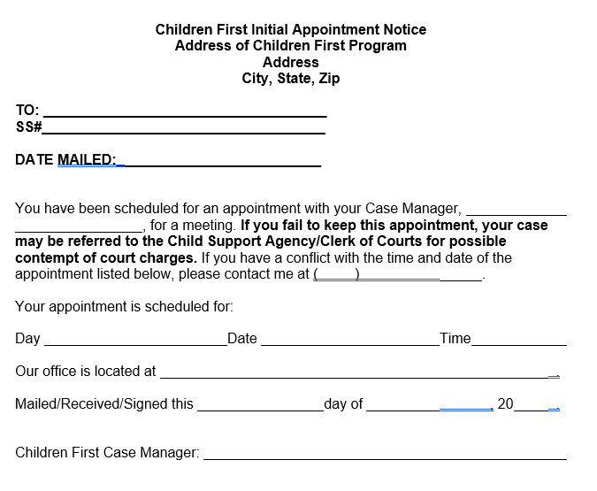

CHILDREN FIRST RECONCILIATION AGREEMENT
***SAMPLE***
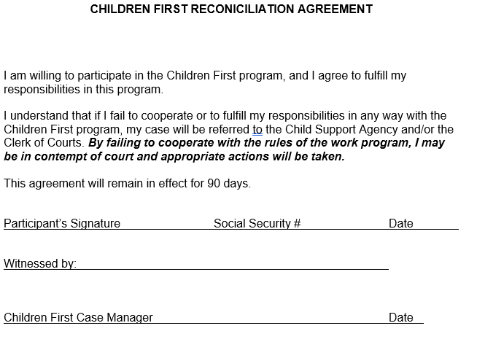

NOTIFICATION OF NON-COMPLIANCE WITH CHILDREN FIRST PROGRAM
***SAMPLE***
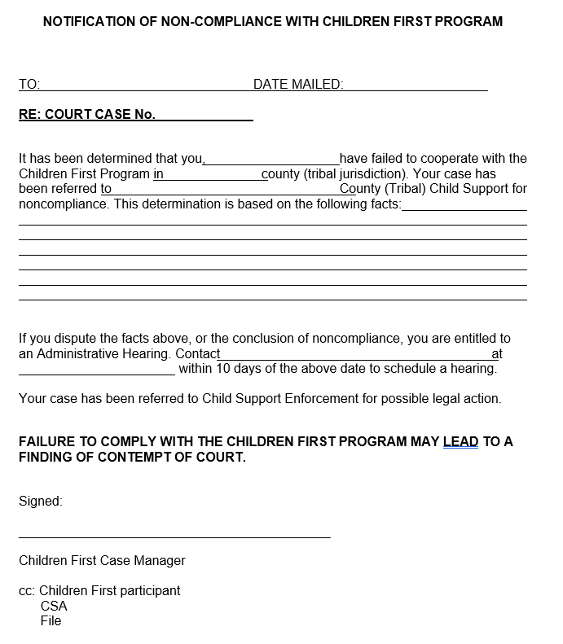

Affidavit of Non-Compliance with Children First Program
**SAMPLE**
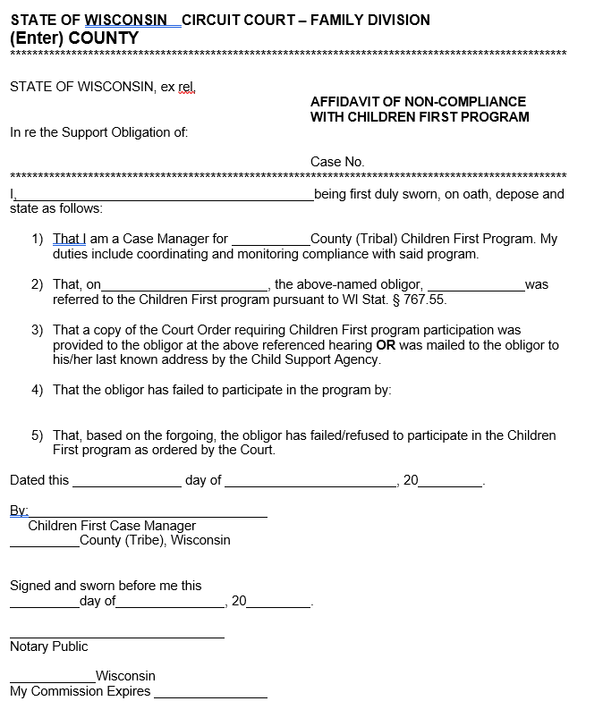

Affidavit of Successful Completion of Children First Program
**SAMPLE**
