SUP Unit Assignment
Creating, Editing & Assigning SUP Units
12/6/2018

Assign a SUP Unit to a worker & Create/Edit a SUP Unit
This document provides an overview for identifying and assigning a Supervisory (SUP) Unit to an existing or new worker. Furthermore, this document outlines the steps for creating a new SUP Unit as well as editing SUP Units that already exist.
Assigning a SUP unit to a worker:
- Under the Worker Tools in CWW, click on the Administrative Structure Management/Search link.
- The admin units can then be searched by county: 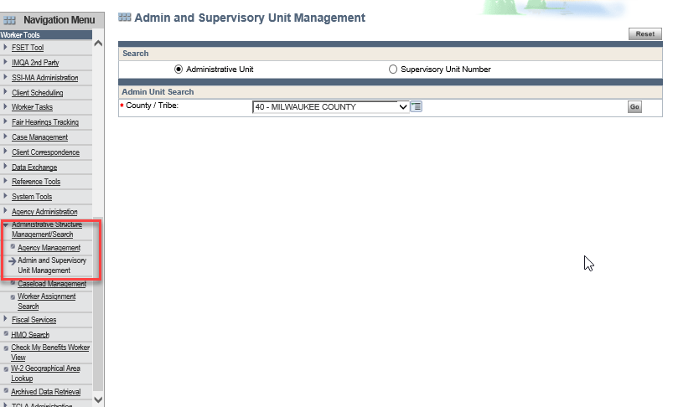

- On the Search results, identify the admin unit and click the magnifying glass next to the admin unit. This will bring up the Administrative Operating Unit Maintenance page listing all the SUP units under the admin unit:
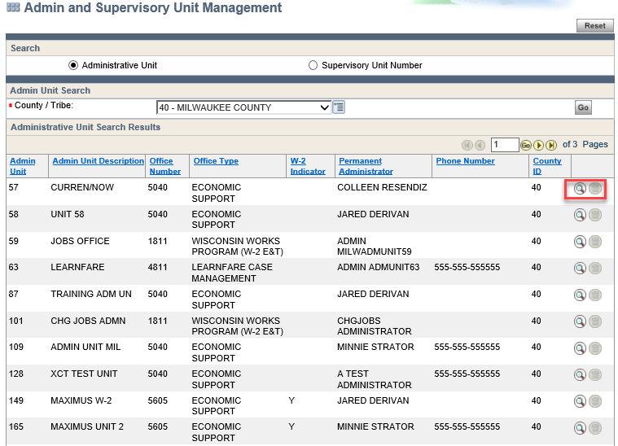
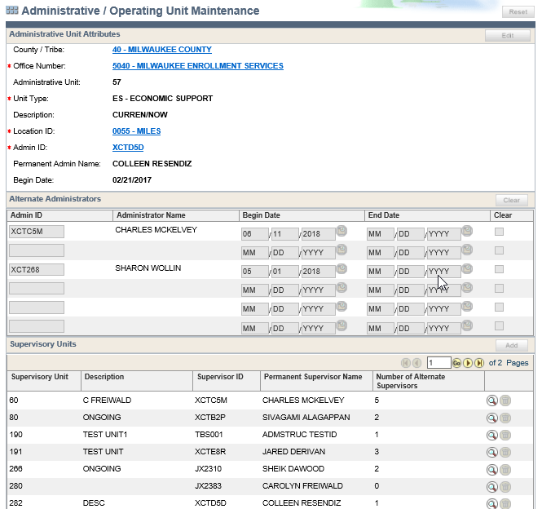

- The FEP worker can be assigned to one of the SUP units by a member from the DHS Security team. When adding a new worker, the DHS Security team member can assign the SUP unit using the WISA application:

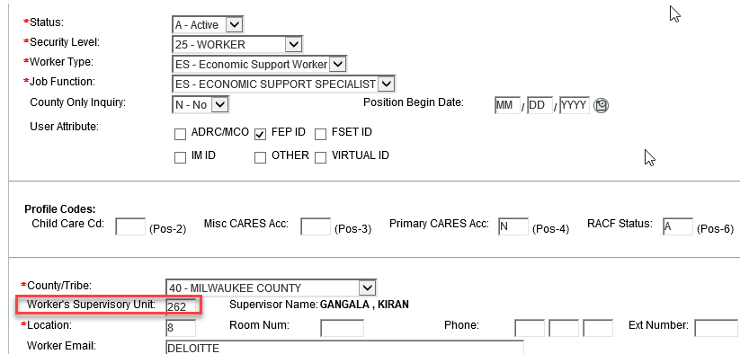

Creating/Editing SUP units:
- A SUP unit can be added to the Admin unit using the “Add” button in the Supervisory Units section on the Administrative/Operating Unit Maintenance page:
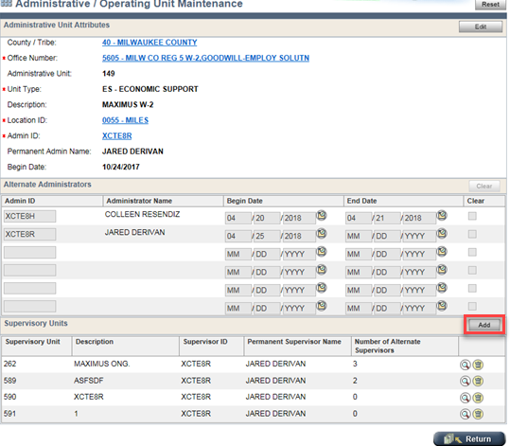

- A Sup unit can be edited (adding Alternate Supervisors or changing the permanent supervisor) by clicking the “Edit” button on the Supervisory Unit Maintenance page:
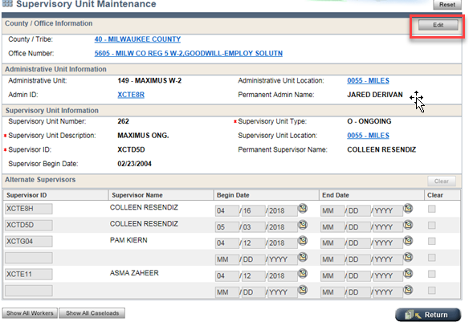
- View of a SUP unit in Edit mode:
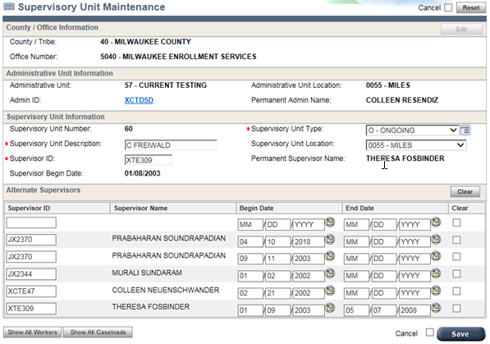

Access to add/update SUP units and admin units:
The workers should be able to add/update admin units and SUP units if they meet the criteria described below:
Update SUP units:
Security Level | Supervisor in the SUP unit | Administrator in the admin unit | Worker belongs to the same eligibility office as the SUP unit
50 | Yes | Yes | Yes
75 | N/A | Yes | Yes
85 | N/A | N/A | Yes
99 | N/A | N/A | N/A

Add SUP units:
Security Level | Supervisor in the SUP unit | Administrator in the admin unit | Worker belongs to the same eligibility office as the SUP unit
75 | N/A | Yes | Yes
85 | N/A | N/A | Yes
99 | N/A | N/A | N/A

Update admin units:
Security Level | Supervisor in the SUP unit | Administrator in the admin unit | Worker belongs to the same eligibility office as the SUP unit
75 | N/A | Yes | Yes
85 | N/A | N/A | Yes
99 | N/A | N/A | N/A

Add admin units:
Security Level | Supervisor in the SUP unit | Administrator in the admin unit | Worker belongs to the same eligibility office as the SUP unit
85 | N/A | N/A | Yes
99 | N/A | N/A | N/A

In addition to the above criteria, the workers should be assigned to one of the following profiles in WISA:
- CWW-IM-SUPERVISOR
- CWW-IM-SUP-WITH-EBT-ISSUANCE
- CWW-IM-SUP-WITH-EBT-REPAYMENT
- CWW-FEP-SUPERVISOR-W2
- CWW-ADMIN-AGCY-MGMT

