

**How to use Call Forward All (CFwdALL) Button**

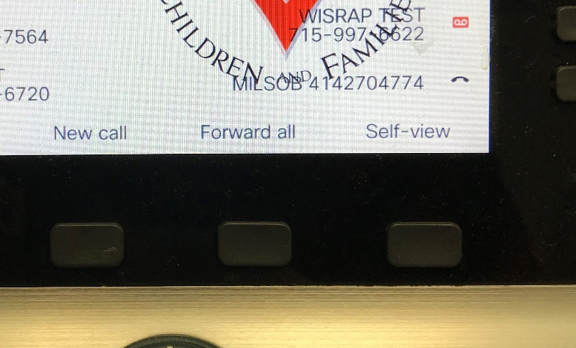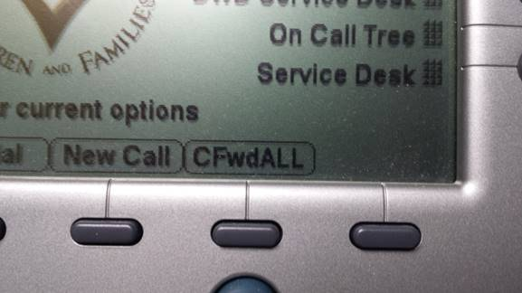

To forward all calls that you receive to your desk phone;

Press the **CFwdALL** or **Forward all** button.

If you are transferring calls to another DCF internal phone number, enter the 5-digit number.

If you are transferring calls to an external number (cell phone for instance) - Enter 9 and then the entire 10-digit phone number (example 91608-xxx-xxxx).

The phone will display "Forwarded to #####"

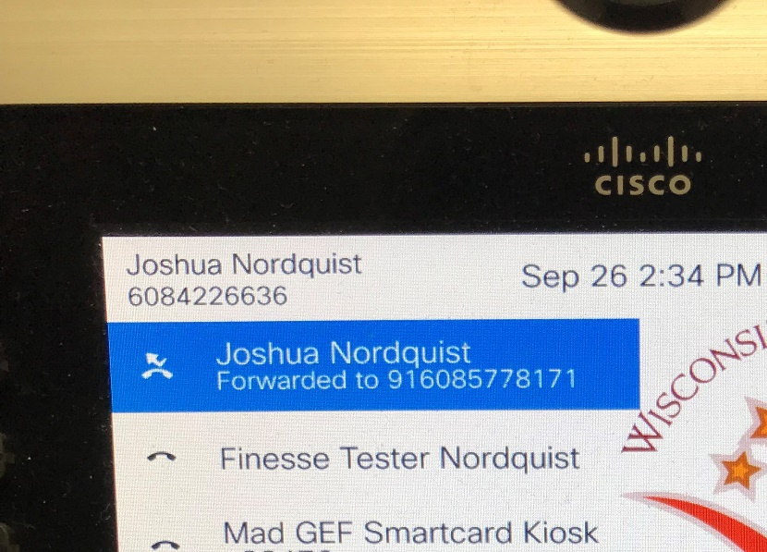

To remove the forwarding press **CFwdALL or Forward off** button